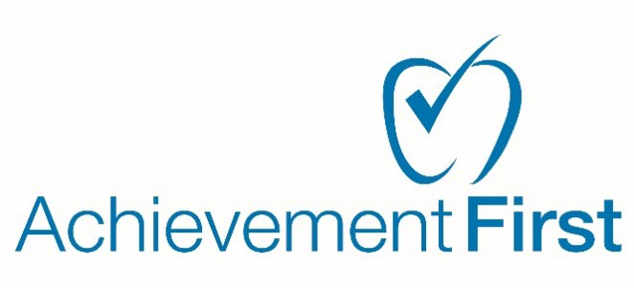

Achievement First Rhode Island
AHERA Inspection Notice

10/28/22
To: Parents, teachers, employees, other personnel, or their guardians. From: Achievement First, Inc.
Diana Perez-Alvarado
370 James St. Suite 404 New Haven, CT 06513

Dear friends and family,
In a continuing effort to keep our schools safe for all scholars and staff, Achievement First regularly inspects its facilities to ensure they comply with all federal, state and local regulations. Included in these inspections are periodic observations of all asbestos-containing materials located in the building.
The Asbestos Hazard Emergency Response Act (AHERA) requires that Achievement First notifies all building occupants of inspections, re-inspections, response actions, and post-response action activities. Please note of upcoming inspection dates for each property:

Providence Mayoral Academy | 370 Hartford Ave., Providence, RI | 11/7/22 | 6 Month re-inspection
AF Providence H.S. | 315 Laurel Hill, Providence, RI | 11/7/22 | 6 Month re-inspection

Inspection reports are kept as part of the Management plan and are available at your request in each facility’s main office building. To give you some background about asbestos; in the 1970’s asbestos was commonly used as a building product due to its resistance against fire and chemicals. It is typically found in pipe insulation, fireproofing, and floor tiles. In 1978 the Environmental Protection Agency (EPA) began to regulate such materials and limited its use thereafter. When properly maintained and protected, asbestos- containing materials pose little to no effect on the environment to which it is in.

For more information you can visit the following resources or contact me directly:

EPA/AHERA - Asbestos in Schools: http://www.epa.gov/asbestos/pubs/abcsfinal.pdf http://www.epa.gov/asbestos/pubs/aherafaq.html#8

Best regards,

Diana Perez-Alvarado
Sr. Director, Team Facilities

