Plan Type: Robust/Day A

Close Reading IPP Pre-Work
Directions: Prior to the IPP meeting, take the following steps.
 | What to do? | Teacher Pre-Work Notes
Step 1 | Use your GBTJ to read and annotate the text | n/a  (Bring annotated text to IPP meeting)
Step 2 | Jot the central idea in your own words | - Migration of different bird and mammal specials by land, sea, and air.  - They migrate for food, water, and warmth; they are migrating for survival.  - Nature clues help them with seasonal migration.  - Important for survival
Step 3 | Brainstorm a roadmap of questions that could be used at key sections of text | - Based on the heading, what is the topic of this section?  - What is author mostly teaching us?  - How is this section connected to the title?  - What does this reveal about the author’s POV?

Close Reading Daily Lesson Resource

Note: Teachers should complete the yellow highlighted sections below as part of their intellectual preparation.
Connection of Lesson to Unit Overview
This lesson is in the 2nd week of Unit 1 and thus, the priority is to pursue the following student mastery goal:
- Students accurately name genre and thinking job by 9.8.

Text Title, Author, Genre
Title: “By Land, Sea, and Air”
Author: Unknown
Genre: Non Fiction/Informational Text

Lesson Aims / Purpose
To teach students to distill the meaning of any short text and to articulate the central idea in oral and written language.
.

Central Idea Bottom Lines
Mostly Teaches Us:
- The article describes the seasonal migration of different bird and mammal specials by land, sea, and air.
- They migrate for food, water, and warmth; they are migrating for survival.
- Nature clues help them with seasonal migration.
POV:
Author thinks seasonal migration is intriguing and important for animal survival.

Key Craft and Structure
- Subheadings: Helps to organize the different migratory habits of different animals i.e. helps to show that the author is mostly teaching us.
- Photographs Show information in text: “Humpback Whales” and “Polar Bears” show the idea that seasonal migration is important for the survival of species i.e. helps to show that the author is mostly teaching us.

Key Sections of the Text
- Introductory paragraph (italics)-paragraph 1: Establishes the topic of the text: migration
- Paragraph 7 (last paragraph): Reveals the author’s point of view: seasonal migration is interesting/intriguing

Teaching for the future: Key Understandings to “Punch”
For this Text:
- Great readers use section headings to anticipate what they will learn about in that section of text.
- Great readers recognize that text features such as picture are either supportive or additive and help build meaning in text.

For the Calendar of Student Mastery:
- Great readers always look at a new text and immediately ask themselves what the genre is so that they can know what to expect as they read.
- Great readers can determine the genre of a new text by looking at the title and reading the first paragraph of the text to look for evidence of nonfiction or fiction elements.
- Great readers keep the GBTJ in their head as they read and use to better understand the text.

Visual Anchor To Be Used / Referenced in Lesson
- Genre Based Thinking Job poster (available on the Curriculum Hub)
- Strategic Reading Plan poster (available on the Curriculum Hub)
- Craft and Structure Moves poster (available on the Curriculum Hub)
- Vocabulary (standing visual anchor in classroom)- migration

Agenda Component | Roadmap of Questions and Teacher Moves | Teacher Notes to Prepare to Teach
Framing and Fluent Read | Note Roadmap of Questions and Teacher Moves:  Before Reading  - Who has ever been curious about animals? Me too.  - Well today, we have the opportunity to read and learn a little more about animals.  - What is the genre? How do you know? What’s our GBTJ? Non-Fiction/Informational Text  - Title, headings, and photographs give us a clue that this is non fiction  - Why is it helpful to consider the GBTJ? GBTJ will help us know what to expect as we read  - So based on the title and the section above the photo, what is the big topic of the text?  - Topic: Animals traveling by land, sea, and air  Fluent Read  - Teacher Fluent Read for first page.  - Choral read for second page. | Note Potential Scholar Misunderstandings and How to Respond:  - Misunderstandings: Scholars may not pay attention to the photographs. Ways to respond:  - Ask: “How could we use the pictures in order to help them determine the genre?”  - Say: “I notice Jose is looking at the pictures to help him determine the genre. Smart!”  Note Teaching for the Future Statements:  - (At the beginning of the introduction): Great readers always look at a new text and immediately ask themselves what the genre is so that they can know what to expect as they read.  - (Before “what is the genre” question): Great readers can determine the genre of a new text by looking at the title and reading the first paragraph of the text to look for evidence of nonfiction or fiction elements.
Reading for Meaning | At end of paragraph 1:  - *What important information are we learning about our big topic? (Z, W, G migrate in summer to find food/water)  - BPQ: Reread the first paragraph. What does the author mean by “on the move?” Why are animals “on the move?” (The author means that the animals are physically moving around in order to find food/water or based on the season.)  - How does this photo contribute to our understanding of the text? (Supports our understanding because it helps us visualize the act of migration)  BPM: We know that text features either “support” or “add on” to the content of the text.  At “Humpback Whales” subheading:  - *Based on the subheading and the big topic of the text, what can we expect this section to be about? (It will be about how whales migrate, probably by water given what we already know about whales)  After “Humpback Whales” Section:  - *What important information are we learning about seasonal migration of humpback whales?  (Humpback Whales migrate to help species survive in cold temperatures; they migrate for warmth which helps them survive)  - How does the photo support or add on? (Supports because it helps us visualize)  - BPQ: What is the meaning of the last sentence of this paragraph? (It shows us that this is a matter of survival)  - BPQ: How does the concept emerging in this last sentence connect back to the previous sections? (Humpback Whales must migrate in order to survive and in the first paragraph, we learned that zebras, wildebeests, and gazelles migrate so that they survive too. It seems many types of animals migrate for survival.)  At “Barn Swallows” subheading:  - *What do you expect this section and the next section to be about? (Based on subheading, I am not sure because I do not know what a barn swallow is. But based on the pictures I am guessing we are going to learn how a type of bird migrates, probably by air, given what I already know about birds).  BPM: Remember to use the pictures to build your understanding of the text. What do you see in the picture? How does that help you better understand this section? (I am guessing we are going to learn how a type of bird migrates, probably by air, given what I already know about birds).  After “Barn Swallows” and “Artic Terns” section:  - *In reading it, how does it connect to our big topic of seasonal migration? (Birds fly a far distance in seasonal migration too.)  At “Polar Bears” subheading:  - *What do you expect this section to be about? (How polar bears migrate too, probably by land, given what I already know about polar bears.)  After “Polar Bears” section:  - *In read it, how does it connect to our big topic? (Polar bears migrate by land in order to care for young).  - *How does it connect to the “Humpback Whales” section? (Both polar bears and humpback whales migrate to care for young.)  After Last Paragraph:  - *What are we learning about seasonal migration? (Nature clues help many types of animals to migrate.)  - What’s the purpose of the last paragraph? (It introduces a key vocabulary word that helps us understand and speak about this whole text—“migrate.” It also helps us to see how nature’s clues guide animal migration. Also it gives us a sense of the author’s POV.)  - *What can we learn about the author’s POV? (Animal migration and the role of nature in helping the animals migrate are really intriguing.)  - BPQ: Read the last sentence. What do you notice about how the author wrote this sentence? How does this help us determine the POV? (The exclamation mark gives us the impression that the author thinks animal migration and the role of nature in helping the animals migrate is really intriguing.) | Note Potential Scholar Misunderstandings and How to Respond:  - Scholars may not make connections between sections. Ways to respond:  - Ask: “How is the main idea of this section connected to the main idea of the last section?”  - Scholars may not make connections back to the title. Ways to respond:  - Say: “Reread the title. How is this section connected to the title of the text?”  - Scholars may not understand that animals are migrating for survival. Ways to respond:  - Ask: What are some of the reasons the author lists for these animals having to migrate? What do all of these reasons have in common?  - Scholars may struggle to find evidence to support the author’s POV. Ways to respond:  - Say: “Reread the last paragraph. What do you notice at the end of the paragraph? What does the exclamation point reveal about the author’s point of view?”  - Scholars may parrot ideas from the text instead of expressing them in their own words. Ways to respond.  - Say: “Great. Now let’s put that idea in your own words.”  Note Teaching for the Future Statements:  - (After questions about headings): Great readers use section headings to anticipate what they will learn about in that section of text.  - (After questions about ‘mostly teaching’ or ‘POV’): Great readers keep the GBTJ in their head as they read and use to better understand the text.
Articulating the Central Idea | Note Roadmap of Questions and Teacher Moves:  Strong readers pause after reading to make sure they fully understand the central idea of the text. Let’s use our annotations to help us synthesize what we’ve learned.  - So what’s this article mostly teaching us?  - Start with the big topic and try to synthesize what all our sections taught us.  - Why do animals migrate? What did we mostly learn about that?  - The last paragraph in non-fiction texts often includes important key ideas that the author wants us to take away. What was important from the last paragraph?  - What is the author’s point of view? How do you know? | Note Potential Scholar Misunderstandings and How to Respond:  - Scholars may give the whole “kitchen sink” and recall facts rather than synthesize across text. Ways to respond:  - Say: “Remember the purpose of pausing at the end of the text to jot the central idea is to make sure we have synthesized evidence throughout the whole text to come up with the deepest meaning possible. Right now, a lot of you are just naming literal facts and you are not finding the connection between those facts. Go back and review your annotation ideas. Think about how each section is connected. In your own words and in one-two concise statements, jot down what the author is trying to teach us about migration.”
Investing in the Prompt | Written Prompt: How did the author use various text features to teach us about seasonal animal migration? Provide 2 details that support your answer.  Note Additional Roadmap of Questions and Teacher Moves:  Scholars, what is this question asking? Say it in your own words.  Potential words/phrases to unpack:  - Question word  - Various  - Text features  - Seasonal animal migration  Scholars, what is your plan to respond to this prompt?  Example Plan:  - Reread central idea to review what the author taught us about animal migration  - Look for examples of text features  - Select the ones that are most supportive of the central idea  - Mark where the evidence can be found in the text  - Think of my answer  Multiple Choice Prompts  Note: The priority during this lesson should be scholars’ ability to articulate the central idea and the short response question. Multiple choice prompts should only be used *after* scholars have completed both of these tasks.  1) Which of the following best shows the author’s perspective of animal migration?  A. The author thinks seasonal migration is intriguing and important for animal survival.  B. The author thinks that seasonal migration is different for every animal.  2) Why do whales migrate?  A. To find warmer waters  B. To find food | Note Potential Scholar Misunderstandings and How to Respond:  - Mix up “how” and “why”. Ways to respond:  - Say: “Many of you appear to not be thinking through the question word when investing in the prompt. Go back and reread the question word and using our question word VA, rethink about what the question word means.  - Forget to leverage their central idea jot in their plan  Say: “I notice that Rosemary’s plan includes reviewing the “mostly teaching” part of the central idea because she knows that will help her answer the question. Smart! I should see everyone doing that too.”  Note Teaching for the Future Statements:
Responding to the Prompt | Level 2 Response (click here for 2 pt rubric):  Examples of Claims  - The author uses subheadings to help draw our attention to a variety of animals that migrate seasonally and shows us how some animals migrate by land, some by sea, and some by air.  - The author uses photographs to help support our ability to visualize the animals migrating.  Examples of Strong Evidence  - Subheadings: Humpback Whales, Barn Swallows, Polar Bears, etc.  - Photographs: Serengheti, whale, etc.  (Evidence can be quoted directly or paraphrased as long as it’s connection to the claim is clear and compelling)  Sample Exemplar Response:  The author uses subheadings to help draw our attention to a variety of animals that migrate seasonally and shows us how some animals migrate by land, some by sea, and some by air. Each of the subheadings (Humpback Whales, Barn Swallows, Polar Bears) introduce what type of animal migration the main idea of each section will be focused on. For example, the main idea of “Whales” is that whales migrate to find warmer waters in the winter so they can breathe and so that their babies can survive.  MC Prompts Answer Key:  1. C  2. B, C | Level 1 Response & Prompts To Coach Level 1 Scholars:  - Only focus on food OR temperature OR survival-> Direct back to question- reasons (more than 1), you gave ONE reason, give another  - Kids might only talk about one species -> Direct back to question- species  - Kids might talk about each species separately (i.e. not connecting back)-> Direct back to “Compare”/plan- need to talk about what’s similar  - Adaptation vs. migration- focus on prior knowledge (based on exposure to similar topics) instead of information in this text ->  - Lack of explanation of evidence -> Why is that important?  - Not including evidence about climate/temperature-> Direct back to text  Who I Will Circulate To:  - Ms. B will pull Joel, Yahir, Elizabeth, and Reagan to work on how to determine the genre of the text.  - Ms. Peters will circulate to all scholars whose individual goals are challenge #1.
Wrap Up | Based on scholar data, what will I look for in scholar work to put under the projector?  Scholar work that used the central idea jot as part of their plan to answer the short response question.  What will I say to scholars to emphasize these transferrable learning points?  What did we learn about reading from this text?  - Great readers use section headings to anticipate what they will learn about in that section of text.  - Great readers keep the GBTJ in their head as they read and use to better understand the text. | Note Potential Scholar Misunderstandings and How to Respond:  - I need to check for understanding of the key points to the left, so that they do not wash over scholars heads

By Land, Sea, and Air
Every year, all over the world, millions of animals are on the move. As the seasons change, they travel to new homes where they can live, find food, and raise their families.
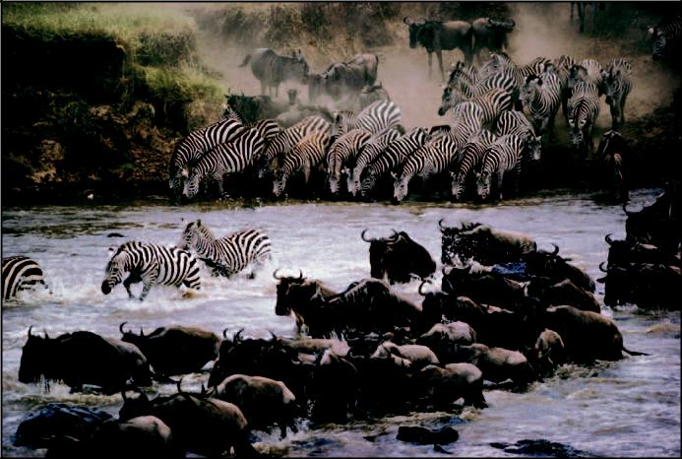

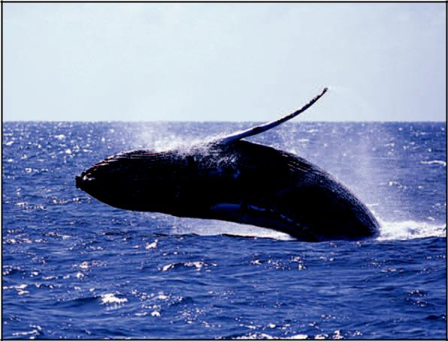
Summer turns the grass of the Serengeti Plain in Africa brown. That’s when more than a million zebras, wildebeests, and gazelles travel north to the woodlands in a huge herd. There the animals will find enough food and water to live until the rainy season brings green grass to the Serengeti again.

Humpback Whales

Humpback whales spend their summers at their feeding grounds—icy cold waters near the North and South Poles. But in winter the water freezes over, and the whales can’t come to the surface

to breathe. So they swim thousands of miles to the equator, where the water is always warm. There in the warm ocean, they have their babies, who would die in the frigid waters near the Poles.

Barn Swallows
Barn swallows fly all the way from North America to South America. They catch insects for the winter as they fly.

Artic Terns
Artic terns fly the farthest, from near the North Pole to near the South Pole, and back – about 25,000 miles – every year.
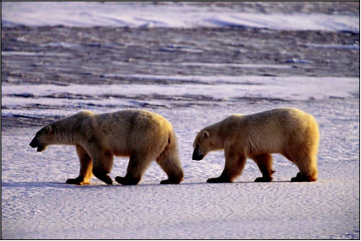

Polar Bears
After hibernating all winter, this polar bear mother wakes up hungry! In spring and summer, she travels hundreds of miles hunting for seals to feed herself and her cubs.

All of this seasonal traveling is called migration. Scientists think some animals use smell, some the Sun, and some even use the stars to figure out where to go!

Central Idea Rubric
Score | Response Features
2 points | - Demonstrates understanding of the idea and places it in context  - Goes beyond a literal understanding of the text to include a deeper meaning
1 point | - Demonstrates an understanding of the idea but it is out of context or overly cliché  - A mostly literal recounting of events or details from the text without addressing the deeper meaning  - May include minor misconceptions
0 points | - Off topic or totally inaccurate  - Demonstrates major misconceptions about the text

Name __________________
Date ___________________
1. How did the author use various text features to teach us about seasonal animal migration? Provide 2 details that support your answer.
________________________________________________________________________________________________________________________________________________________________________________________________________________________________________________________________________________________________________________________________________________________________________________________________________________________________________________________________________________________________________________________________________________________________________________________________________________________________________________________________________

*******************
Redo Space
________________________________________________________________________________________________________________________________________________________________________________________________________________________________________________________________________________________________________________________________________________________________________________________________________________________________________________________________________________________________________________________________________________________________________________________________________________________________________________________________________________________________________________________________________________

2-Point Rubric—Short-Response*
Score: 0  - I didn’t understand the the central idea  ___I need to reread the text and then revise my answer.  - I didn’t answer the question  ___I need to break down the question and think about what it is asking me.  - I did not include any evidence.  ___I need to reread the text and find evidence that supports my claim.  - My work is unreadable because of my spelling and grammar  ___I need to reread my work and correct my mistakes. | Score: 2  - I have a clear claim/ideas to answer the question.  - I have at least 2 strong, different pieces of evidence that clearly support my claim.  - I have explained my evidence, including its deeper meaning and how it connects to my claim.  - I have complete sentences with correct spelling and grammar
Score: 1
- I only answered part of the question
___I need to break down the question and think about what it is asking me.
- My claim is unclear.
___I need to think about the question and make my claim more specific
- My evidence doesn’t support my claim.
___I don’t have 2 pieces of evidence. I need to find more evidence to support my claim.
___I need to find stronger evidence to support my claim
___I need to explain the deeper meaning in my evidence
___I need to explain how my evidence supports my claim.
- My writing has errors in spelling and grammar.
___I need to reread my work and correct my mistakes.

