Leading Special Services in 2016-17

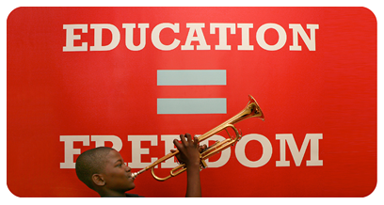

All Leader Training 2016

Turn and Talk: Connecting to your personal why
My top 5 values are…
1.
2.
3.
4.
5.

A time I felt most connected to one or more of these values at work was_____________________________________
________________________________________________________________________________________________
________________________________________________________________________________________________
….and the impact it had on what I was working on was ___________________________________________________
________________________________________________________________________________________________
_______________________________________________________________________________________________.

A time I felt disconnected from one or more of these values at work was ____________________________________
________________________________________________________________________________________________
________________________________________________________________________________________________
….and the impact it had on what I was working on was ___________________________________________________
________________________________________________________________________________________________
_______________________________________________________________________________________________.

Aims:
School Leaders Will Be Able To:
- Begin to articulate their “personal why” by identifying the personal values that guide their work and examining when they feel connected or disconnected from those values at work
- Articulate the importance of “starting with why” when inspiring others around a vision for special services work
- Using the Vision & Inspiration CFS and planning questions, plan for how they will communicate the “why, how, and what” for one special services must-do to school-based staff
- Commit to a next step in order to implement this framework when setting up special services at the beginning of the year.

Agenda:
1 | Turn + Talk: Connecting to Personal Why
2 | Why “Starting with Why” Drives Behavior + Decision-Making
3 | Applying “Start with Why” Framework to Special Services Leadership: Model + Criteria for Success
4 | Applying “Start with Why” to YOUR Leadership
5 | Committing to a Next Step

360 Survey Feedback: Vision + Inspiration at 10,000 and 5,000 feet.
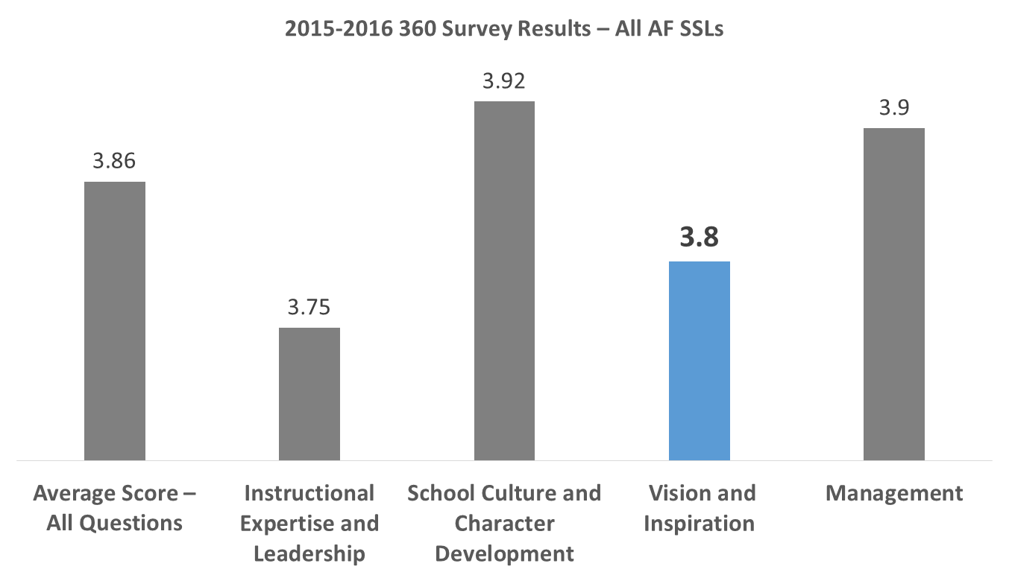
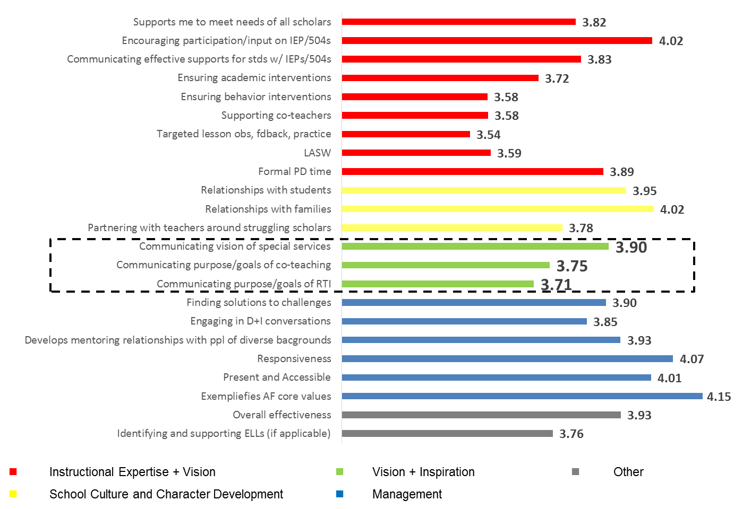

Special Services Leadership Challenge: Implementing Accommodations
(Why)
At AF Imagine, we are a courageous team that never fails to rise from a challenge. We believe that the worthiest efforts are the hardest ones.

One of the most challenging things a teacher is asked to do is to meet the needs of all learners in their classroom. My experience has shown me that there are too many teachers in this country who do NOT rise to this challenge each day within the four walls of their classroom to do this.

And the reality is, that at AF Imagine, our walkthrough data suggests that we’re implementing accommodations only 60% of the time. That means that our kids with disabilities are missing out on 24 minutes of instruction for every hour. This helps explain our achievement gap for students with disabilities: they are beginning the race from way behind the starting line.

(How)
Implementing accommodations for every student with an IEP for every lesson – and doing so effectively – is not easy, and I won’t pretend it is – but with practice, you will get better at it. As the SSL, I’ll take the IEPs and make them easier for you to understand by creating an IEP-at-a-glance. On this document I’ll list the accommodations that work most effectively for the student. I’ll even compile these into a binder for you so you can reference them quickly. Then, as you’re lesson planning, you’ll review these accommodations and include them onto your lesson plan. While this will take more time, and sometimes it will be challenging to implement – especially at first -- I’ll try to make it efficient for you. Even more, I’ll be working with coaches at the beginning of the year and then ongoing to providing you targeted feedback to help you do this more effectively.

(What)
At AF Imagine, we will meet the needs of all of our students by effectively and consistently providing accommodations for students with disabilities. We are a team that has courage, and we don’t shy from a challenge.
What makes this a more effective way to rally a team around planning for and implementing accommodations? Please read and annotate.

Vision & Inspiration Feedback Cheat Sheet

Priority Points (focus on the mastery of these points first):
- Use values and imagery to create a sense of shared purpose for your team.
- Appeal to both hearts and minds – through both emotional and rational arguments - to inspire urgency and action around the shared purpose.

 | Constructive Feedback (“Next time try…”)
Connects to Vision | - Identify and connect to a value, belief, and/or characteristic of the community that relates to the challenge and is necessary to draw upon in order to meet the challenge.  - For example, “we are a team that ____.” “At AF Imagine, we _______ (never shrink from a challenge, care deeply about our people, face the brutal facts, grow from our mistakes….)”  - Describe what it will look and feel like in the future for the team, scholars, and/or families.  - Use imagery to paint a clear picture of the future. (for example: “I picture a spring in the near future when we are flooded with college graduation invitations – and where we’ll check off the names, one-by-one, of every senior who left us four years earlier.”)  - Boil it down to a “sticky message” that you can return to in the future.  - For example, “what we focus on gets better,” “climbing the mountain to college”  - Create greater urgency. Describe the current reality and what the impact will be on kids, families, the school, teachers, etc. if things stay the same.
Inspires | - Use emotional arguments to appeal to the heart.  - Use a story to…  - Illustrate the value, belief or characteristic of the team.  - Paint a picture of the change you want to see  - Show concretely what the current reality is  - Use humor (as appropriate) to boost engagement, defuse tension, and create sense of camaraderie and safety.  - Be vulnerable by sharing your personal feelings or struggles with the challenge (i.e., identify/connect with the feelings/struggles of the team)  - Use rationale arguments to appeal to the mind.  - Use data and facts to illustrate the challenge and create urgency.  - Use logic to build an argument for the change. (i.e., show the connection between the desired action and the impact it could have).  - Create opportunities for individuals to connect with what they care about and to contribute to the vision.  - Create reflection opportunities around personal values, beliefs, and vision.  - Construct a vision of the future together (e.g., pose the question, what would it look like or feel like if ____?” and have folks contribute the details to the vision/)  - Prompt individuals to think of and share how scholars, families, the school community, staff, etc. will be impacted if this is successful

Reflection
Think about a time in the last 6 months when you needed to rally a group of adults around a piece of work and you did not successfully connect the work to a vision or inspire them.
- What was the challenge or initiative?
- Why was it important?
- What impact did insufficient vision + inspiration have on the work, the team, and/or the outcome?

Planning Sheet
Communicating Vision + Inspiration: Questions to Spark Reflection and Begin Planning

What is the leadership challenge?

Who are the people you’re trying to lead?

What is it that you are trying to lead people to do/believe/get on board with?

Why
What value(s) do the people you are leading share that you can tap into?

Is there a particular aspect of your team’s identity to connect to here (e.g., we ask for and give help when it’s needed, we commit to big goals, we don’t shy away from tough feedback)?

What stories or anecdotes illustrate this aspect of the team’s identity?

Imagine you are wildly successful in getting people to do/believe/get on board with this. What is the potential impact (on students, the school, the community, your school’s vision)?

Why is this so important, now? What facts & figures, as well as stories of students, classes, and/or families, paint a picture of the current reality?

How
What are the most important parts of your plan (or strategy) that people need to know in order to trust in it and to follow it? List them here.

If this question is hard to answer, think about these questions:
- What could be hard about this work that your plan/strategy takes into account? (ex.: IEPs are lengthy and hard to interpret. Our IEPs at a glance are short and stated in plain language that any teacher can understand.)
- What are the parts of the plan that, if you took them out, failure would be guaranteed?

What
Imagine again that you and your team are wildly successful in this effort. What does that look, feel, sound like? Use powerful imagery to describe it.

What values and aspects of your team’s identity will you see “live” as they do the work successfully?

