Behavior Intervention Resource Packet
All of these materials can be found on the Behavior Intervention Hub on Many Minds. Search Many Minds for “Tier 2 Behavior Interventions.”
Table of Contents
All About You: Blank Template 2
All About You: Carlos’ Example 3
CICO: Blank TEMPLATE 4
CICO: Jeremy’s Example 5
SKILL Building: Blank TEMPLATE 6
SKILL Building: Sonya’s Example (2 pages) 7
BIP Lite: Blank Template (2 pages) 9
BIP Lite: Jay’s Example (2 pages) 11
Agreement – Blank Template (2 pages) 13
Writing Tier 2 Plans: Behavior Intervention Feedback Cheat Sheet 15
Rolling Out Tier 2 Plans: Behavior Intervention Feedback Cheat Sheet 16
Social Skills to Build Lagging Skills (K-5/6) 17
Social Skills to Build Lagging Skills (Adolescent Version – Grades 5-12) 23
Preventative Teacher Strategies (to prevent the problem behavior from occurring) 28

All About You: Blank Template
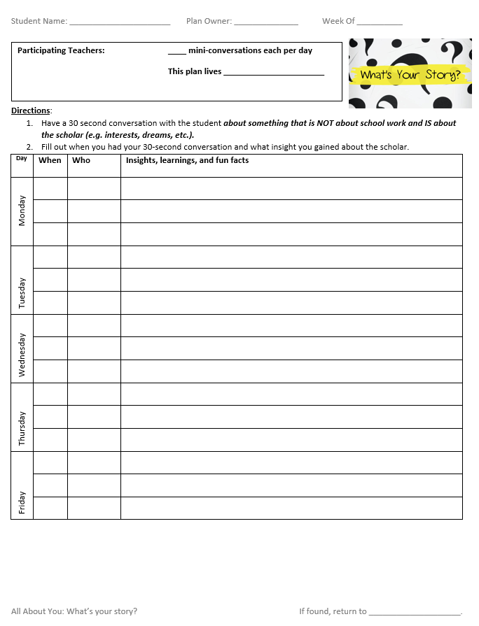

All About You: Carlos’ Example
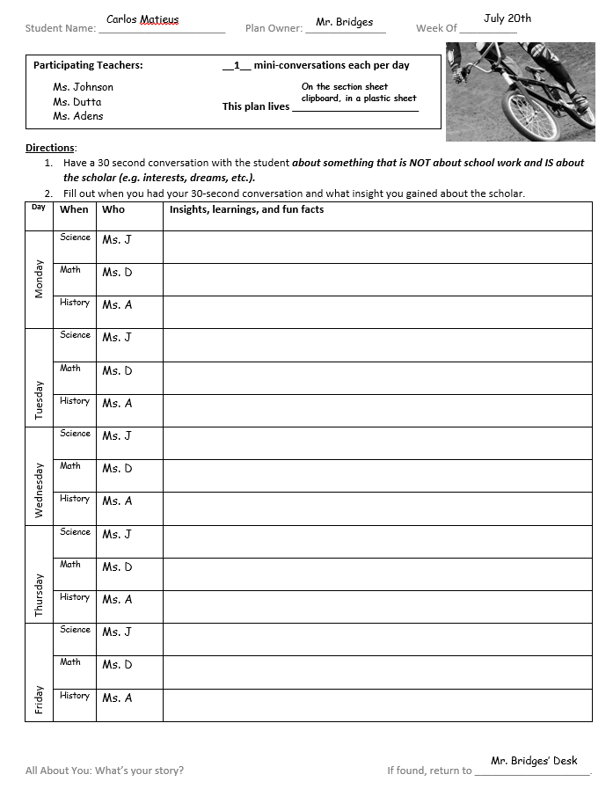

CICO: Blank TEMPLATE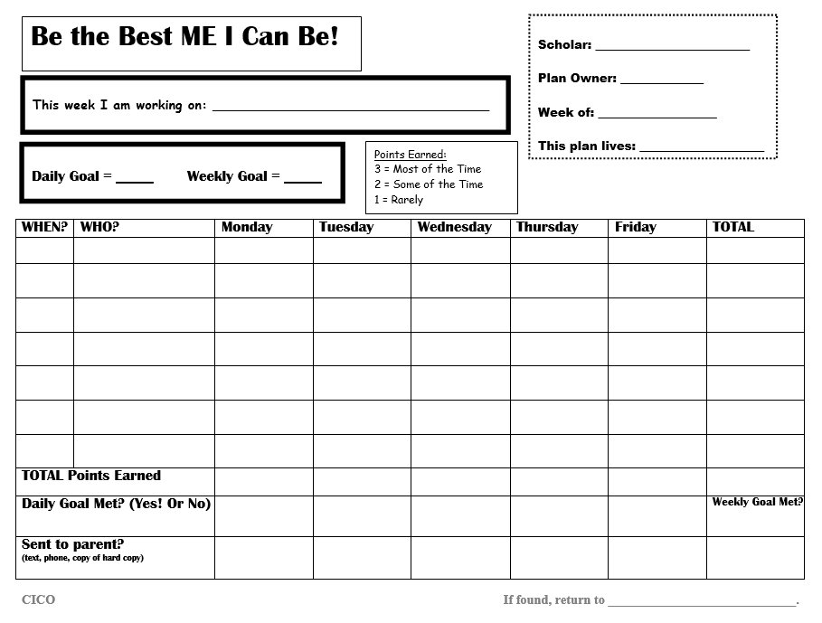

CICO: Jeremy’s Example
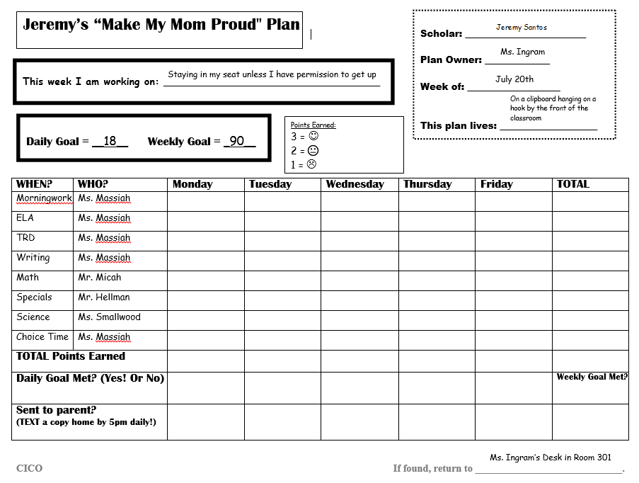

SKILL Building: Blank TEMPLATE
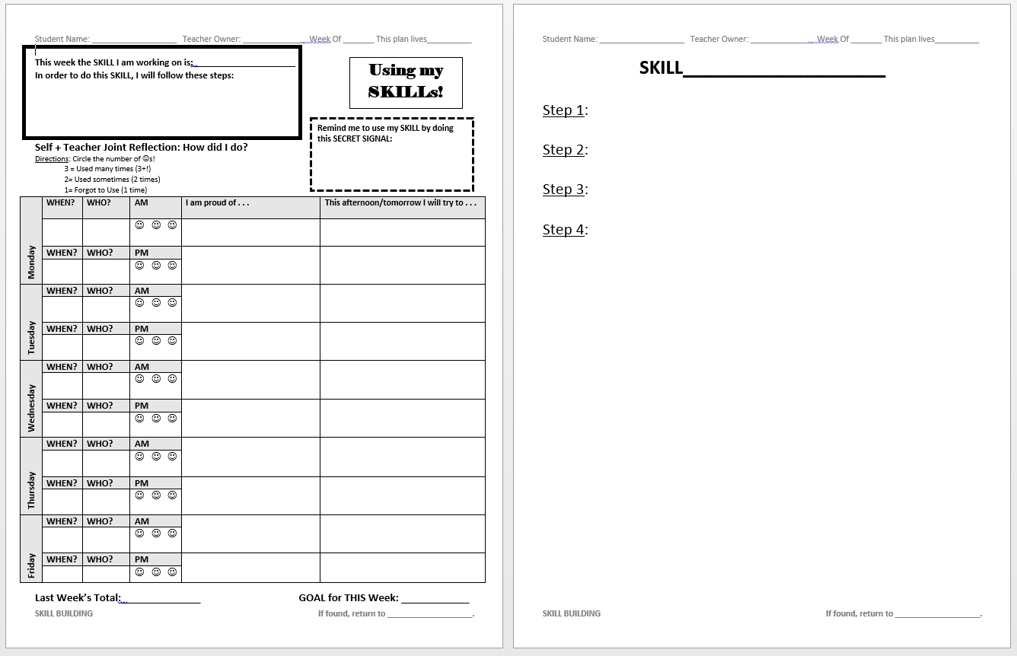

SKILL Building: Sonya’s Example (2 pages)
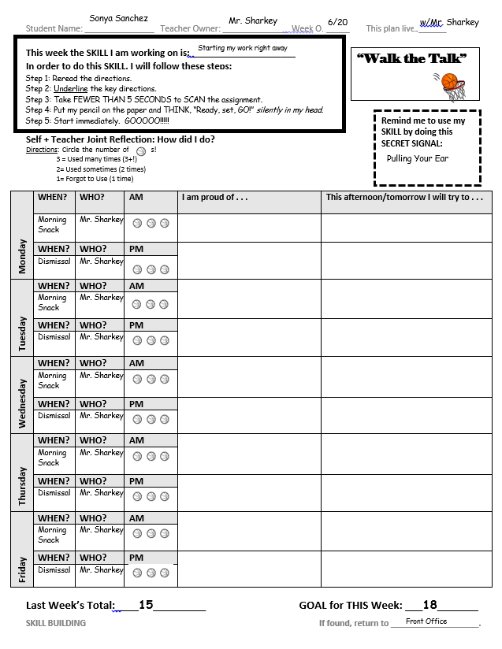
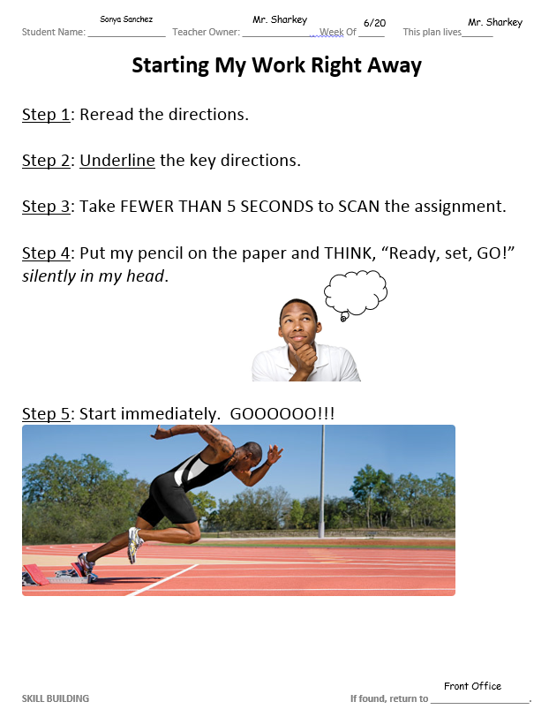

BIP Lite: Blank Template (2 pages)
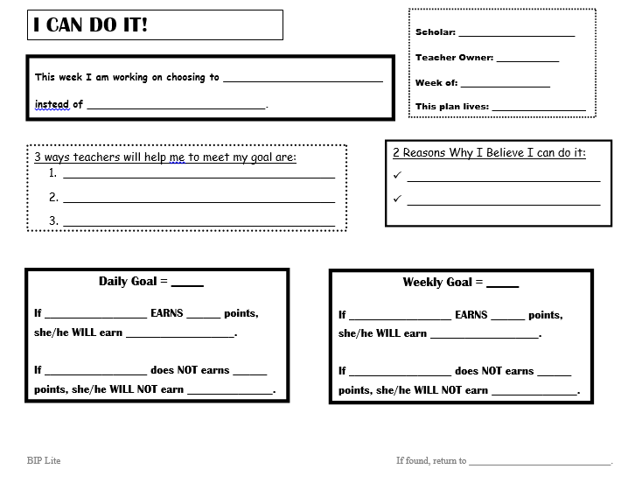

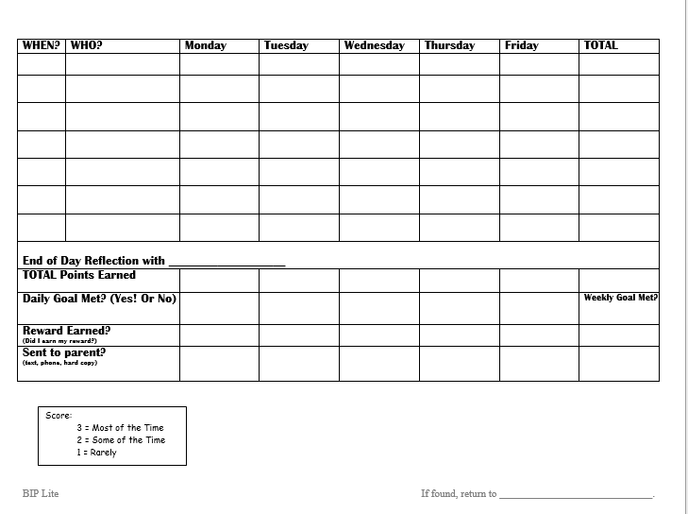

BIP Lite: Jay’s Example (2 pages)
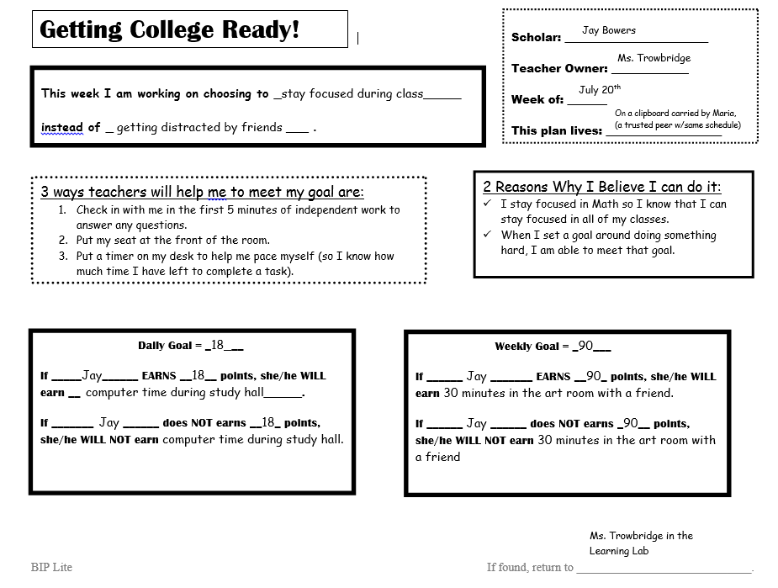
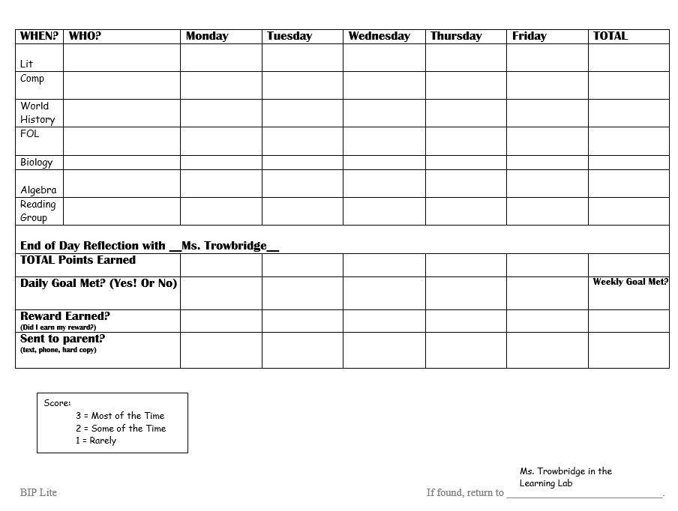

Agreement – Blank Template (2 pages)
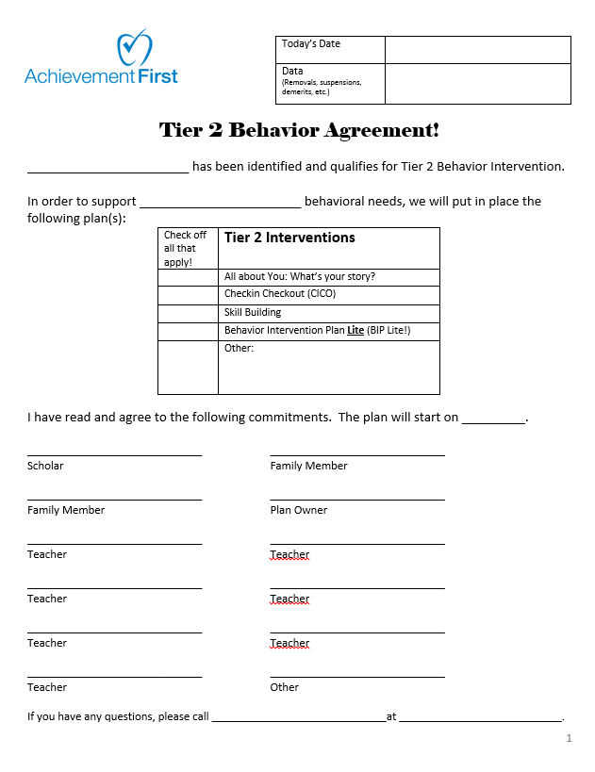

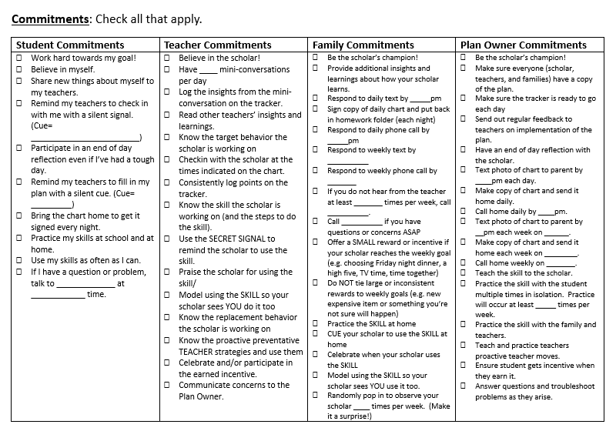

Writing Tier 2 Plans: Behavior Intervention Feedback Cheat Sheet
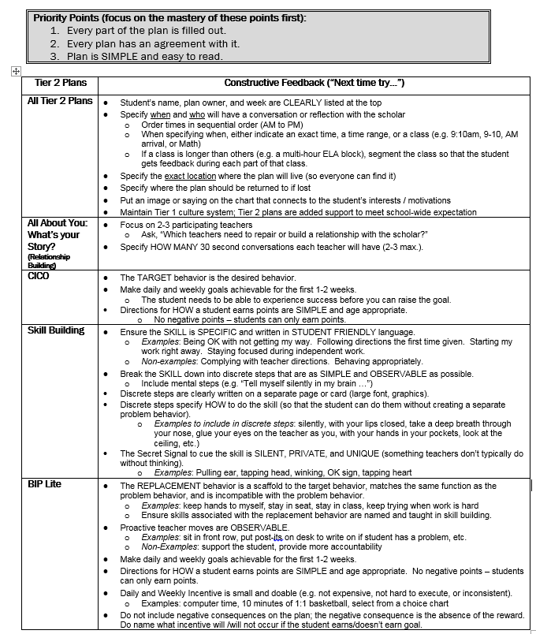

Rolling Out Tier 2 Plans: Behavior Intervention Feedback Cheat Sheet
Priority Points (focus on the mastery of these points first):
- The majority of the agenda is spent on practice (more than 75% of the time).
- The plan is printed out and everyone has a hard copy.

All Tier 2 Plans | Ask yourself:  - Am I meeting the student’s need for competence?  - Am I meeting the student’s need for autonomy?  - Am I meeting the student’s need for connectedness?
Make sure to practice the following when rolling out a plan.
All About You: What’s your Story?  (Relationship Building) | - Conducting a 30 second relationship building conversation  - Conversation is QUICK (takes <30 seconds)  - Conversation is not about class or the task at end  - Eye contact  - Connect to scholar’s interests and motivations  Examples: asking a question, talking about something that interests him/her, sharing a picture or artifact that shows that you were thinking about the scholar outside of class (e.g. I saw this picture in a magazine and thought of you because I know how much you enjoy …)
Skill Building | - Using the SECRET SIGNAL  - Eye Contact  - Clear / exaggerated gesture  - Giving specific positive praise to the student for using his/her skill  - Name the discrete step the scholar is using before assigning praise (“Jon, I see you taking a calming breath. Nice job – keep it up.”  - Use a neutral/positive tone  - Praise is positive not effusive  - Using the discrete steps to TEACH the student to use the skill in the moment  - Do the steps together by directing the student to do the steps (“the first step is reading the question. Read the question.”)  - Use skill card/chart as a visual  - Use a neutral/positive tone  - Avoid asking, “Have you reread the directions?” (This is not a conversation ABOUT the skill. It’s an opportunity to use the skill to respond in the moment.)
CICO and BIP Lite Debrief Conversations | - Conducting a 30 second beginning of class conversation  - Conversation is private  - Conversation is QUICK (takes <30 seconds)  - Name what student is working on (read this verbatim off the chart)  - Use chart as visual (has chart in hand)  - Give positive authentic example for why the teacher believes in the student  - (for BIP Lite) Explain what teacher will do to help  - Gives a specific direction to get started  - Neutral tone  - Conducting a 30 second end of class conversation  - Conversation is private  - Conversation is QUICK (takes <30 seconds)  - Name what student is working on (read this verbatim off the chart)  - Review how the student earns points (review scoring)  - Ask the student to self-reflect first (“How many points do you think you earned?”)  - Tell the student how many points he/she earned  - Mark points on chart in front of scholar  - End on a positive note setting the student up for the next class  - Neutral tone

Social Skills to Build Lagging Skills (K-5/6)
Social Skills to Build Lagging Skills (Younger Version – Grades K-5/6)
Priority Points:
- Discrete steps are clearly written on a piece of paper or cardstock (large font).
- Key steps are illustrated (graphics).
- Adjust discrete steps to specify HOW to do the skill (so that the student can do them without creating a separate problem behavior).
Examples to include in discrete steps: silently, with your lips closed, take a deep breath through your nose, glue your eyes on the teacher as you, with your hands in your pockets, look at the ceiling, etc.)
- There is a SECRET SIGNAL to cue the student to use the skill that is SILENT, PRIVATE, and UNIQUE (something teachers don’t typically do without thinking).
Examples: Pulling ear, tapping head, winking, OK sign, tapping heart

Skill | Discrete Steps to Execute Skill | Suggested modeling situations | What to keep in mind
Taking a Break | - Decide if my body is telling me that I'm getting anxious/worried/uncomfortable.  - Tell myself, "I can walk away from this."  - Pick up my break card and hand it to the teacher.  - Go to my designated break area.
Asking for help | - Ask yourself, "Can I do this alone?"  - If not, raise your hand.  - Wait. Say to yourself, "I know I can wait without talking.”  - Ask for help in a friendly way. | Classroom: You do not understand what you need to do next on a class assignment.  Home: You can't find your favorite video game and you ask your sister for help.  Peers: You want your friend to teach you a new dance that everyone is doing. | - Make sure you practice what it looks like to do something "in a friendly way" focus on body language, tone and volume of voice.
Following Directions | - Lock your eyes on the teacher.  - Listen carefully to the directions.  - Repeat the directions in your head.  - Follow the directions. | Classroom: Teacher explains an assignment.  Home: Your mom asks you to do a chore.  Peers: A friend tells you the rules to a new game. | - To be successful, students must be able to complete the task required of them independently.  - It will only increase frustration if they follow the steps and find that it is too difficult.
Ignoring Distractions | - Lock your eyes on the teacher.  - Count to five in your head.  - Say to yourself, "I won't look. I'll keep on working."  - Continue to work.  - Say to yourself, "Good for me; I did it!" | Classroom: Another student asks the teacher a question about completing the work.  Home: Your brother or sister tries to get you to come watch a TV show when you are trying to do your homework.  Peers: A classmate tries to get your attention during class (e.g. making eyes or whispering). | - Figure out a signal for the scholar to acknowledge every time they ignored a distraction.
Knowing your Feelings | - Stop and think of how your body feels.  - Decide what you could call that feeling.  - Say to yourself, "I feel _____." | Classroom: You receive a failing grade on your weekly quiz.  Home: Your parents forgot the special dinner you were having to celebrate your grades.  Peers: Another kid says mean, teasing things to you. | - This should be done in collaboration with the social worker.  - The scholar will likely need additional practice and a feeling identification chart.
Expressing your feelings | - Stop and think of how your body feels.  - Decide what you could call that feeling.  - Think about your choices:  - Say to the person, "I feel ____"  - Move away for now.  - Get involved in an activity/work.  - Act out your best choice. | Classroom: You want to participate and give an answer, but you are afraid your answer will be wrong.  Home: You parent will not allow you to watch a move that all your friends get to go see.  Peers: Someone call you a not nice name. | - It is important that teachers model this on a regular basis (e.g. expressing their OWN feelings and narrating this aloud).  - Also important that if a scholar is feeling an intense feeling (like anger) it is important to wait before acting on best choice.
Recognizing Another's Feelings | - Watch the person.  - Name what you think the person is feeling.  - Decide whether or not to ask the person if he/she is feeling that way.  - Ask in a concerned way. | Classroom: After the weekly quiz grades are handed out, the scholar next to you puts his head on the desk.  Home: Your mom walks in the door muttering to herself and slams the door behind her.  Peers: A friend wasn't chosen for a game and goes and sits by himself on the steps. | - Practice what a "concerned way" would look like. Have a list of feeling words ready to use.
Using Self-Control | - Stop and count to 10.  - Think of how your body feels.  - Think about your choices:  - Move away for now.  - Do a relaxation exercise.  - Write about how you feel.  - Talk to a teacher about it.  - Act out your best choice. | Classroom: You do not finish your work and have to miss recess to finish.  Home: You parents won't let you go to your friend's house.  Peers: You lend your friend something and they accidently break it. | - Teach relaxing before or part of this skill.  - Discuss how your body can give you cues into how you are feeling (sweaty palms, hot, cheeks flushed, shaking, etc.).
Asking permission | - Decide what you want to do.  - Decide whom to ask.  - Plan what to say.  - Choose the right time and place to ask.  - Ask in a friendly way. | Classroom: Ask the teacher to take a break.  Home: Ask your parents if you can go to a friend's house for a sleepover.  Peers: Ask a friend if you can borrow something important. | - It can be difficult to hear the answer NO after asking permission.  - Accepting No should be taught immediately after this skill.
Responding to Teasing | - Stop and count to five.  - Think about your choices:  - Ignore the teasing  - Say how you feel.  - Give a reason for the person to stop.  - Tell the teacher.  - Act out your best choice. | Classroom: Someone is making faces at you in class.  Home: You brother laughs at you.  Peers: Some teases you about your shoes. | - Students will need to practice saying "I feel" statements.
Staying Out of Fights | - Stop and count to 10.  - Decide what the problem is.  - Think about your choice:  - Walk away for now.  - Talk to the person in a friendly way.  - Ask an adult to help in solving the problem.  - Act out your best choice. | Classroom: Someone tells you that you better stop looking at them.  Home: Your sibling tells your parents that you did something wrong.  Peers: Someone cheats in a game.
Dealing with a Problem | - Stop and say, "I have to calm down."  - Decide what the problem is.  - Think about different ways to solve the problem.  - Choose one way to solve the problem.  - Do it.  - Ask yourself, "How did it work?" | Classroom: You aren't sure how to complete an assignment.  Home: You accidently broke a window at the house.  Peers: You lost something you borrow from a friend. | - Give lots of possible problems and then think through the different ways to deal with the problem and the possible consequences for each alternative. Students can then choose the best alternative.
Accepting Consequences | - Decide if you were wrong.  - If you were wrong, say to yourself, "I have to accept consequences for my choices."  - Say to the person, "Yes, I did _________ (describe what you did."  - Say something else:  - How will you avoid this next time?  - Apologize. | Classroom: You forgot your homework.  Home: Your parents tell you that you can't go to your friend's house because you didn't finish your chores.  Peers: You and your friends are asked to leave a movie because you were being too loud. | - Teach problem solving first.  - Make sure you go over that it is ok to be wrong and that everyone makes mistakes.
Dealing with an Accusation | - Stop and say, "I have to calm down."  - Think about what the person has accused you of.  - Ask yourself, "Is this person right?"  - Think about your choices:  - Ask a question.  - Explain, in a friendly way, that you didn't do it.  - Apologize.  - Offer to make up for what happened.  - Act out your best choice. | Classroom: A teacher accused you of cheating.  Home: Your parents accuse you of breaking something.  Peers: A friend accuses you of taking something that belongs to him/her. | - Reinforce that everyone makes mistakes and it is important to be honest if you made the mistake.  - Practice talking in a "friendly way"
Reacting to Failure | - Decide if you have failed.  - Say to yourself, “I didn’t succeed this time, but I know that I can succeed. Im hard working.”  - Think about what you could do differently next time.  - Decide what you will do differently next time.  - Move on (stop thinking about it). | Classroom: You failed a test.  Home: You didn't do the dishes so you parents won't let you watch TV.  Peers: You lose at a video game. | - Go over that no one is perfect and everyone fails. Instead of focusing on the failure, think about what you learn and what you can do better next time.
Accepting No | - Decide why you were told no.  - Think about your choices:  - Do something else.  - Say how you feel in a friendly way.  - Write how you feel.  - Act out your best choice. | Classroom: Teacher says you can't do an activity.  Home: Your parents say you cannot stay up late.  Peers: A friend tells you she won't come over to your house. | - Have "I feel _____" sentence starter practice.
Relaxing | - Decide if you need to relax.  - Take three slow, silent, deep breaths.  - Tighten the muscles in your shoulders, count to three, and relax.  - Continue this for other parts of your body (legs, face, and stomach).  - Ask yourself how you feel. | Classroom: You feel nervous before a test.  Home: It’s the night before your birthday and you can't get to sleep.  Peers: You are upset with your friend and you don't know why. | - This will take A LOT of practice and training to do this effectively. Practice on a regular basis.
Making a Decision | - Think about the problem.  - Decide on your choices.  - Think of the possible consequence of each choice.  - Make the best choice. | Classroom: Decide what group to play with.  Home: Decide how to spend your money.  Peers: Decide whether to go to a movie or stay home and study for a test. | - Teach how to anticipate short and long term consequences. Practice determining choices and consequences.
Being Honest | - Decide what might happen if you are honest.  - Decide what might happen if you aren't honest.  - Think of how to say what you have to say.  - Say it.  - Say to yourself, "Good for me. I told the truth." | Classroom: You tore up your homework assignment when you were frustrated.  Home: You were disrespectful to your teacher at school.  Peers: You borrowed your friend's bike without permission. | - This needs to be taught after Accepting consequences.

Social Skills to Build Lagging Skills (Adolescent Version – Grades 5-12)

Social Skills to Build Lagging Skills (Adolescent Version – Grades 5-12)
Priority Points:
- Discrete steps are clearly written on a piece of paper or cardstock (large font).
- Key steps are illustrated (graphics).
- Adjust discrete steps to specify HOW to do the skill (so that the student can do them without creating a separate problem behavior).
Examples to include in discrete steps: silently, with your lips closed, take a deep breath through your nose, glue your eyes on the teacher as you, with your hands in your pockets, look at the ceiling, etc.)
- There is a SECRET SIGNAL to cue the student to use the skill that is SILENT, PRIVATE, and UNIQUE (something teachers don’t typically do without thinking).
Examples: Pulling ear, tapping head, winking, OK sign, tapping heart

Skill | Discrete Steps to Execute Skill | What to keep in mind
Taking a Break | 1. Decide if my body is telling me that I'm getting anxious, worried, or uncomfortable.  2. Tell myself, "I can walk away from this."  3. Look at the teacher and show him/her the “I need a break” signal.  4. Wait for the teacher to give me a thumbs up.  5. Go to my designated break area. | - Specify how many minutes the student can stay in the break area and how many breaks he/she can take.  - Be clear that, if the student stays longer in the break area, he/she will lose the privilege to take breaks.
Asking for Help | - Decide what the problem is  *** Be specific: who and what are contributing to the problem; what is its effect on you?  - Decide if you want help to solve your problem.  - Think about different people who might help you and pick one person.  - Good people are trusted friends, adults, parents.  - Not good examples are friends who don’t have your best interests at heart.  - Tell someone about the problem and ask that person to help you. | - Make sure to define a problem.  - A problem is anything a person needs help with and cannot complete alone.  - Discuss appropriate people who can help solve a problem and people who should not help solve a problem.
Following Directions | - Lock your eyes on the person giving directions.  - Listen carefully while you are being told what to do.  - (OPTIONAL STEP) Raise your hand to ask questions about anything you don't understand.  - Repeat the instructions to yourself.  - (Optional Step for 11th and 12th grade) Write the directions down.  - Decide that you will follow the directions.  - Follow the directions. | - This skill involves listening to others and complying with their requests.
Apologizing | - Decide if it would be best for you to apologize for something you did.  - Think of the different ways you could apologize.  - Say something (“I apologize for …”)  - Do something (smile apologetically)  - Write something (write an apology note  3. Choose which way you will apologize.  4. Choose the best time and place to apologize.  HINT: Do it privately and as quickly as possible after creating the problem.  5. Make your apology. | - Discuss how tone, volume and body language help portray sincerity.  - Discuss the importance of owning mistakes.  - Discuss how you feel when someone apologizes to you.
Knowing your Feelings | - Tune into what is going on in your body that helps you know what you are feeling  - Cues are blushing, sweaty balms, butterflies in stomach, tight muscles, clenching teeth, shaking, blinking  2. Decide what happened to make you feel that way.  3. Decide what you could call the feeling. | - Use a feelings chart to help label and name emotions.  - Add nuanced feelings to the chart over time.
Expressing your Feelings | - Tune in to what is going on in your body.  - Decide what happened to make you feel that way  - Decide what you are feeling.  - Think about the different ways to express your feeling.  - Say something (“I feel …”)  - Use an expression (grin)  - Write something (write down how you feel)  - Pick the best one for the situation.  - Express your feeling. | - Master the skill of knowing your feelings prior to beginning the skill of expressing your feelings.  - Ensure scholars take into account time and place for expressing his or her feelings, as well as the audience.
Asking Permission | - Decide what you need permission for.  - Decide whom you have to ask for permission.  - Decide how to ask for permission.  - Ask out loud  - Ask privately  - Ask in writing  - Pick the right time and place.  - Ask for permission. | - When teaching this skill, brainstorm examples and non-examples of when a scholar may need to ask for permission.
Using Self-Control | - Tune in to what is going on in your body that helps you know you are about to lose control of yourself.  - Are you getting tense, angry, hot, short of breath, or fidgety?  - Decide what happened to make you feel this way.  - (high school) Consider both outside events and internal thoughts.  - (middle school) Ask yourself, “Why do I feel this way?”  - Think about ways in which you might control yourself.  - Slow down  - Count from 10 to 1 in your head  - Breathe deeply  - Distract yourself with work/task  - Put your hands in your pockets (so you won’t use them)  - Stand in the back of the classroom  - Stand outside the classroom door  - Decide how you will make the choice to control yourself based on the situation.  - Do it. | - Discuss various ways to control anger or frustration that are age and school appropriate (narrowing the list to 2-3 options).  - Practice during role plays and keep track of the techniques that work.
Avoiding Trouble with Others | - Decide if you are in a situation that might get you into trouble.  - (middle school) Ask yourself, “Could I get in trouble if I stay here?”  - (high school) Examine both immediate and long term consequences.  - Make the choice to get out of the situation that might cause you to get into trouble.  - Tell yourself, “It’s not worth it. I make my own choices.”  - Do what is best for you.  - Leave.  - Suggest other things you might do.  - Tell the other people what you decided and why. | - Role play LOTS of scenarios.  - Individualize the scenarios based on situations the student faces (e.g. interactions in the hallway, bathroom, after school walking home, after school in the bodega, afterschool in the park, etc.).
Keeping Out of Fights | - Stop and think about why you want to fight.  - Think, “I want to fight because …”  - Think about what will happen if you fight.  - Make the decision not to fight.  - Think about other ways to handle the situation:  - Negotiate  - Ask for help  - Pacify the person  - Walk away  - Decide the best way to handle the situation.  - Do it. | - It is important to teach Using Self-Control prior to this skill.  - Generate examples of and practice what negotiating looks like and what pacifying another person looks like.
Responding to Failure | - Decide if you have failed at something  - Is it interpersonal, academic or athletic?  - Think about why you failed.  - Focus, time spent on task, didn’t ask for help, motivation, luck, circumstance  - Think about what you could do differently next time.  - Evaluate what is under your control to change.  - Effort  - Focus  - Time spent on the task  - Asking for help  - Thoughtfulness  - Decide when you will try again (now or next time).  - Try again using your new idea. | - Some students can benefit from a self-efficacy statement like: Say to yourself, “I didn’t succeed this time, but I know that I can succeed. Im hard working.”  - Add this as a step if appropriate.
Accepting consequences | 1. Decide if you were wrong.  2. If you were wrong, say to yourself, "I have to accept consequences for my choices."  3. Say to the person, "Yes, I did (describe what you did)."  4. Say something else:  a) Say what you’ll do differently next time. (“Next time, I will …”)  b) Apologize. (“I apologize for …”) | - Teach problem solving first.  - Make sure you go over that it is ok to be wrong and that everyone makes mistakes.
Dealing with an Accusation | - Stop and say, "I have to calm down."  2. Think about what the person has accused you of.  3. Ask yourself, "Is this person right?"  4. Think about your choices:  - Ask a question.  - Explain, in a friendly way, that you didn't do it.  - Apologize.  - Offer to make up for what happened.  5. Act out your best choice. | - Reinforce that everyone makes mistakes and it is important to be honest if you made the mistake.  - Practice talking in a "friendly way"
Ignoring Distractions | 1. Lock your eyes on the teacher or on your work.  2. Count to five in your head.  3. Say to yourself, "I won't get distracted. I'll keep on working."  4. Continue to work.  5. Say to yourself, "Good for me; I did it!" | - Figure out a signal for the scholar to acknowledge every time they ignored a distraction.

Preventative Teacher Strategies (to prevent the problem behavior from occurring)
Function of Behavior | Teacher Preventative Strategies (to prevent the problem behavior from occurring)
Get/Obtain Emotional Support | - Provide informal check-in (greeting) and recognize a change in behavior which may be a clue that problems have occurred earlier in the day (e.g., missed breakfast, disagreement with sibling, etc.).  - Leave notes for the scholar to set a goal for the day’s class.  - Address problems (“Are you okay? You seem upset about something”… then listen to student).  - Recognize that students in distress may try to engage adults in “Conflict Cycles” and escalate a problematic situation. Adults stay calm and provide supportive statements (e.g., “I see you’re upset. Something’s not right. Talk to me”)
Get/Obtain Attention Adults | - Provide a daily check-in with student  - Provide opportunities for recognition and leadership  - Increase amount and frequency of positive feedback (4 positives to 1 correction)  - Provide opportunities for involvement in lesson (pass out materials, etc.)  - Allow student to request time with counselor--provide a specific number of requests student can use over the course of one day  - Immediately recognize positive behaviors  - Provide mentor relationship with a supportive adult at school  - Establish increased communication system with family – texts/calls/emails at certain points of the day  - Assure predictable attention in school by adults maintaining schedules (i.e., related service appointments)  - Develop a reinforcement schedule at school that results in time spent doing desired activity with parent  - Avoid use of the word “No.” Tell students what they should do to gain positive attention/recognition instead of what they shouldn’t do (e.g., instead of "No more calling out," replace it with a live in the now correction, "Remember to raise your hand.”)
Get/Obtain Attention Peers | - Allow student to lead lessons and discussions (age appropriate)  - Assign a support buddy and have student sit near peer  - Use socially competent peers to model and reinforce appropriate behavior  - Plan supervised socialization in schedule so students can connect with each other  - Arrange for student to be a peer tutor or to help others  - Arrange opportunities to increase peer status for pro-social behavior, realizing that past peer status reinforced misbehavior  - Have student earn time with peer via a token economy system
Get/Obtain Sensory | - Allow student to walk around while reading  - Allow student to move seat toward desired element (light, heat, good smell)  - Give student opportunities for preferred sensory stimulation (i.e., music, object) while on task  - Allow student to hold preferred item during lessons  - Provide selection of activities for student to choose from when overwhelmed (drawing, classroom chore, stretch in back of the room)  - Provide selection of activities for student to choose from when low alertness (deep breaths, stretch, drink, quick walk, carry heavy load, etc.)  - Create sensory area in class (i.e., plush chairs, sand tub etc.) as a place to take scheduled breaks (developed in collaboration with physical therapist/occupational therapist)
Get/Obtain Tasks/Activities | - Keep items out of sight/reach  - Have more than one popular item available  - Consider seating and proximity of desired items  - Use a timer to structure amount of access to preferred items  - Use a visual schedule to let student know when their turn will come  - Have picture representation of desired tangible item as reminder of what student working towards  - Use creative ways to show student what he/she is working towards (i.e., create image of desired object, divide image into puzzle pieces, when student does ______ he/she earns a piece of puzzle, when puzzle is complete, student obtain
Avoid/Escape Emotional Support | - Prepare the student ahead of time for changes, transitions, stressful situations  - Prep student of when he/ she will be called upon in class  - Structure tasks for success and frequently provide reassurance  - Provide more cues and reassurance before the lesson, e.g., “Remember to tell me if you want help.”  - Provide more reassurance before a stressful situation by giving cues to what has been taught and practiced, “Remember to use your words to let me know if ________ (problematic situations).”  - Develop a signal between teacher and student that is not obvious to other students, indicating when help is needed.
Avoid/Escape Attention Adults | - Adult tells assignment, then walks away to allow processing time and reduce power conflict  - Adult avoids correcting student publicly (have a private conversation)  - Adults avoid power struggles and using negative “You” messages (e.g., “You never listen!)  - Adults model respectful behavior (words, gestures, body language, etc.) expected of students  - Adults correct misbehavior immediately in calm, business-like manner  - Allow student to go to alternate class when a substitute teacher is present
Avoid/Escape Attention Peers | - Allow student to work alone, if appropriate  - Allow student to work in a separate location (e.g., another teacher’s room, library, etc.)  - Allow student to move seat away from non-preferred peer  - Allow student to choose to work with preferred peer or group for support  - Allow student to share in a one-to-one setting  - Allow student to attempt something new in private before doing it in front of peers
Avoid/Escape Sensory | - Permit student to sit near front of class  - Allow opportunities for students to adjust seats, positions, etc. for sensory reasons  - Allow student to stand while working  - Allow use of “wiggle cushion,” heavy rubber bands, “squish balls,” weighted lap pad, tilted chair, slant board, bean bag chairs (these must be introduced/practiced)  - Be aware of sensory elements in the environment that may be overwhelming and attempt to regulate (lower lights, less noise, fewer things on walls, student in smaller groups, etc.) This may include large unstructured environment adaptations such as lunch and recess.  - Create a quiet area to reduce distractions as much as possible  - Provide study carrels (cardboard dividers) to avoid distractions  - Provide advance notice of next event in the schedule (non-preferred) and how soon it is coming  - Schedule preferred subjects after non-preferred subjects  - Counseling sessions may include (as appropriate) teaching relaxation strategies to use when stressed (deep breathing, progressive relaxation, creative visualization)  - Confer with guidance counselor about integrating relaxation strategies in classroom  - Provide different work spaces for different tasks, clearly identified  - Teach other students about “personal space” for students who are highly sensitive to touch
Avoid/Escape Tasks/Activities | - Change format (digital text, enlarged print size, pictures/graphics, auditory instead of print, manipulatives or hands-on learning, manila folder to cover portions of work etc.)  - Allow choices of activities within subject  - Allow completion of tasks in small segments (complete every other question) or short amounts of time (use a timer)  - Provide a quick brain break after X minutes of work  - Alternate assignments between easy/more difficult

