Authentic Compliance: Beyond the Playbook

**­­­­­­­­­­**

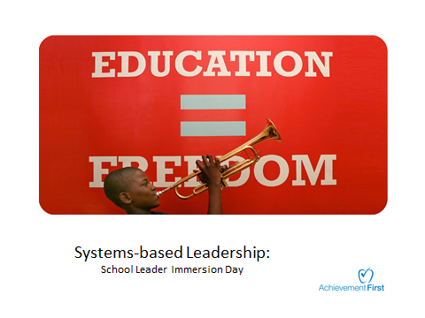

All Leader Training 2016

|  |  |
| --- | --- |
| **Aim** | **Agenda** |
| **SSLs will be able to:**   * effectively lead Authentic Compliance PD which both invests teachers *and* guides them to discover key points, by implementing tight planning and powerful execution. | * Do Now/Aims & Agenda * AA #1: *Clear Directions (PD Power Skill #1)* * Application #1: *Practice Clear Directions* * AA #2: *Hunt, Don’t Fish**(PD Power Skill #2)* * AA #3: *Facilitating Discussion (PD Power Skill #3)* * Application #2: *Practice (Hunt, Don’t Fish and Facilitating Discussion)* * Application #3: *PRACTICE (All 3 Power Skills)* * Reflection/Close Out |

**Do Now, Please ☺**

|  |
| --- |
| * Think about a PD session that you’ve attended that fundamentally changed at least one aspect of your coaching, thinking, instructional or cultural practice. What was the session and how did it change your practice? * Now think about the BEST PD you’ve ever attended. Was it the same session or not? Why? |

**Date #1:**

**Date #2:**

**Date #3:**

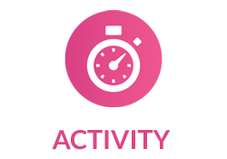

**Purpose of the Airtight Activity**

**(1)**

**(2)**

**Criteria for an Effective AA**

1. **Alignment with key points:** It effectively triggers thinking - or “moments of insight” which lead to the key points.
2. **Examples and non-examples:** It provides an exemplar and – if possible—a clear non-example.
3. **Rigor and investment:** It is rigorous, challenging participants’ thinking at the appropriate level, and it effectively engages and invests participants.
4. **T**
5. **S**



**Airtight Activity #1: Clear Directions (PD Power Skill #1)**

**Directions:** *Read the model of the directions you will give to set up the “Tactical vs. Authentic Compliance” section of the Delivering on Equity: Special Education for Every Educator PD. As you read, underline strong parts of the directions, then go back and annotate for what makes them noteworthy. If you have time, mark deltas in places where these directions could be even stronger!*

“Please turn to page 5 of your guided notes. [pause to scan to ensure everyone gets there] In a moment, I’m going to set the timer for 12 minutes. During that time you will be working with a partner at your table to review the various roles that every teacher has in the special education process. For *each* role, you will read both the tactical example of compliance and the authentic example. [point to this in notes] Then, you will work together to name what the implications of authentic compliance would be for both the student *and* for the student’s family.

Teacher A, can you summarize the directions for me to ensure I was clear?

Great [or, alternatively call on someone else to correct any inaccuracies]. There are 12 minutes on the timer; go!”

**Criteria for Success: Clear Directions**

**(1)**

**(2)**

**(3)**

**(4)**

**(5)**

|  |  |
| --- | --- |
|  | **Constructive Feedback (“Next time try…”)** |
| **Framing an AA**  **(Clear Directions)** | * Including a starting cue * “I will set the timer…” “Four minutes, go!” * “ As you watch, I want you to focus on ___” * Specifying how (volume and individual/group) work should be completed * Including how long the work should take * Directing participants to the correct materials * “On page 4 of your guided notes…,” “On the pink page in your supplemental packet…” * Show a slide that presents a visual of the needed material. * Utilizing a CFU (check for understanding) * “X, to make sure I was clear, can you repeat back what we’re doing now?” * Clarify any misconceptions that a participants shares. |

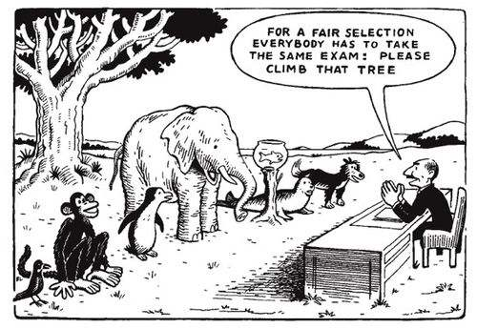

**Lock in the Learning (Why is it important to give clear directions before an Airtight Activity?:**

**Our Haiku**

****Airtight Activity #2: Hunt, Don’t Fish (PD Power Skill #2)**

**Backstory***: Ms. Model Facilitator gave clear directions to set up partner work for the teachers at her school, and now they are hard at work on the “Tactical vs. Authentic Compliance” Airtight Activity in her Delivering on Equity PD. While they work, Ms. Model Facilitator circulates among them with a data collection sheet.*

**Directions***: Read the data sheet that Ms. Model Facilitator created in advance and then read the “handwritten” notes she took as she circulated on page 6. Finally, answer the questions that follow (4 minutes solo, 4 minutes to discuss with a partner.)* 

**Questions:**

1. What steps can you infer that Ms. Model Facilitator took to prepare the below data sheet in advance?
2. What steps can you infer Ms. Model Facilitator took while circulating?
3. Ms. Model Facilitator chose to review the following two general educator roles with her staff: *providing input to formal meetings* and *collaborating with special educators*. Why? What gaps did she see as she circulated?
4. What are the back pocket questions that Ms. Model Facilitator planned in advance? How do those questions differ from the BPQs she added as she circulated?

**This Page Intentionally Left Blank, Except for this Cool Cartoon.**

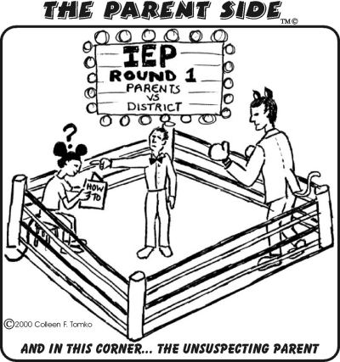

|  |  |  |  |  |
| --- | --- | --- | --- | --- |
| **For all General Educator Roles, look for answers that…**   * Reflect an accurate understanding of compliance. * Are thoughtful (not vague). * Consider the specific impact on both families and students. | | | **While circulating…**   * Collect data from approximately 3 teacher pairs per role. * Rate each teacher pair on a scale of 1 – 5, with 1 = “completely confused/not thoughtful” and 5 = “thoughtful compliance expert.” * Select the 2 general educator roles that have the lowest average score and discuss/debrief these. * Determine who to call on first after the opening question. * Identify 1 – 2 partners to target with BPQs. | |
| **General Educator Role** | **Participants are doing heavy lifting if I see…** | **Participants are not doing the heavy lifting if I see…** | **Data Collection** | **Discussion Questions** |
| Attending formal meetings | -Scholar can discuss teachers at home with informed family  -Scholar receives consistent messaging from home and school  -Families authentically engage with the adults who work with their child each day  -Families feel genuinely comfortable voicing concerns and asking questions  -Families have a network of people (not just one!) they can go to | -Scholar is supported by teachers  -Families are partners  -Families get face time with teachers | Pair #1 (Names, Rating, Notes):  *Anthony/Susan – 3*  *strong understanding of impact on parents/nothing on impact on kids*  Pair #2 (Names, Rating, Notes):  *Lane/Uma – 5*  *Wow!*  Pair #3(Names, Rating, Notes):  *Femi/Danielle – 4*  *great; probably a 5 when finished* | **Opening Question:** Let’s dive in to the first role, attending special education meetings. What is the implication of the authentic compliance teacher’s actions on students and on families?  **BPQs:**  -Why is that important?  -What does that mean for the scholar’s success at school? |
| Providing input to formal meetings | -Scholar has a living document that truly outlines what s/he needs to be successful  -Families have a clear visual for where scholar is now vs. where he needs to be and will be  -Families have a network of teachers who support their scholar year after year | -Scholar gets the right supports  -Families know that all teachers provide input to IEP | Pair #1 (Names, Rating, Notes):  *Brenda/Eva – 1*  *don’t know what formal meetings ARE; confused about gen. ed teacher’s role in meetings*  Pair #2 (Names, Rating, Notes):  *Melany/Ralph – 2*  *not doing heavy lifting; basic answers*  Pair #3(Names, Rating, Notes):  *Rosie/Jeff – 3*  *not as sure about impact on scholar* | **Opening Question:** *Rosie, what is the impact of the authentic compliance teacher’s actions of attending formal meetings on the family in question?*  **BPQs:**  *-What’s an example of a formal special education meeting?*  *-Melany or Ralph, can you say more about the impact of scholars getting the right supports?* |
| Providing accommodations and modifications | -Scholar receives targeted, scaffolded supports which are grounded in data, thus leading to academic and behavioral success  -Scholar is deeply aware of his teachers’ care for and commitment to him/her  -Scholar internalizes that s/he can learn and achieve at high levels  -Family feels the impact of scholar believing in him/herself and sees the data-driven results | -Scholar gets legally-mandated services  -Family knows that IEP is followed | Pair #1 (Names, Rating, Notes):  *Chris/Danny – 4*  *added smart thinking grounded in mindset of “fair isn’t equal!”*  Pair #2 (Names, Rating, Notes):  *Eloise/Tyler – 3*  *probably a 4 when they finish*  Pair #3(Names, Rating, Notes):  *Amber/Kerri – 4*  *solid answers* | **Opening Question:** What is the impact of the authentic compliance teacher’s actions of providing accommodations and modifications on students and families?  **BPQs:**  -Why is that important?  -What does that mean for the scholar’s success at school? |
| Collaborating with special education providers | -Impact of all special education is maximized for scholar because every support “lives” in every setting (i.e: speech services not silo-ed to one a week)  -Family deeply understands the supports scholar is receiving  -Family has a number of professionals providing support to reach out to with questions | -Scholar is more successful because teachers/RS providers talk  -Families get communication from teachers | Pair #1 (Names, Rating, Notes):  *Will/Mel – 2*  *not seeing the difference btwn authentic and tactical here*  Pair #2 (Names, Rating, Notes):  *Hannah/Jane – 2*  *not clear about impact on families; not understanding their role in collaboration*  Pair #3(Names, Rating, Notes):  *Ben/Morgan – 3*  *reflects solid understanding* | **Opening Question:** *Ben, what is the impact of the authentic compliance teacher’s actions of collaborating with special education providers on students? Morgan, what about on families?*  **BPQs:**  *-Both the tactical and the authentic compliance teacher are implementing suggested supports. What about the authentic compliance educator’s actions are different? How will they lead to student success?*  *-Hannah and Jane, what does the family know as a result of this collaboration?* |

**Criteria for Success: Hunt, Don’t Fish**

**(1)**

**(2)**

**(3)**

**(4)**

**(5)**

**Airtight Activity #3: Facilitating Discussion (PD Power Skill #3)**

**Backstory***: Ms. Model Facilitator gave clear directions and circulated throughout the partner work during the “Tactical vs. Authentic Compliance” portion of her PD. Then she led a discussion, part of which is outlined below. Miss Informed Facilitator did the same thing, and her entire discussion is also outlined below. Let’s read the two discussions aloud together.*

|  |  |
| --- | --- |
| **Discussion A:** Miss Informed Facilitator’s Conversation after “Tactical vs. Authentic Compliance” Partner Work | **Discussion B:** Ms. Model Facilitator’s Conversation after “Tactical vs. Authentic Compliance” Partner Work |
| **Miss Informed**: OK, let’s come back together and share out, starting with the first example, attending formal meetings! **Participants**: [silently look at Miss Informed expectantly]  **MI**: Who can share ONE implication on the family when the general education teacher is authentically compliant with attending meetings?  **Teacher A:** Well, families get face time with teachers, so they feel like partners.  **MI:** Exactly! What about an example related to providing input into formal meetings?  **Teacher B:** Well, a formal meeting is like, any meeting at the school. So that means parents will be around a lot and feel included!  **MI:** Hmm…not exactly. A formal meeting is any legally mandated meeting, like an IEP meeting. Does anyone else have an example?  **Teacher C:** I think the impact on the family is that they have a clear idea of where their scholar is and where he SHOULD be, and that’s grounded in data.  **MI:** Excellent answer! Let’s look at the third example, providing accommodations in IEPs. What’s the impact on the scholar?  **Teacher A:** The scholar gets the services they need. So you’re in compliance!  **MI:** Yep. And who can take us home? What’s the implication of the authentically compliant teacher regarding collaborating with special educators?  **Teacher D:** Well the answer to all these questions is the same, right? The scholar gets the support they need and the family is included.  **MI:** [pauses awkwardly] Well, yes, I guess that’s true overall. So let’s move on… | **Ms. Model:** Time’s up! I’m psyched to come back together to chat about the implications of authentic compliance on scholars and families. We’re not going to look at all four roles here, but rather do a deep dive into two. Rosie, I saw you and Jeff having a great conversation about providing input to formal meetings and the impact on families. Can you share what you were talking about?  **Rosie:** Yes! Jeff mentioned that the family will have a clear idea of where their scholar is and where he SHOULD be because all input is grounded in data.  **MM:** And do *you* remember what you added?  **Rosie**: Hmm…no, I’m not sure.  **MM:** You mentioned a network of teachers.  **Rosie:** Oh, yes! I mentioned that the family will have an entire network of teachers to ask questions to or voice concerns to, since the authentically compliant teacher’s duty doesn’t end with the school year.  **MM:** Why is that important? Someone who isn’t Rosie?  **Teacher A:** It’s important because they are embodying the mindsets we already talked about, like fair is not always equal. They wouldn’t necessarily provide that level of input or support for every scholar who leaves the class, just the scholars that need it.  **MM:** Awesome. Let’s zoom out just to make sure we’re clear. What IS a formal special education meeting?  **Teacher B:** I think it’s any legally mandated meeting, like an annual IEP meeting or a triennial.  **MM:** Yes, thank you Teacher B. Brenda and Eva, do you guys have any questions about that?  **Brenda/Eva:** [shake heads, give thumbs up]  **MM**: Ok, we talked about the impact on families. What about the impact on students when we’re authentically compliant about providing input into formal meetings? Melany, what do you think?  **Melany:** Well, the scholar gets the right supports because they take teacher’s input into account.  **MM:** True. Can you say more about the IMPACT of scholars getting the right supports?  **Melany:** Well, the scholar will be more successful, I think.  **MM:** You’re not wrong! I just want more. Can someone rephrase what Melany said and add on from there?  **Teacher C:** Melany said that the scholar will get more classroom help, like the right supports. This means that the scholar will be more successful, especially because it says that the IEP is updated as needed, so it’s a living document.  **MM:** Agreed. Let’s move to another role I want to dive into, which is collaborating with special educators and related services providers…. [discussion continues] |

**Questions:**

1. How do you suppose that Miss Informed Facilitator prepared to facilitate this discussion? How is that different than the steps Ms. Model Facilitator likely took?
2. What is one question you think is particularly strong in Ms. Model’s discussion? What makes it strong?
3. Fast-forward to the end of Ms. Model’s discussion. What steps do you **think** she’ll take to end the discussion? Why?



**Criteria for Success: Facilitating Discussion**

**Discussing the Airtight Activity**

**(1)**

**(2)**

**Framing Key Points**

**(1)**

**(2)**

**(3)**

**My Notes on Next Steps**

|  |
| --- |
|  |