
YEAR 5:
DARING GREATLY
Why the Week 6 Culture Vision?
We believe that our culture systems exist as a means to the end of scholar achievement. In order to maximize instructional time and deliver high-quality instruction to our much-deserving scholars, we focus on scholar habits (work ethics), on-task behaviors (work quality), and character (life work). As such, one of the major priorities will be a consistent school wide system that will foster community through collective ownership and responsibility. If our systems are not executed with fidelity and consistency across classrooms, then they will not be effective or taken seriously. With clear and consistent systems, our scholars will develop the foundational habits that will put them on a college bound path. In addition, we believe that our school culture needs to be one that is both joyful and overwhelmingly positive. We know that for this to happen, we need a strong foundational culture in place with clear and consistent routines and student habits. In the first 6 weeks of the school year we have the opportunity to set the table for a year of dramatic achievement.
Our scholars (and we, the adults) will form habits during the first 6 weeks. That is a given, whether we have a 6-week plan or not. The beginning of the year is our opportunity to build and develop an “in-the-arena team” (Everyone, in the ring)! Conversely, it is the time we could, if mismanaged, virtually ensure a year of set-backs, battles, and lost time. We must know precisely what we want to achieve in these 6 weeks—which student and teacher habits will be most impactful if established at the beginning of the year—and backwards plan meticulously to ensure we meet those outcomes. Everything speaks. By the end of 6 weeks, every class in our school (and our school as a whole) will be telling a story. That story will be a virtuous and self-fulfilling cycle, or a counter-narrative that we must then “battle” against to “reclaim” our culture. The Network says we technically have eight weeks to get there. But, Endeavor is AUDACIOUS! We take the given baselines and build the exemplary. Endeavor is in the prime position to hit the Week 6 goals faster and at stronger proficiency level! DO WE DARE?!
We are most concerned that, by the end of Week 6, our school day tells the story that:
- 95%+ of scholars are on task and engaged in class
- 100% of staff members proficient in core 8 taxonomy moves
- 100% of staff members have a clear vision, can teach, and can reinforce the Power 12 Common Pictures every day in their classroom
- 100% of staff have a clear vision of what a warm-demanding school culture feels like and have a plan to implement this in their classroom
- 100% of staff care and expect the best from scholars at this school.
- 100% of scholars follow directions and meet expectations at this school.
- We build relationships with colleagues inside and outside of your team; new staff members feel part of the team
- We are a school community and our collective power is greater than our individual strength.
- We recognize that our own growth and development is directly impacted by feedback and practice; therefore, we embrace feedback and actively, authentically engage in practice.
- Our school is an overwhelmingly warm, positive, and joyful place to learn (for both scholars and adults) and everyone in the building Wants to come to school, Wants to develop here and are deeply invested in learning, all the time.

Week 6: Vision of Excellence for On-Task Behavior, Scholar Habits & Classroom Climate
OUTPUTS |  | GOAL
On-Task Behavior | Time on Task | 95% of students are on task  On Task is defined as each scholar following every behavioral direction AND completing the work assigned for the given time.  Examples of On-Task:  - Student A has back straight, tummy to table, working with pen(cil), writing complete sentences.  - Student B is tracking his fellow classmate during the discussion and using discussion non-verbals to agree, disagree, or add-on.  Examples of Off-Task:  - Student A has back straight, tummy to table, doodling with pen(cil) on the paper as they are “thinking”.  - Student B is looking around the room and using discussion non-verbals to agree, disagree, or add-on as his fellow classmate shares during the discussion.
Scholar Habits | Posture/SLANT | 95% students mastered  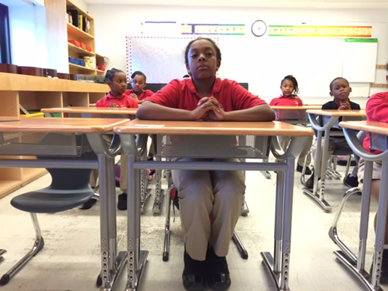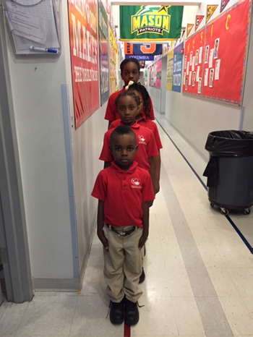
Scholar Habits | Tracking | 95% students mastered  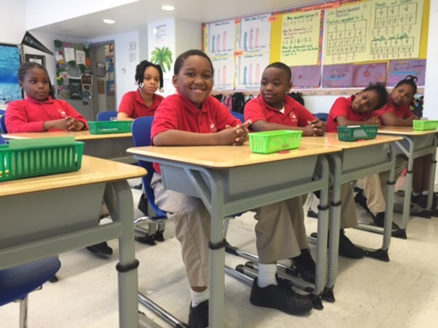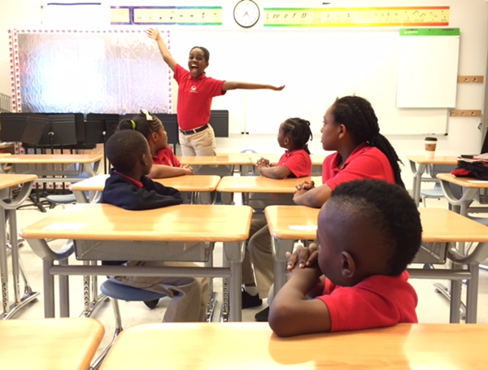
Scholar Habits | Vertical Hand | 95% students mastered  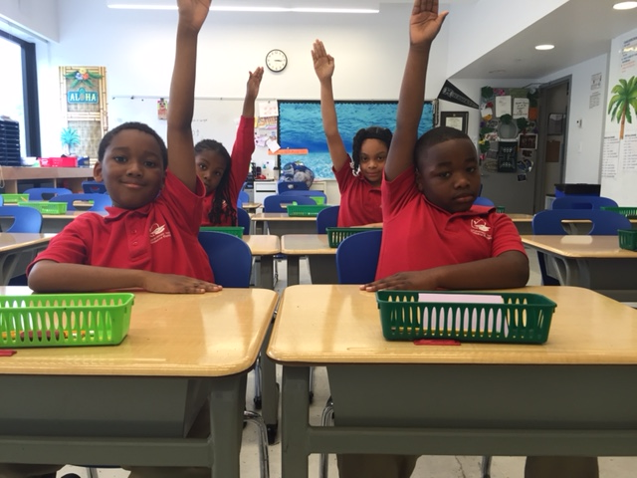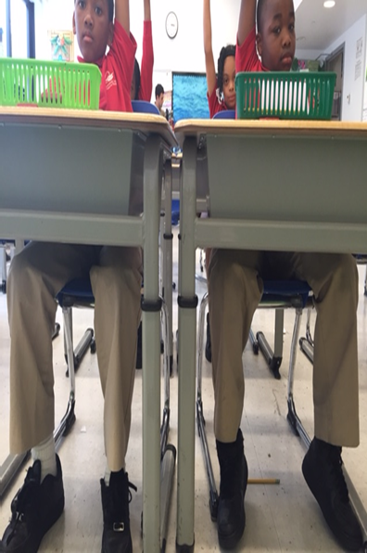
Scholar Habits | Loud & Proud | 95% students mastered
Scholar Habits | Complete Sentences | 95% students mastered
Classroom Climate | Rapport between teachers & students | 95% of students exhibit feelings of happiness in their class through joyful tones, energy, and zest for learning.  95% of students encourage their peers by “sending love”, clapping, patting on the back, supportive verbiage, etc., without prompting.  (Ways to maintain such climate: using nicknames, the random but natural joke, a knowing look, etc.)

Outcomes for Our 6 Week Plan
There will be six guiding outcomes that will drive our actions during the first 6 weeks of school:
- Ensure that 95% of students are consistently working to meet the criteria for success (CFS) for both work and habits.
- Ensure that 95% of students are consistently exhibiting the core habits and executing core routines/procedures within defined time allotments.
- Ensure that 100% of Power 12 Common Pictures have been mastered
- Ensure that 100% of staff can manage and track behaviors consistently across classrooms
- 100% of staff have a clear vision of what a warm-demanding school culture feels like and have a plan to implement this in their classroom
- Ensure that 100% of teachers have baseline proficiency (used effectively more often than not) in the core taxonomy techniques: strong voice, precise directions, precise narration, positive framing, 100%, circulate, corrections, and work the clock.
Week 0-1: Moving Between Spaces and Accountable Listening
Week 2: When we do it, we ALL do it – 100%
Weeks 3-4: Speaking to One Another
Weeks 5-6: Best Work

Week + Big Picture Goal | Teacher Data and Mastery Expectations  100% Mastered | Scholar Data and Mastery Expectations  95% On Task; 95% at Vision of Common Pic | Blocks That We Are Prioritizing Getting to Excellence | Narration – Habits & Routines  Direction Cues | Language with Routines | Incentives
Week 0/1 – Moving Between Spaces, Accountable Listening | Teachers:  - Precise Directions  - Strong Voice  - Behavioral Narration (heavy emphasis on precise narration)  *If mastered, prioritize Positive Framing | LEARNING HABITS:  - HALLS  - Stairs  - SLANT  - Tracking  COMMON PICTURE:  - Outside Arrival  - Outside Dismissal  - Lunch  - Hallway transitions (include lining up)  - Stairwell transitions  - Desk to Carpet/Carpet to Desk  - Whole-school Calls to Attention  *Week 0, Day 1 – REACH bar used w/ heavy rationale, but no REACHess consequence  *Week 0, Day 2 – REACH bar used to fidelity for Grades 1-4  *Week 1, Day 1 – REACH bar used to fidelity for ALL grades | Teachers are teaching the lesson plans in all blocks with fidelity. Focus on the AGENDA! | Narrates Multiple (5-6) Students Every Single Direction  CUE + MVP | Full Language | Individual affirmation - Scholar dollars, treasure box, smelly markers
Week 2 – When we do it, we ALL do it  Teachers are responsible for planning habits and CPs into LPs. Deans will provide feedback on this. | Teachers:  - Positive Framing  - Do it Again  - 100%  - Correction/ Rewards (Affirmation, Scholar, etc.) | LEARNING HABITS:  - HALLS  - Stairs  - SLANT  - Tracking  - Choral Response  - Vertical Hands  COMMON PICTURE:  - Inside Arrival (breakfast, morning meeting, uniform, etc.)  - Inside Dismissal (cooperative play, pack-up, lining up, parent pick-up, late pick-up)  - Scholar tidiness (uniform – shirts tucked, shoes tied, etc.)  - Lunch  - REACHess  - Reading Room and Departmentalized Grade Transitions | Teachers are teaching the lesson plans in all blocks with fidelity | Narrates 3-4 groups of students or individual kids that need more support  CUE + MVP | Full Language | Row Points by Day (at the end of the day, leaders get to pick from treasure box)  Smelly markers, stamps, stickers
Week 3- Speaking to One Another | Teachers:  - Positive Framing  - Do it Again  - 100%  - Correction/ Rewards  *If mastered, prioritize Circulate | LEARNING HABITS:  - Turn and talk  - Loud and Proud  - Complete Sentences – Grammatically Correct  - Scholars speak to each other, not the teacher  - Hands down when someone is speaking  COMMON PICTURE:  - Turn and Talk  - Time Out  - Lunch  - Inside Dismissal | GR Preparation and Timestamps  (Don’t teach GR?) Focus on Math Stories preparation  (Don’t teach GR or Math?) Focus on your content’s preparation | Narrates 2-3 groups of students or individual kids that need more support  CUE + MVP | Shortened Language | Row Points by Day (at the end of the day, leaders get to pick from treasure box)  Smelly markers, stamps, stickers
Week 4 – Speaking to One Another | Teachers:  - Circulate  - Work the Clock  - Format Matters  - Right is Right  - 100% | LEARNING HABITS (ACCOUNTABLE TALK)  - Turn and talk  - Loud and Proud  - Complete Sentences/Grammar Correct  - Scholars speak to each other, not the teacher  - Hands down when someone is speaking  COMMON PICTURE:  - Reading Room Transitions/Hallway Transitions  - Lunch  - REACH Bar  - Inside Dismissal | GR Before Reading  (Don’t teach GR?) Focus on Math Stories preparation  (Don’t teach GR or Math?) Focus on your content’s preparation | Narration 1-2 groups + students with additional support  CUE | Number Cue (given verbally) | Row Points at End of Week (at the end of the week, leaders get to pick from treasure box)  Smelly markers, stamps, stickers
Week 5 – Best Written Work | Teachers:  - Circulate and feedback  - Work the Clock  - Format Matters  - Right is Right  - 100% | LEARNING HABITS:  - Neat Handwriting  - Complete Sentences in Written Work  - Posture for Independent Work | GR During Reading  (Don’t teach GR?) Focus on Math Stories preparation  (Don’t teach GR or Math?) Focus on your content’s preparation | Narrates 0-1 group  Narrates 1 student after each direction  CUE | Non-Verbal ONLY | Row Points at End of Week (at the end of the week, leaders get to pick from treasure box)  Smelly markers, stamps, stickers
Week 6 – Best Work | - Circulate and feedback  - Work the Clock  - Format Matters  - Right is Right  - 100% --> MASTERY | LEARNING HABITS:  - Complete Work  - Re-Do | GR After Reading  (Don’t teach GR?) Focus on Math Stories preparation  (Don’t teach GR or Math?) Focus on your content’s preparation | Narrates 0  CUE | Non-Verbal ONLY | Class Points (after 10-20 points, guest during cooperative play)  Extra 5 mins of coop play, special treat, 3-5 mins dance party

Building STRONG ADULT CULTURE
We all collectively create our adult culture. We are adults who genuinely celebrate others and support one another without judgement. We build strong personal, interpersonal, and professional relationships from Day One. We are school teachers. We are never thinking MY classroom and MY way. We are humble. We are WE! These are our children and we help one another. We are vulnerable. We are collaborative, never working in a silo. We share best practices school wide. We lend a hand. We are Children first! We demand the very best from them. We hold a high bar for each other and support each. We are optimistic and do everything in our power to make the day great for ourselves, our teammates, our families, and our scholars.
We will achieve this by team building in and out of school, purposefully mixing practice groups only as needed, offering more opportunities for observations in other classrooms, engaging in cross-grade and cross-discipline, and opening mass email to ask or offer assistance to team members during busy times of year (testing, tutoring, Report Card/Progress Report completion, etc.).

Data Collection & Data Sharing During the First 6 Weeks
Given our focus on “winning” the Week 6 vision, we will be collecting A LOT of data to determine how close we are to our goals and what interventions we need to put in place to get there. Each week, the leadership team will collect data from individual classroom observations and school-wide walkthroughs. We will collect data on your use teacher taxonomy moves (goal = 100% mastery), scholars on task (goal = 95%), learning habits (goal = 95%), and common picture mastery (goal = 100%). On Thursdays, the LT will meet together to create an action plan based on the data we collect.
We value ownership. Just like with all academic data is posted network-wide, we will all share our culture data. Our expectation at Endeavor is that you take personal ownership of ALL data – culture and academic. Ownership means, “I see it. What teacher actions did I take to get these student actions and _______ in my classroom. I want to make it better. What do I need to do to improve? How can I offer my strengths to improve our school and help my colleagues? No excuses “i.e. The observation was only a snapshot, My coach isn’t helping me, I didn’t understand the feedback, That question was too hard, We didn’t teach that unit yet, I can’t teach with them here. I can’t hit the Week 6 vision with him/her here. I was too focused on culture, etc.” This will start out as a request in the moment. We recognize that most of our staff wants to assist others with their experiences and learnings. During initial practice sessions, teachers will be asked to share their feedback, their strengths, and their areas for improvement. Throughout the following weeks, grade levels, groups, and individuals will use the feedback and data they have received to name their feedback, their strengths, and their areas for improvement. We need to be able to seek out help, advise, and learn from each other. When a teammate or class is not meeting the Week 6 Vision, it is ALL of our responsibility to get them there. The amount of time that we will put into this in the first 6 weeks is tremendous, so we should be openly celebrating the wins coming out of our hard work and genuinely hearing feedback coach to coachee, LT to staff, and staff to LT. We will do this by receiving feedback forms after each major practice session, hosting a brief input session by Week 4 and another post Week 6.
Here is how the data will be shared:
- Individual observation data will be shared with teachers each week.
- In a weekly data meeting, LT will group teachers into four different tiers based on their performance to the Week 6 vision. Each week, your tier and the level of support you will get based on your tier will be directly communicated to you from your coach. In the event, you feel as though this has not been communicated and or you are not receiving the level of support you should be getting, it is your responsibility to reach out to your coach.
- One-on-ones and optional input feedback sessions will be held sporadically throughout the first six weeks to improve our practice.
- Celebrations will occur for hitting all absolute benchmarks taxonomy goals 95% or higher, habits at 95% or higher, common picture at 100%, on task at 95% or higher, all of the above, individual growth,
- Teachers who continuously achieve mastery in all of these areas will have the opportunity to be coaches at in-school professional development sessions, spotlight teachers for Network sessions, observations, and visitors.
- 100% of grade-wide percentages, as well as school-wide common pictures, will be shared (i.e. lunch, insider arrival, and dismissal.)
- Teachers who have met the weekly vision and shown growth will be celebrated at Friday’s Afternoon PD.
- Every two weeks, we will highlight how our school looks like to-date. Ms. Edwards will compile a 5-minute video that presents highlights of Every class to show whole school improvement-to-date. We value all improvement. This footage will show how far our school has come in biweekly increments and give us a peek into each other’s classroom space to pick up actionable techniques, master taxonomy usage, etc.

Coaching During the First 6 Weeks
The LT’s #1 goal is to WIN on the Week 6 vision. To that end, we will spend most of our time coaching and supporting teachers to master the weekly goals.
Types of Coaching
With limited prep time in the first six weeks, coaching will take different forms. Real Time Coaching will be the most frequently used structure. Based on quick turnaround, taxonomy mastery, and number of scholars on-task, quick individual or group coaching will occur in-the moment or just after a lesson. Co-teacher coaching will occur each day during preps, before or after school, to ensure that both teachers are improving, resulting in exponential improvement of taxonomy use and scholar performance. There will also be self-coaching throughout the week. Based on staff response to pre-work and summer practice, it is expected that each person develops an eye for what is and what is not acceptable and hone their own craft.
Real Time Coaching (RTC) – RTC is a support mechanism. It consists of immediate feedback in many different forms including giving nonverbal cues, whisper coaching, sideline chat, or modeling a specific skill. Our goal is to do this in a way that it preserves your authority in the classroom while simultaneously allowing you to get better faster. Please note: Immediate implementation of RTC feedback will help you in the moment. The real goal is for you to transfer the skill we help you with long-term in your classroom.
Individual and Group Practice – All practice at Endeavor focuses on mastering skill while not in front of children. Individual and group practice allow for more one-on-one training.
Co-Teacher Coaching will occur in classrooms each day, PD session, pairing meeting, etc.
Self-Coaching includes reading pertinent resources, observing other classrooms, video protocols, etc.
Lesson Plan Feedback – During Weeks 1-6, coaches will provide LP feedback to ensure that our lessons are high quality! You will receive feedback on standard/aim alignment, daily assessment, your criteria for success and annotated exemplar for that exit ticket/assessment, alignment to the FOI, and rigor in general.

LT Time during the First 6 Weeks
LT MEETINGS – DURING STAFF TRAINING
7:45 – 8:00 – Morning Meeting (8/3 (not 8/4), 8:14, 8/17, 8/18)
30-60 minute debrief each day after training (times TBA)
LT COACHING – DURING STAFF TRAINING
- Session feedback
- Rehearsal feedback
- Practice during LT meetings
- Weekly 30 minute check-ins (personal check-in, craft aims/agenda for upcoming sessions)
- Immediate feedback on how you are coaching teachers
LT MEETINGS/CULTURE WALKTHROUGHS – FIRST 6 WEEKS
Week 0 1:20 – 1:30 – Daily Debrief in Broken Windows room
Week 1 4:20 – 4:30 – Daily Debrief in Broken Windows room
6:45 – 7:00AM – Daily Check-In Meeting (everyone shares personal goals for the day)
M 8:00 – 9:30 – LT Meeting (starting Week 2)
M, T, W, Th – 30 Minute Morning Culture Walkthrough
M, T, W – 30 Minute Afternoon Culture Walkthrough
Th – Lewis, Max, Tommy (optional) Do 2 Hour School-Wide Culture Walkthrough
Th 2:30 – 3:30PM – Data Analysis Meeting in Steph’s office
LT COACHING – FIRST 6 WEEKS
- Lewis does 1-2 hours of co-observations with Goldstein, Bursky, Kerri, Shurpin each week (Tommy joins co-obs if he is available)
- Lewis does 30 minute of observation of Tommy in send-out room
- Lewis observes one practice session per week of each dean
- Lewis co-observe Extra Practice Sessions at least 1 time per week
- Lewis gives feedback to deans on real-time coaching
- Lewis does 1 20-30 minute check-in with each dean each week

TEACHER COACHING
Tier 3 Support:  These are teachers that are struggling with multiple things and not on track to hit the weekly goal. | Tier 2 Support:  These are teachers that are struggling with isolated skills but are either reaching or very close to the weekly goal. | Tier 1 Support:  This is the baseline support that ALL teachers will get. Tier 2, Tier 3 and Push Forward Support would all be in addition to this. | Bright Spot Support – These are teachers that are at or beyond the weekly goal that we will be pushing to excellence.
-15-30 minutes of extra Real Time Coaching  -Extra homework + video protocols  -Extra Practice Sessions (Two 45-minute “Tutoring” sessions to practice taxonomy skill without lessons.  -Might get another LT member to lean in, extra HW (per dean’s discretion), observations out of class, LT member models portion of a lesson, or light takeover | -15 minutes of observation with Culture Walkthrough Tool  -15 minutes of Real Time Coaching per week  -15-30 minutes of extra Real Time Coaching on that specific skill, preempted with a “pre-meeting”  -30 minutes of data analysis and practice per week  -Bank of strategies to use: | -15 minutes of Straight Observation  -15 minutes of Real Time Coaching per week  -30 minutes of data analysis and practice per week | -Baseline changes to moving ahead to future taxonomy skills/habits  -Extra 20 minutes is dedicated to making your classroom a magical place (teacher has the choice of planning support, extra real time coaching, observing in another classroom, extra practice, observing and providing feedback in other classrooms)

**If one dean has all the struggling teachers, the LT comes together to split the load early. Considerations to be made at that point include: number of teachers that require support, areas in which they need that support, times of day and LT availability.*
**We will maximize our strongest teachers in the following ways: opportunities for coaching during practice sessions, having an open classroom for observations from others both internally and externally, being used for best practice video protocol

Interventions during the First 6 Weeks
Because we MUST win the Week 6 vision, we will put several interventions in place for teachers and scholars that are not on track. You will be placed in interventions based on assessments/observations during training and based on the culture walkthrough data that we collect in your classroom each week Being in an intervention is not a bad/punitive thing; it’s all about growth and getting to the Week 6 vision. We anticipate that beginning teachers and experienced teachers will have interventions. Action planning for these Interventions will flow as follows: See Appendix.
Extra Practice Sessions aka. Culture Club
- Extra Practice Sessions is an intervention that is meant to support teachers that are struggling with multiple skills and are not on track to hit the Week 6 vision based on data. The goal is for teachers to rapidly increase their teacher skill and build confidence.
- Extra Practice Sessions will meet during…
  - Summer training based on drill from day before (30 mins) 8/11, 8/12, 8/13, 8/14
  - Week 2 during tutoring. 4:30 – 5:15PM.
- You will know the Friday before if you will be in Extra Practice Sessions the following week.
- Tommy will be running Extra Practice Sessions after school ; other LT members may attend and provide feedback during this time as well.
- All LT will run taxonomy sessions before training.
- Bring your lesson plans for the following day to Extra Practice Sessions
- Feel free to seek out the
- Sample agenda of Extra Practice Sessions:
  - 10 minutes – Video protocol
  - 35 minutes – Practice (either advanced drills or rehearsal) + Lots of Feedback
  - 5 minutes – Name what you’re working on TODAY (Personal Reflection)
Video Protocol
- We will use Video Protocol for a wide variety of needs. We will use it with teachers that are not on track to hit the Week 6 goal – particularly teachers that are struggling with having and maintaining a high bar. We will use it with teachers that are struggling with an isolated skill, and we will use it as a tool to push our proficient teachers ahead! The goal is for teachers to see themselves in action and develop self-reflection tools to identify the problems and come up with solutions for how to make it better.
- Video Protocols will be assigned on by Friday each week and will happen on your own time. Your coach will set a clear deadline for when the video and reflection needs to be complete (likely before your next practice session)
- Sample Video Protocol Assignment:
  - Check out flipcam from Priscilla
  - Video 15-20 minutes of your lesson
  - Upload to our school video account and view by EOD
  - Complete 20-30 minute reflection before your next coach meeting

Classroom Observations
- We will use Classroom Observations for a wide variety of needs. We will use it with teachers that are not on track to hit the Week 6 goal – particularly with visual learners who need to see the skills in action to replicate in their own classroom. We will use it with teachers that are struggling with an isolated skill, and we will use it as a tool to push our proficient teachers ahead! The goal is for teachers to learn from each other’s’ strengths so that we can all hit the Week 6 vision. In most cases, we will have teachers observe teachers that are bright spots in terms of the Week 6 vision.
- Classroom observations are assigned by coaches as an intervention . The coach will schedule any necessary coverage for your observation time. Reflection and debriefs will occur during your prep time or afterschool.
- Sample Classroom Observation Assignment:
  - Coach informs you of who you are observing and when; coach also walks you through the specific things that you are looking for using a criteria for success
  - You set the person that if covering your classroom up for success by walking them through your lesson plan/materials; note that you are responsible for lesson prep
  - You observe solo or with your coach using the criteria for success
  - Coachee completes 20-30 minute reflection before your next coaching meeting
Teachers Implement Scholar Interventions
- The Scholar Intervention is meant as a time to build relationships with scholars as well as set clear bar for what is expected in your classroom
- Scholar Interventions happen during specials time and are only led by a Teacher-Dean/Coach team, if Dean deems necessary
- Sample Agenda for Scholar Intervention
  - Teacher drops off scholars at specials; bring scholar(s) that are in Scholar Intervention back to the classroom
  - Scholars sit at their desk in SLANT
  - Using strong voice, teacher clearly states why they are in the classroom and not in specials
  - Scholars take 5-10 minute time out; during this time teacher circulates and has 1:1 private conversations about expectations in the classroom
  - After timeout, teacher leads “practice session.” Teacher teaches lesson and gives specific feedback to scholars on the student habits that they are working on.
  - In Grades 1-4, the last 5-10 minutes are reserved for an independent scholar reflection sheet which is turned into the teacher.
- If Scholar Intervention is not producing change, your coach may also plan a “village meeting” with the entire grade team, LT, and the scholar’s family

Partnering with Families to HIT WEEK 6!
We value our family partners. We recognize that parents are their children’s first teacher. We support them with family night practice, resources to improve scholar learning, fun events to connect families across grades and years. We offer families opportunities to volunteer and build a sense of classroom community. During weeks one through six, we will leverage our families in the following ways
- Key families call other families to build relationships! This will begin over the summer, per initial arrival packet.
- Throughout the year, utilize more active parents to keep other parents who cannot be as active as they would like to be, in the loop of classroom and school activities.
- Parents will also enhance our Week 6 vision. The principal will send home a letter each week with a message such as, “This week we’re working on ____________. You can help us by _______. Our ultimate goal is (connected to learning)”, along with their scholars’ exemplary work from the very first full week.

Data Meeting Protocol
Prior to the Meeting (20 minutes):
While there is no written pre-work due for our meeting, all LT members will have done the following analysis on their own prior to the meeting:
- For each grade level (or subject area) you observed, are we on track to reaching goals for the percentage of students on task? Percentage of students displaying key habits? Percentage of routines meeting the Common Picture?
- Where are the bright spots? How can we leverage those bright spots?
- Hypothesize on root causes. Why are we not on track to meet certain goals? Note: the more specific you can be, the quicker you will develop teacher skill. For example, stating that narration needs to be more precise and less frequent and more formal will be more effective than stating that we need to work on strong voice.

During the Meeting (60 minutes):

High-Level Progress  (5 minutes) | Are we on track to meeting our Week 6 Vision?  What percentage of our classrooms are hitting our benchmarks?
Assess Effectiveness of Past Week  (15 minutes) | Review Previous Commitments  Celebrate the teachers we moved.  Which teachers did we commit to moving but did not? Why have they not moved?  Coaching Effectiveness:  How can we address the sticking points for teachers that are not moving? Do they need additional support?  Intervention Effectiveness:  Intervention owners share trends they are noticing during interventions  Best Practice Notes  What are the gaps that we see between our proficient teachers and our exemplar teachers? Coaches share what the highest-performing teachers in their cohorts are doing that should be replicated across the school.
Segmenting  (10 minutes)  (Review Teacher Tracker Google Doc) | Struggling Teachers  Are there trends in the gaps identified in the Teacher Tracker?  How can we orient interventions to address these gaps most effectively?  Cusp Teachers  Are there trends in the gaps identified in the Teacher Tracker?  How can we orient PD to push the most teachers to proficiency?  Exemplars  Are we effectively leveraging our highest performing teachers in the process of pushing struggling and cusp teachers?
Play of the Week  (20 minutes)  (in conjunction with the Commitment Chart) | Purpose: How are we allocating Dean time next week? Are we pushing on new skills or are there broad pain points that need to be addressed?  Goal Setting  How many teachers do we need to move on each metric to stay on track?  Each coach commits to a list of teacher-skills s/he will get to proficient.  Tier 2  You are on this Tier.  You are working on __________. (on-task number increase, taxonomy skill, etc.)  You will receive this level coaching that includes ______________. (45 minutes of intervention, RTC, etc.)  Tier 3  You are on this Tier.  You are working on __________. (on-task number increase, taxonomy skill, etc.)  YOU will need to ________ (record a lesson,view footage, determine the action step, etc.)  WE will check in on __________ to practice and debrief.)  What Will PD Look Like?  Are we seeing a lack of progress in any particular skill/habit?  Do we need to divide PD into sub-groups?  Who is in charge of leading PD?  Interventions  What will each intervention focus on?  Who is in charge of owning each intervention?
Next Steps  (10 minutes) | Each LT member chronicles and names their next steps/due dates.  LT member will also explain what they expect to see based on that action.  One LT member sends out action steps from the meeting.

Principal and DOS Week 6 for Data Process
Roles & Responsibilities
Role | Description | Name(S)
Overall Owner | This person is ultimately responsible for the entire school reaching the Week 8 Vision. This person should have the highest expectations in the building and be willing to push the leadership team and teachers towards the Week 8 goals and beyond. | Sarah Lewis
Observers | Every member of your leadership team (Principal, Academic Deans, Deans of Students, Special Services Leaders) will participate in the norming, observations, action planning and interventions. | All LT
Teacher Coaches | The overall owner should decide if any teacher coaches should also participate. | Sarah Lewis
Norm Master | This person oversees the norm-setting process before formal observations begin. S/he finds video or a teacher to observe and leads the process to norm on the Culture Walkthrough Tool. This person also leads the process to norm on the length and frequency of observations, as well as the Taxonomy techniques to focus on each week. | Sarah Lewis
Chief Scheduler | This person schedules all of the observations, action planning meetings and due dates for data entry. | Sarah Lewis
Action Planning Facilitator | This person leads the Action Planning Meeting each week. S/he reviews the leadership team’s pre-work, facilitates the discussion and records next steps. | Sarah Lewis – Week 0, 1, 2  Tommy Micah – 3-6
Data Cycle Process: Weekly Goals & Timeline

Day | Action
Monday | School leaders observe 100% of teachers
Tuesday | School leaders observe 100% of teachers
Wednesday | School leaders observe 100% of teachers
Wednesday by 5:00pm | All data is entered in the AOTY Tool.
Before Thursday’s data meeting | Each school leader spends 30-45 minutes analyzing their data (in the same pairs as their observations, if possible).
Thursday 2:00p – 3:30pm | Action Planning Meeting (60m)
Friday | Data shared with teachers Thursday evening  Whole school data shared on Friday morning  All action steps implemented for next week
Repeat each week

Co-Observations & Walkthroughs: Set goals for the number of walk-throughs and co-observations your leadership team will conduct each day. Try to structure them such that there are as many co-observations as possible. This will allow you to continue to norm as a team, raise your expectation bar higher each day and learn from one another.
- All teachers observed by Wednesday at 12PM
- 2 30-minutes observations per day (Full LT)
- School-Wide Walkthrough with Max on some Wednesdays and Thursdays
Daily Leadership Team Communication:
- 6:45 – 7:00 – Daily LT Meeting
- 7:00 – 7:15 – School-Wide Morning Meeting
- TWO 30-minute Co-obs Per Day
- Monday LT Meeting and Thursday Data Meeting
APPENDIX

 |  | # of Teachers Meeting Goal | # to Move by Next Week | Committed to Moving
 |  | # of Teachers Meeting Goal | # to Move by Next Week | Coach 1 | Coach 2 | Coach 3
On-Task Behavior  Goal: 95% | Time on Task |  |  | Teacher A  Teacher B  Teacher C | Teacher D  Teacher E | Teacher F  Teacher G
Scholar Habits  Goal: 95% | Posture/SLANT |  |  | Teacher H  Teacher I
Scholar Habits  Goal: 95% | Tracking
Scholar Habits  Goal: 95% | Vertical Hand
Scholar Habits  Goal: 95% | Loud & Proud
Scholar Habits  Goal: 95% | Complete Sentences
Taxonomy  Goal: 95% proficient on all three | Strong Voice
Taxonomy  Goal: 95% proficient on all three | Precise Directions
Taxonomy  Goal: 95% proficient on all three | Narration
Classroom Climate  Goal: 95% proficient | Classroom Climate Score
LT Planning Document

Real Time Coaching: Application Cheat Sheet
(“Make sure to keep…” and “Next time try…”)
Nonverbal Cue  - Using highly animated and very clear signal (exaggerated)  - Getting teacher’s attention | Whisper  - Assigning a burst of independent work so you can privately speak with teacher  - Specifying what you want to see the teacher do next | Prompt  - Raising your hand to be called on  - Asking a question to teacher or class; feigning ignorance | Take Over/Model  - Calling your shot  - Modeling a specific move
Prioritize
- Assessing highest impact time to jump in (without derailing lesson)
- Making the feedback bite-sized
- Aligning to teacher/school current PD goal(s)
Make It Clear
- Using fewer words
- Preventing confusion about the teacher’s next step by minimizing inferences: make it a strong “alley-oop”
- Adjusting the pace of speech and/or emphasis of key words
Maximize teacher uptake
- Making your move transferable to future lessons by embedding taxonomy/TCP language
- Assessing teacher application (and intervene again if needed to ensure success) before leaving the classroom
Use a positive tone
- Smiling
- Affirming teacher action (after RTC is delivered) with a thumb’s up, etc.

