**MONDAY – THURSDAY SCHEDULE**

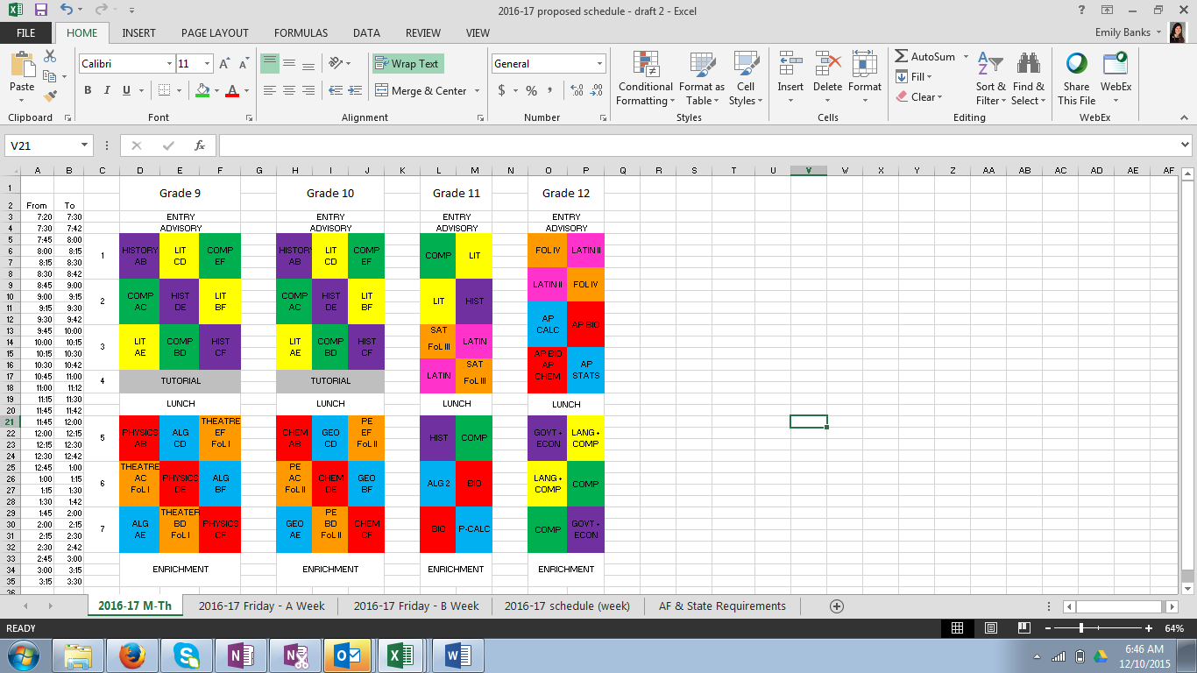

**FRIDAY – A WEEK**

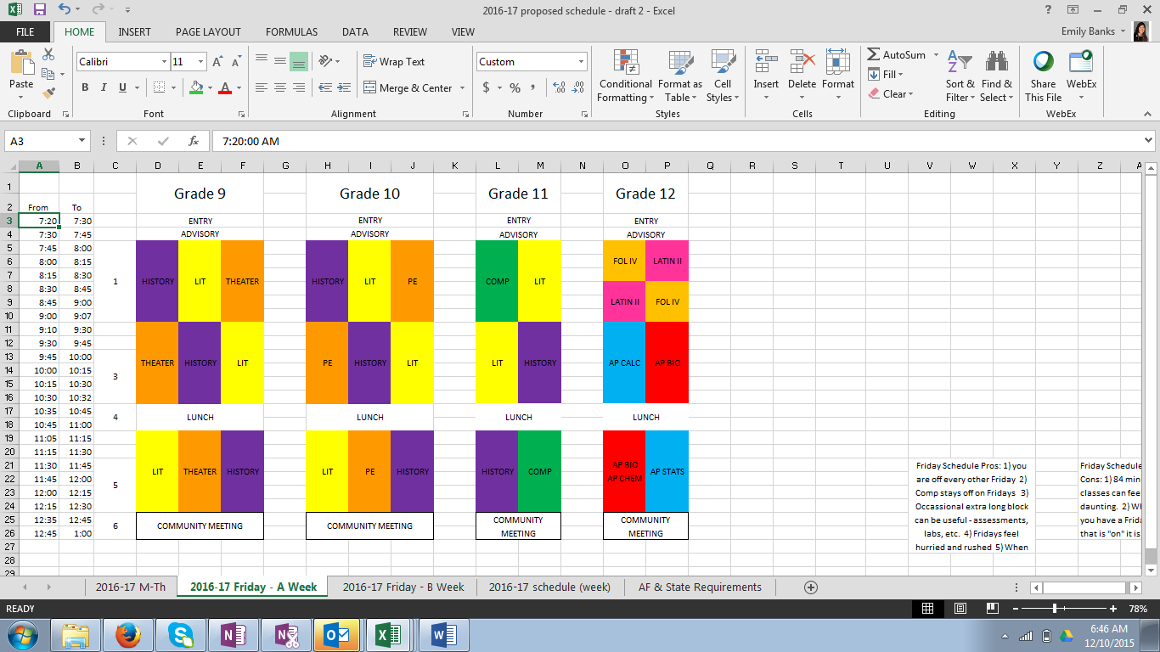

**FRIDAY – B WEEK**

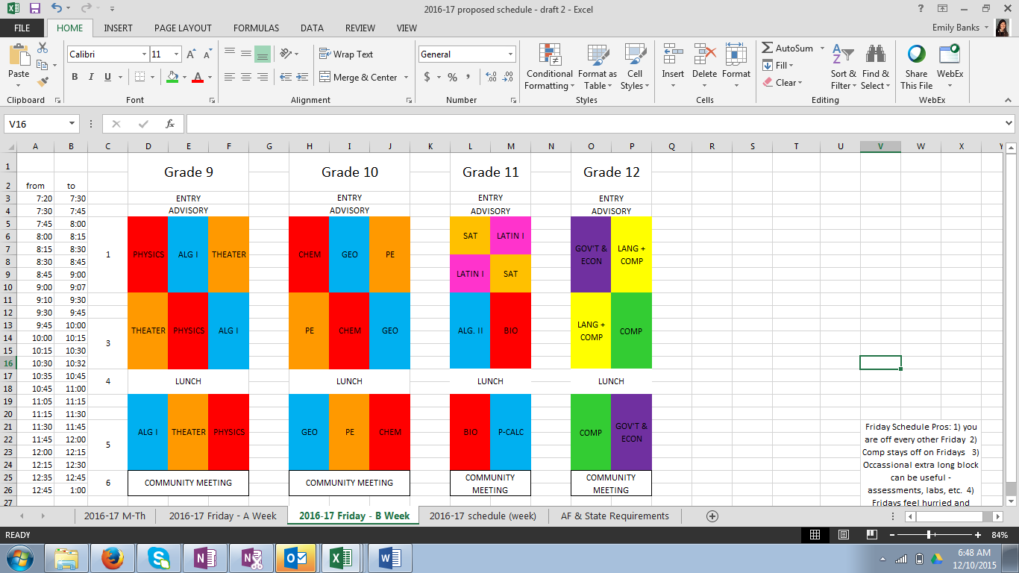

**WEEK OVERVIEW**

