East New York Middle School Independent Reading Culture Vision
2015-2016

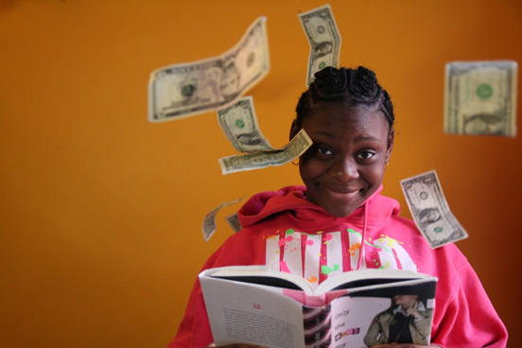

Vision
As a network, we know that scholars who read high volumes of text and understand what they read perform better academically in all subject areas. They also become more competitive against other young people as they vie for academic opportunities at middle school, high school, and university level. We also believe as a school that the best way to ensure that our scholars are successful in academia and beyond, is to guide them towards developing an authentic, profound love for reading. The following document outlines our approach to realizing this vision.

The Research
Research by scholars such as Richard Allington suggests that scholars with voracious reading habits consistently outperform their peers on standardized assessments across content areas. According to Allington, children who read one million words a year tend to score in the top 2 percent of the overall population on standardized exams.

Counting Words
Accelerated Reader software includes a precise word count for every book in its database. We measure achievement by words earned. With this shift, scholars are free to read books of any length and genre in their effort to accomplish their word goal for the year. Scholars who want to take two or three weeks to finish a 900 page Harry Potter book may do so without penalty. Likewise, those who love nonfiction may read shorter books, although they have to read more of them in order to keep pace and remain on track to achieving their end-of-year word count goal.

Measuring performance based on comprehension and word count also has the benefit of mobilizing scholars around a meaningful end-of-year goal. Every year we share the research in scholar-friendly language and message to them frequently that strong independent readers absorb more background knowledge of the world and develop superior critical thinking skills. Scholars at AFENYMS know and can articulate the connection between a voracious independent reading habit and opportunities to outcompete other young people their age for access to great high schools and universities.

The Millionaire Reader
Because the research suggests that if a child consistently reads as much as one million words per year, they will score among the top 2% of all children on standardized reading tests, we want all of our scholars to be reading millionaires. As such we have set up a campaign to motivate scholars to become “millionaires.” Achieving millionaire status is a mark of pride and distinction at AFENYMS that is celebrated by everyone.

AR System and Goals

Tiered Reading Goals
Because we recognize that not all students read at the same rate, we want to set goals that are motivating and attainable for all students. So, we’ve separated students into reading tier, with each tier at each grade level receiving a tailored goal appropriate for their age and ability.

Tier 1: The student is on or above grade level. So, a 5th grader reading on a 7th grade level will be in 5th Grade Tier 1 with a goal of 500,000 words. An 8th grader reading on an 8th grade reading level will be in Tier 1 with an 800,000 word goal.

Tier 2: The student is not on grade level, but less than two years behind grade level. So, a 6th grader reading on a 5th grade reading level would be in 6th grade tier 2 with a 500,000 word goal.

Tier 3: The student is two or more years behind grade level. So, an 8th grader reading at a 5th grade reading level would be in the 8th grade tier 3 with a 600,000 word goal.

 | Tier 3 | Tier 2 | Tier 1
5th Grade | 200,000 | 400,000 | 500,000
6th grade | 400,000 | 500,000 | 600,000
7th grade | 500,000 | 600,000 | 700,000
8th grade | 600,000 | 700,000 | 800,000

Year End Goals by Grade:

- At each grade level, we believe at least 85% of kids should reach tiered goal.
- 35% of 8th graders should become millionaires
- 30% 6th and 7th graders should become millionaires
- 15% of 5th graders should become millionaires

Comprehension Matters
We want scholars to read a lot, but more importantly, we want them to understand what they are reading. In terms of comprehension, we have the following goal: 90% of scholars will achieve an average comprehension score of 75% on their independent reading books by the end of the school year.

Authentic Love for Reading
Although state test scores, reading growth, and improved literacy are all hugely important, our ultimate and far less measurable goal is to instill a genuine and authentic love of reading on our scholars’ hearts and minds.
To measure this goal, we will give an EOY survey and track the participation in voluntary reading events. Specifically, our goals are:

- 90% of students report reading independently generally feels like a reward, not a punishment.
- 95% of students can name a book they’ve read this year that they loved.
- 80% of students report high or very high levels of enthusiasm about reading.
- 80% of students can list two books they’ve read independently this year that exposed them to something new.
- Average of 100 students attend school book clubs.
- Average of 150 students take and pass AR on student book club

Creating a Culture that Celebrates Reading
A love of reading cannot come at the barrel of a gun; people develop a love of reading because they find books they love, see the importance of reading, and feel like they are a member of a community of readers. With than in mind, the primary tactics for motivating students to read aspire to create a school wide culture in which reading is celebrated, books are advertised, and students feel excited, not obligated, to read.

Data Management
We believe strongly in using data to motivate our scholars and to inform our practices as teachers and supporters of the abovementioned goals.

Accelerated Reader
Accelerated Reader is a powerful tool for monitoring and managing independent reading practice. It offers over 150,000 quizzes on books from a variety of different levels and genres. Based on quiz performance, AR provides teachers with immediate information that helps monitor the comprehension skills of each student and inform further instruction or intervention. Students and teachers get instant feedback on AR quizzes to help motivate success and avoid future errors. Furthermore, because Accelerated Reader has a precise word count for every book in the database, we can get updated, on demand reports on scholars’ word counts and comprehension rates.

The Reading Achievement Tracker
Our Reading Achievement Tracker helps aggregate information from the Accelerated Reader database with our own, school-based data. First, we input scholars F&P levels into the tracker. From there, we sort scholars into one of the three tiers and generate an annual word goal. Based on the end-of-year goal, we generate a weekly word goal that would assure scholars meet their end-of-year goal promptly. From Accelerated Reader, we pull total word counts and comprehension averages each week. By combining this information, each week we are able to assess whether scholars are on-track to meeting their goal, or off-track to meeting their goal.

The following are screenshots from the tracker that show just a few of the ways that data are combined and sorted for our use:

Communication to Scholars and Families
Each week, the Dean of ELA updates the AR stat sheet that pulls data from the AR Tracker and presents it in a more user-friendly manner. The stat sheet gives scholars and families the most up-to-date information about a scholar’s current word count, annual word goal, reading level, and comprehension average. Most importantly, the tracker denotes whether or not a scholar is on-track or off-track. Scholars are required to get parent signatures on reading trackers each week to assure that parents can encourage independent reading at home and help support scholars in their efforts to meet their tiered goals. The following is an example reading stat sheet and tracker:

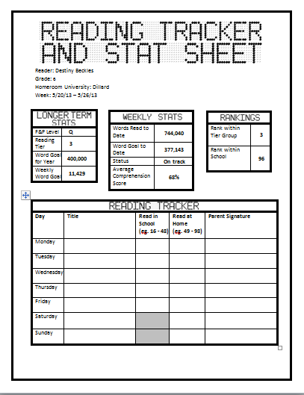

Course Grades
Research shows that independent reading has a direct effect on reading growth. As such, independent reading is a graded subject at East New York Middle School. Literature teachers input IR grades to Student Campus each trimester. Students receive a grade based on their reading volume, and on their comprehension. The grade is reported on report cards, but is not used in calculating GPA or in retention decisions.

Coaching Meetings and Individualized Interventions
At each coaching meeting between the Dean of ELA and her Literature teacher coaches, both will discuss independent reading. Guiding questions are below:
-Who is on track? Why? What trends do we see in what on track students are reading?
-Who is off track? Why?
-Who could be pushed to become a millionaire?
-Who needs support in getting on track? What should that support look like: help finding books, extra reading time during recess or after school, calls home?

Hype Plan and Incentive Systems
One of the keys to our success in achieving scholars’ independent reading goals is investing heavily in incentivizing and marketing success. The following are some of our most powerful levers for increasing “hype”.

Reading Culture Events

Community Circles
On the second Friday of each month, the whole East New York Middle School community celebrates reading at the reading Community Circle. Here, the reading culture lead and the Dean of Culture recognize on track readers, stat freaks, and millionaires, while also hyping upcoming events like book clubs, monthly challenges, or face offs.

School Wide Book Clubs
At two different points (once in the Fall, once in the Spring) over the year, the Reading Culture Lead will announce a whole school book club. Students may sign up to receive their own copy of the chosen book, and participating readers will meet to discuss the book after a set period.

Book Release Parties
When a book that will be of massive interest to a large number of students (for example, when the next book of any Rick Riordan series is released), we hold a book release party where students dress as their favorite characters, read, purchase their own copy of the book, and celebrate reading. In 2015, our first book release party will be around October 6th, when The Sword of Summer by Rick Riordan is released.

Celebrating On-Track Readers
Although we want every scholar to be a millionaire, we want to emphasize the significant achievement of consistently being on track to meeting one’s yearly tiered reading goal. The reading achievement tracker allows us to know exactly how many words each individual scholar should have read by a given week in the school year in order to be on track to meeting the end-of-year goal.

The Millionaire
We reserve our greatest reading honor for the scholars who hit the one million-word count by inducting them into the Millionaire Hall of Fame. To celebrate such a significant achievement, we have multiple incentives reserved specially for our millionaires:

- Moment you are a millionaire, the teacher announces the achievement in class and puts your name on board.
- At the end of the day, the Dean of ELA reads your name over the loud speaker
- At the next Community Circle, new millionaires receive their t-shirts
- A laminated millionaire image flyer is placed in the “Hall of Millionaires”
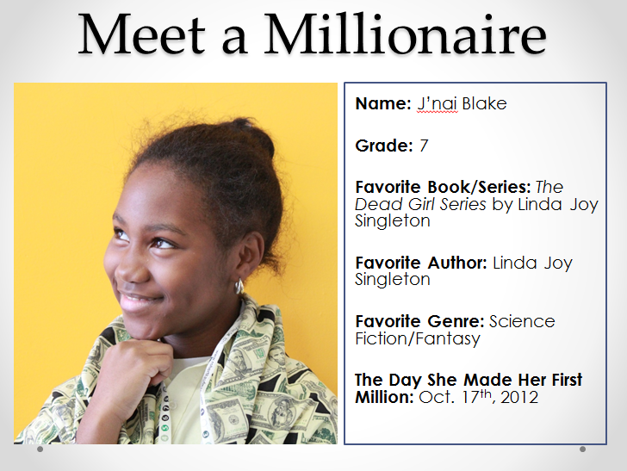

Millionaire Bracket
To keep competition stiff among millionaires, once a scholar becomes one he or she is entered into the Millionaire Bracket. Depending on their word count, scholars are categorized as Bronze, Silver, Gold. As scholars move up in the brackets, they earn new privileges (jeans passes, candy, etc.). Furthermore, the scholar at the top of each bracket will earn a trinket to wear over their uniforms (pennies, medals, diamonds, etc.).

Millionaire Banquet
Each trimester, Millionaires are invited to attend a Millionaire Banquet. At the Millionaire Banquet, scholars come together to discuss their independent reading books while enjoying a meal provided by the school. At the banquet, scholars join together to celebrate individual achievements, bracket movement, and learn of their school-wide ranking.

The Reading Face Off
To motivate all scholars - high and low level, bookworms and reluctant readers - a number of scholars in each grade level are entered into a reading face off. Scholars entered into a reading face off can choose ANY scholar in their homeroom to challenge. Face offs can fall into a number of categories, including: the individual face off, the sibling face off, the friend group face off, and the teacher face off. In any face off, the scholar (or group of scholars) who reads the most words in the allotted time period wins the honor of Reading Champion for themselves and their homeroom. During a face off, posters are hung around the school to update scholars on their current standings. The following are some examples of the initial challenge presentation from circle:

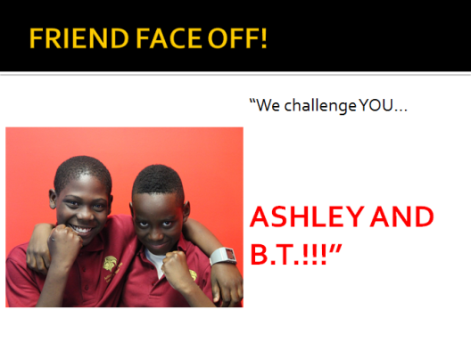
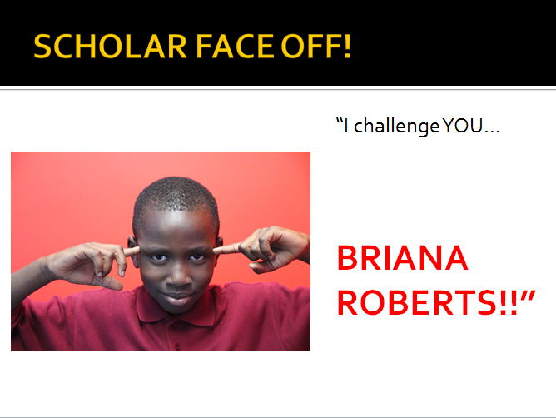
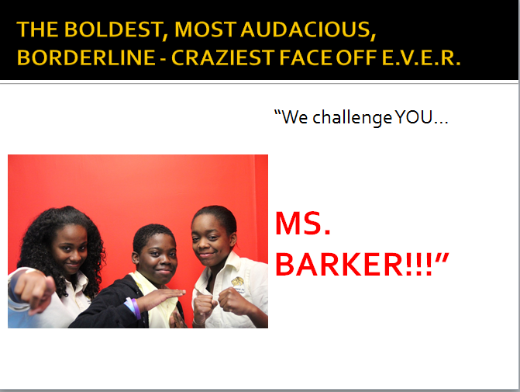
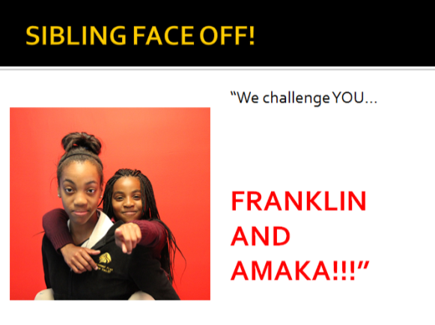

We also like to keep our adults involved and show scholars that we practice what we preach. The following slide shows the results from a spring face-off challenge between the Dean of Students and the Academic Dean of ELA:



Library Systems
Headlines in Library changes for 2015-16

The purpose of our library is not to store as many books as possible so that a kid who knows what they are looking for can find it. Instead, our library, like a bookstore, should sell kids on as many books as possible. So, this means we:
-Have fewer books out on shelves, so attention is drawn to those that are there
-Regular, planned cycling of books into curated spaces so that student interest is continually renewed

Most libraries | East New York Library
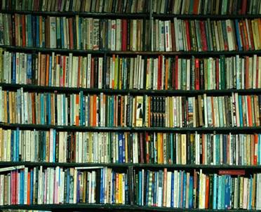 | 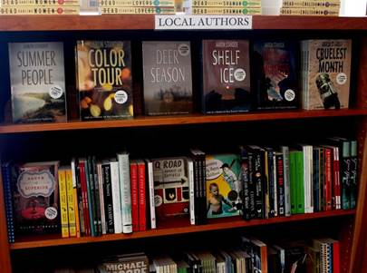

Our library books are organized into sections (except for special collections) by genre, and within genre, alphabetically by author. An appendix listing the genres categories and their specific contents is listed at the end of this document. Each genre will be denoted by a number written on the spine of each book (this way, we can always easily add new genres). Book difficulty is denoted by the colored tape on the spine of each book. Because we know quantitative measurements of book difficulty are often misleading, the Dean of ELA and Reading Culture Lead will review and re-categorize book difficulty each year to ensure students know Diary of a Wimpy Kid (which is over 1000 Lexile) is a really easy book, for example.

- The most difficult books (1000+ lexile) = blue
- Medium difficulty (700 – 999 lexile) = green
- Easiest (<700 lexile) = yellow
All of the library books in the main library are inventoried noting author, title, genre, lexile, and tier, and are stored on a Googlesheet .

Genres
In determining which genre a book goes into, go numerical order. So, Harry Potter, which could go in either the Series section, or in the Sci Fi/Fantasy section goes in to the Series library because Series () comes before Sci Fi/Fantasy (in our genre listing).

- Series : The following series are placed in their own separate section for ease of perusal by students who enjoy reading series books.
-Harry Potter
-Percy Jackson and the Olympians
-Heroes of Olympus
-The Maze Runner
-Dear America
-Immortal Instrument and Infernal Devices
-Pendragon
-Bluford High
-Kane Chronicles
-Secrets of the Immortal Nicholas Flamel
-Songs of the Lioness Quartet
-Vladamir Todd
-Mysterious Benedict Society
-Twilight
-Unwanteds
-Hunger Games
-Gregor
-Ranger’s Apprentice
-The Last Apprentice

- Classics: This section should only include classics written for an adult audience. So, Huckleberry Finn, Invisible Man, and Pride and Prejudice should be here; Harry Potter and Maniac Magee should not.

- Graphic Novels

- Sports: This section will be organized by sport, regardless of whether a book is fiction or non fiction. So, both Slam by Walter Dean Myers and a biography about LeBron James could be found side by side because both are about basketball and will appeal to readers interested in the sport.

- Mystery

- African-American Literature

- Sci Fi/Fantasy

- Teen Drama: Students who tell the librarian, “I’m looking for a book that’s interesting, you know, with some drama,” should be directed to this section, where they can find books by authors like Jodi Picoult, or books like The Sisterhood of the Traveling Pants that are about teen romance, family drama, and friend drama.

- Librarian’s Choice
This section, before being alphabetized by author, is first separated in to the three reading level tiers—high, medium, and low.
In this section, we collect together interesting historical fiction, realistic fiction, and books like The Tale of Desperaux that has an animal as a character, but is not a fantasy book of interest to the same kind of student who wants to read the Redwall fantasy series, which also has mice as characters.

- Non-fiction
The non-fiction section is an unusual genre. In general, we adhere to the spirit that we are not a research library; students do not need access to a huge trove of resources. Instead, we want to curate this section in such a way that kids easily find books of high interest to them. With that in mind, there will be some non-fiction books always available and displayed—high interest biographies and memoirs, like the “Wicked History” books (see below)

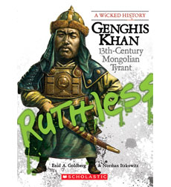

We will also always have two rotating sections of non-fiction books, curated by the librarian on display. The librarian will choose books from the following sub-genres to place out on spinning racks. The librarian will choose a theme to advertise within each sub-genre. Examples are below, although the librarian should use his/her professional discretion to curate.
Non-fiction Sub-genres
- Animals (potential themes might be: books about mammals; Animals from Africa; etc)
- Science (Books about natural disasters; books about how different types of technology work)
- Places (Books about Latin American countries during Hispanic Heritage month)
- Historical time periods (The Revolutionary War; The Civil Rights Movement

*Special Collections*
Curated Unit Connections
This section will display books that connect with the current units of study in Literature, Science, and History classes. Both fiction and non-fiction can appear and be taken from any other section of the library. So, books by the same author as the author being read in a Literature class should appear here; books about the same historical period or scientific field should as well. This section should be organized not by author, but by grade and subject—ie: 6th Grade History. Books selected for this section will change out monthly, and should retain their original library genre markings (African-American Lit, or Sports). These curated selections should be attractively advertised on bookshelves like in the picture below
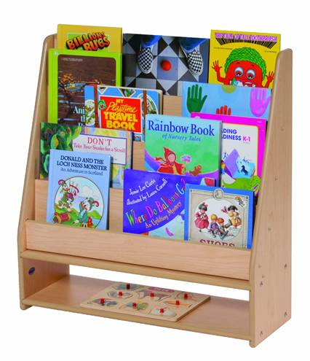

Banned Books
Students will need parent permission to read from this section, which will contain books with mature content, as well as books historically banned from schools. Steph, the Dean of ELA, and Ben, the Reading Culture lead, will curate the books for this section. These books, for special effect, should be kept in a closed cabinet with windows in to it, as with the blue cabinets in teacher classrooms.

Children’s Books
We have a number of wonderful children’s books that should be put out for students to take home to read to their siblings, or just to read quickly for pleasure. These will be displayed on the type of shelves as the curated unit connections books.

Monthly Challenge Books
Each month, we will select a challenge genre for students to read 3 books from to earn a prize. Books fitting in this genre (books with animals as characters, for example) will be attractively advertised on a low table as in the picture below:
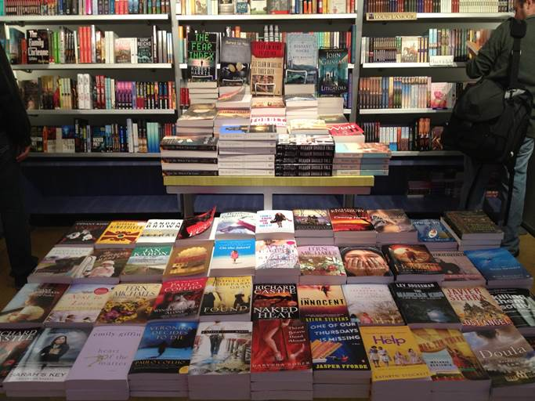

Long Term Library Storage
Because of our shelving approach, in which the top three shelves of all library bookshelves are used to create attractive, book store like displays, not all of our thousands of books can be stored in the library. To facilitate ease of book cycling, books will be stored in genre specific boxes and sections in the attic; twice per year, the librarian, Dean of ELA, Reading Culture Lead, and Literature teachers will conduct an “all hands on deck” reshelving operation to bring fresh books in to the library, and neatly store those being moved out.

Informative and Attractive signage
Just like at a bookstore, our goal is to advertise our products in such a way that students can find what they want, and, in some cases, be inspired to read books they would not have previously realized they were interested in. So, on the walls we will have large pictures of our students reading, as well as photos of famous authors like Toni Morrison, Sherman Alexie, Rick Riordan, James Baldwin, and Maya Angelou. On shelves and bulletin boards, we will have professionally laminated signage advertising the different genres and sections.

Procedures for Borrowing Books
The Library is outfitted with a scanner system for checking out books, and a return book bin for returned books.

Library Guided Tours
Students will have regular, guided tours of our library. Its layout is complex, and we want students to feel invited in to it. We are not the Toys ‘R Us warehouse model of library; we are the EducationExpress model, where customers (kids) have a curated experience that develops a long term interest and relationship with the institution (our library). So, on a regular rotating basis, Ben and the TIR will take advisory groups on a 15 minute morning tour of the library during the 7:30 – 7:45 slot. If possible, we will also hold afternoon tours in the 3:45 – 4:00 slot.

Morning and Focus time check outs
Each day in AM Homeroom and again in Focus time, teachers can send two scholars to the library. Before scholars are sent, the teacher should: Sign a time-stamped pass. Scholars should be given up to 20 minutes in the library. If there is not enough time for the student to have at least 8 minutes in the library, please do not send them.

Scholars may check out up to 4 books at a time for a period of up to 4 weeks.

Lost books should be returned to the “Lost Book” bin in the library. If a student loses their book, he/she may ask for a pass to the library during the appropriate times. Once there, they must ask the librarian for permission to check the lost book bin. Students will have until Friday of that week to claim the book. If the book remains unclaimed at that time, it will be scanned back into the system and the librarian will impose a “lost book” fine of 200 scholar dollars on the student’s account.

Procedures for Taking AR Quizzes
Anytime a scholar takes an AR quiz, they must have the book they are taking the AR quiz on with them, and an adult must be present and actively monitoring.

This is to prevent scholars from reading one book about Harriet Tubman, then taking 20 different quizzes on biographies about her, or from taking quizzes on books about topics they might already know so much about (like soccer) that they do not need to have read the book to pass the quiz. This is rare, but preventing this kind of dishonesty is essential to the integrity of the system. It is corrosive to the culture of achievement and nerdy reading if there is any taint of cheating.

Additionally, once a scholar takes a quiz, the adult must enter the AR password. This is to prevent scholars from taking quizzes for another scholar. If a scholar enters the password themselves, the first consequence is a minor. At this time, the adult should have a conversation about the importance of letting the adult enter the password. If you must correct a scholar a second time for this offense, the consequence is a major.

Scholars can take quizzes at any of the following times:

-AM homeroom*
-IR block during Literature class*
-Any IR block on alternate schedule days (Fridays, IA Week, etc)
-Off track reading time
-Any time they go to the library (AM homeroom, recess, Focus, etc)

*At these times, teachers should name to students that only two scholars are likely to have time to take quizzes. If teachers find that they are able to get to 3 – 4 students without disrupting the block following their period, then this decision is left to their professional discretion.

Roles and Responsibilities
Librarian | Reading Culture Lead | Dean of ELA
Communication and Hype  - Print and distribute stat sheets each week to homerooms  - Print, laminate, and maintain millionaire signage  - Print, laminate, and maintain reading face off, monthly challenge, and upcoming event signage  - Distribute millionaire t-shirts  - Update millionaire rankings  - Create and post library hours  - Print and distribute late book notices each week;  - Pass out silver/gold millionaires prizes and order new ones  - Meet w/ Reading Culture Lead to develop plan for upcoming Community Circles; create initial PowerPoints  - Create “Banned Book” permission slips; distribute to interested students.  Organization of Library  - Curate books for the librarian’s choice, unit connections, monthly challenge, and non-fiction genres  - Be present during posted library hours to facilitate book check out  - Process returned books  - Maintain library signage  - Repair or retire damaged books; issue fines for lost or damaged books  - Integrate new books into library catalogue  - Oversee student library assistance who will assist the librarian with library maintenance tasks such as shelf neatening and book reshelving.  Professional Development  - BOY shadow Reading Culture Lead on “Library Tours” and IR block audies  - Rehearse and deliver sections of Community Circles beginning in November  - Plan and execute one whole school reading culture event per month beginning in January  - Weekly meeting w/ ELA Dean and Reading Culture Lead; repeatedly do’s:  -Check in about hype and signage  -Check in about state of the library  -Look forward to upcoming events  -Look back at recent events and debrief | Culture Events  - PD for staff at BOY  -Library systems for all staff  -AR Quiz expectations for all staff  -Vision for IR blocks for Lit teachers  -Intro to reading culture for new staff  - Plan + Execute Community Circles  -Meet w/ Librarian to plan rough draft PowerPoint  -Review and finalize PowerPoint  -Rehearse CC w/ Culture Dean  -Execute community circles with Culture Dean  -Reflect on CC with Dean of ELA and Librarian  - Daily “library tours” with advisories  -Create and send out tour schedule for advisories  -Review student on-track/off-track status and library books before tour  -Execute tours  - Calendar, plan, and execute reading joy events  - Monthly smaller events  - Every trimester is something bigger, like book release party  Adult Management  - BOY training of librarian w/ ELA Dean  - Weekly audit of IR blocks  - Monthly audit of quiz-taking time  - Oversee twice per year book cycling from attic to main library  - Weekly meeting w/ Librarian and ELA Dean; repeatedly do’s:  -Check in about hype and signage  -Check in about state of the library  -Look forward to upcoming events  -Look back at recent events and debrief | Data Management  - Update 2015-2016 tracker with new goals/tiers  - Set up shared calendar and trackers for TIR to use  - Update and e-mail out AR tracker  - Bi-weekly check tracker for bugs:  -Are goals updating?  -Are word counts correct?  -Are reading tiers accurate?  - Train librarian on using and maintaining the AR tracker  - Make decision about off-track reading based on schedule  - Monthly review AR quiz taking data; check with coaches with an eye toward catching cheaters:  -Are many students taking the same quizzes on the same days?  -Is a student taking quizzes on books the teacher has not seen them reading?  -Are students taking multiple quizzes about the same subject, ie: Harriet Tubman?  Culture and Hype  - Read millionaire names each day at EOD announcements  - Plan and execute millionaire banquets each trimester  - Secure or make templates for millionaires and top ten  - Design and order millionaire t-shirts  Adult Management  - Weekly check in’s with coaches about course grades and off-track/on-track trends  - Weekly meeting w/ Librarian and Reading Culture Lead; repeatedly do’s:  -Check in about hype and signage  -Check in about state of the library  -Look forward to upcoming events  -Look back at recent events and debrief

