
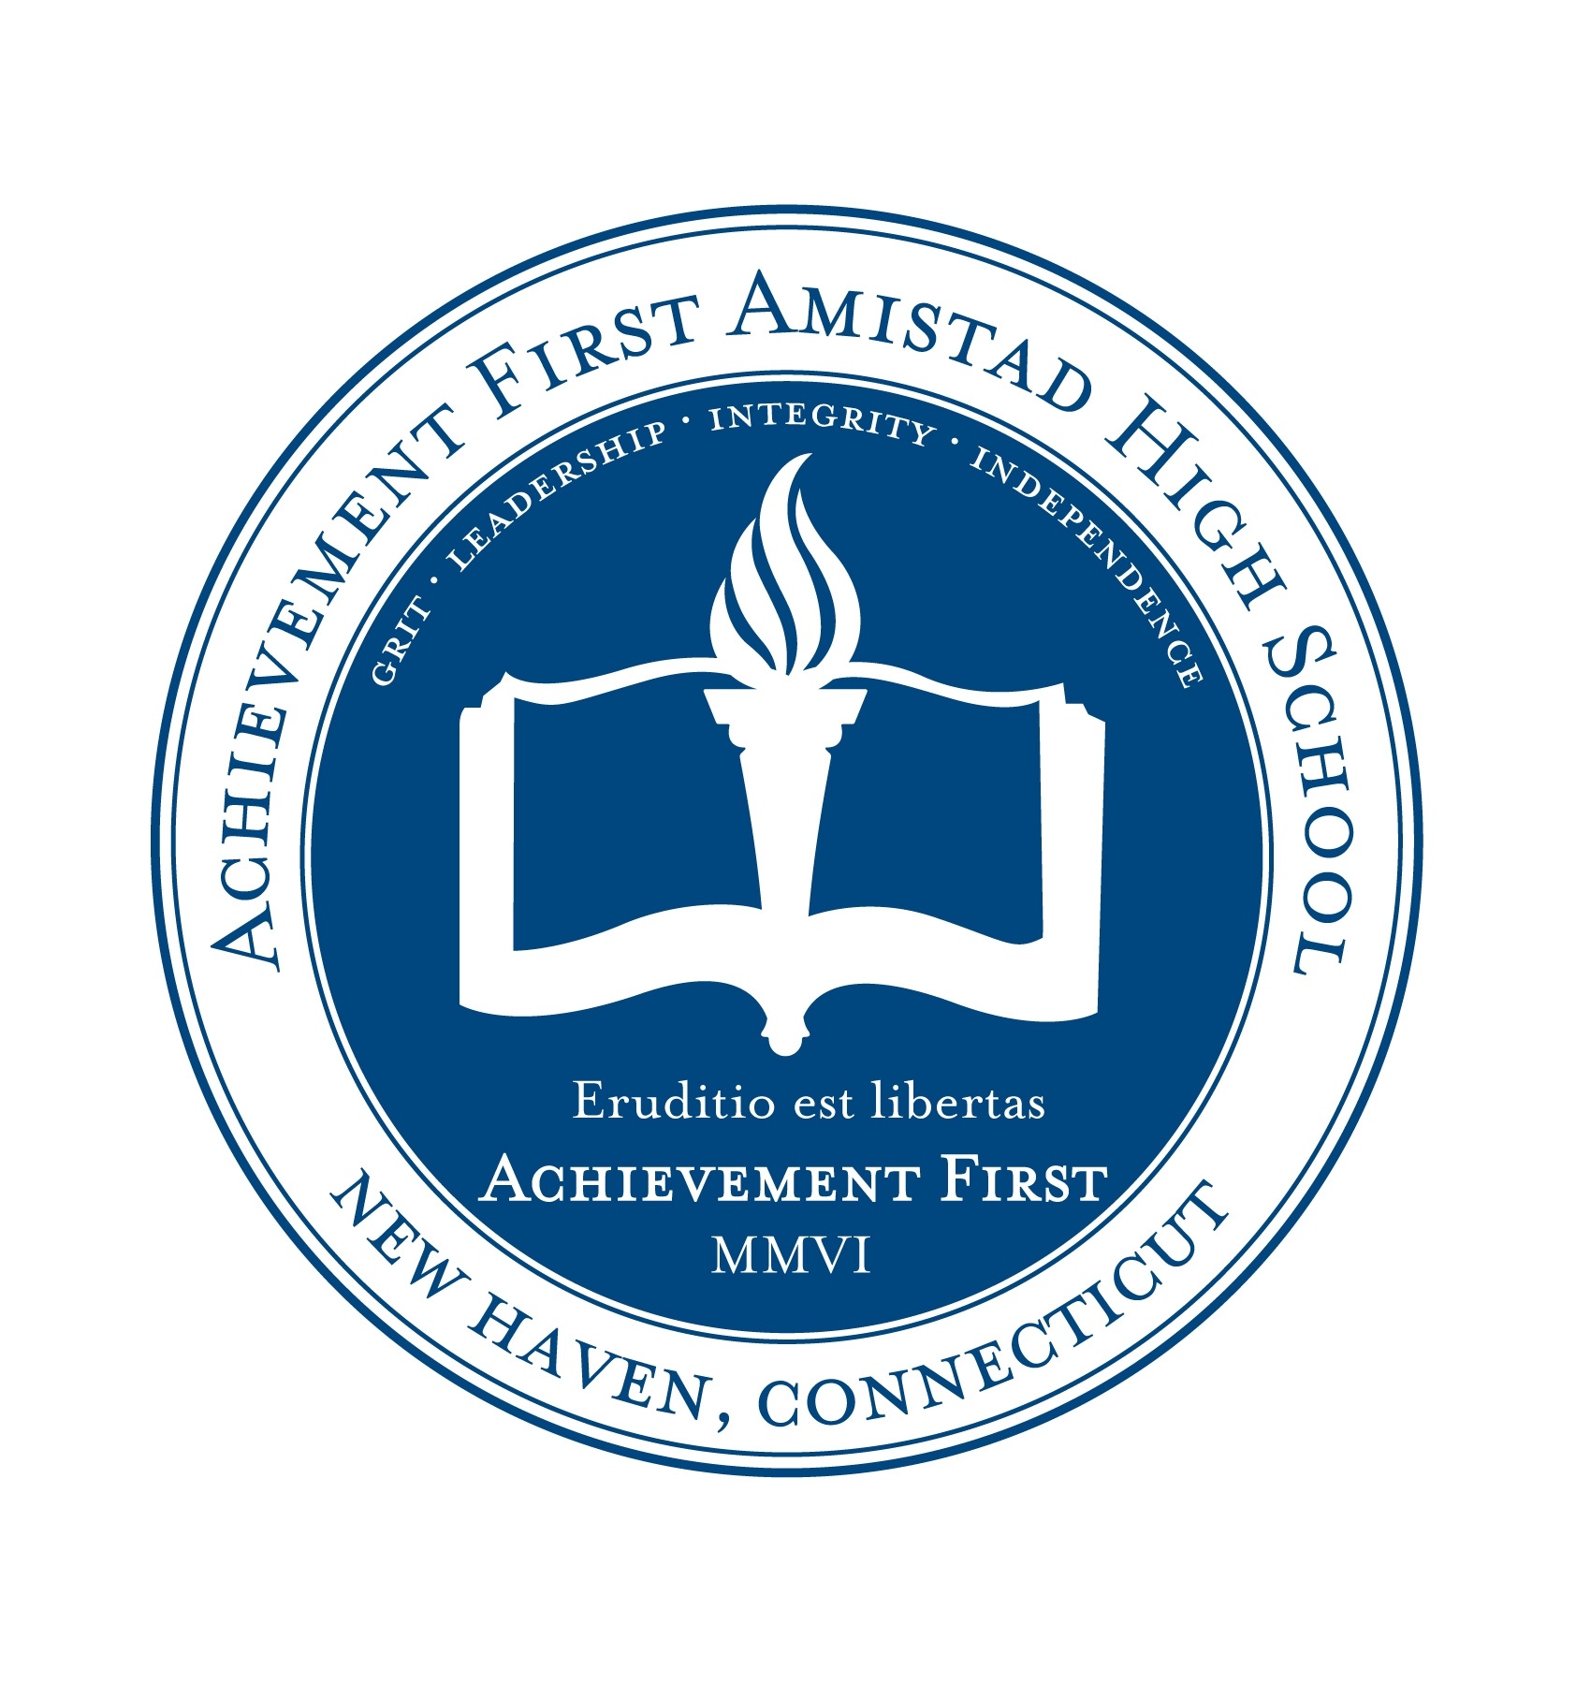

Desk: 203.772.1092
Cell: 719.964.3263

49 Prince Street
New Haven, CT 06519

www.achievementfirst.org
At AF Amistad High School, it is mandatory that all scholars complete 3 summer programs in order to graduate. This is done in an effort to give our scholars a competitive edge for college, as well as the opportunity to put the skills and knowledge they learn every day during the school year to the test. Every scholar’s summer experience will look different and each summer program varies in its location, area of interest and time commitment. At AF Amistad High, we will work tirelessly to get your scholar the experience that most benefits and interests them.

Summer Programs
Jeff Sudmyer
Principal
AF Amistad
High School

Summer
Programs

For more information, please contact
MaryAnn Holland
Summer Program Coordinator


College is the ultimate goal for our scholars, so why not give them a pre-view? For AECHS scholars with a 3.0 grade point average and good character standing, Pre-College Summer Programs are an excellent option. We are currently working with students who are interested in attending Smith, Morehouse, Yale and UNC Chapel Hill.
Another option for AECHS scholars is Community Opportunities, designed to give our scholars the chance to work in different capacities in New Haven and neighboring communities. This is a great option for scholars, as internships are carefully tailored and selected according to each scholar’s interests.
Scholars will have the opportunity to work one-on-one with the Summer Program Coordinator to decide how they would like to spend their time this summer and where they think they would be most interested in having an internship. The sky’s the limit—art, architecture, business, medicine, auto repair, writing, dancing, sports… if there’s a scholar with an interest, there’s an internship waiting.

For scholars that need to recover a credit, there are still opportunities to get out into the community. Scholars attending the Summer Academy in 2010 will be participating in field trips to various businesses in our community where they will learn how each business operates and interview the business owner/manager. It’s very important that every scholar has the opportunity to see what kind of career awaits them.

Summer Academy
Option 3

Internships/
Community Opportunities
Option 2

Pre-College Program
Option 1
High school junior Tia Council from Boston, MA participates in the Smith College Summer Science Program for Women, summer 2009
Luke Harrison, Dean, works with scholars in Summer Academy




