Name: ______________________________ | Date: ____________________
College Readiness II – IA#2 | CH PRIDE!
ANNOTATION KEY:
Mark $ for evidence that supports prioritizing lifelong earnings.
Mark for evidence that supports prioritizing happiness/job satisfaction.
! = surprising, ? = unfamiliar vocab, * = key points
Major Decisions
By CECILIA CAPUZZI SIMON
What’s your major? It’s the defining question for college students — and the cliché that’s launched a thousand friendships and romances. It’s also a question that has become harder for students to answer.
Blame it on the growing number of possibilities. Colleges and universities reported nearly 1,500 academic programs to the Department of Education in 2010; 355 were added to the list over the previous 10 years as colleges, to stay competitive and current, adopted new disciplines like homeland security and global studies, cyberforensics and agroecology.
At the University of Michigan and Arizona State University, students choose from a dizzying 251 and 250 majors, respectively. DePaul University in Chicago offers 24 more majors than it did in 2002, for a total of 98.
And graduating with a double (or triple) major, minor or concentration as a way to hedge bets in an uncertain job market has become increasingly popular; the number of bachelor’s degrees awarded with double majors rose 70 percent between 2001 and 2011, according to the Education Department.
Some students go to college knowing exactly what they want to do. But most don’t. At Penn State, 80 percent of freshmen — even those who have declared a major — say they are uncertain about their major, and half will change their minds after they declare, sometimes more than once. How to decide?
THE NEW EXPLORER
Colleges and universities have vested interests in students declaring early. Retention rates for declared students are better, and they are more likely to graduate in four years. But college officials also recognize that deciding on a major can be overwhelming, especially when coupled with the fear that a wrong choice will result in added semesters and tuition. “Students no longer have the luxury of stumbling into a major or making mistakes,” says Neeta P. Fogg, a research professor at Drexel University’s Center for Labor Markets and Policy, and a co-author of “College Majors Handbook With Real Career Paths and Payoffs.”
“Exploratory” is the new undeclared. Colleges have moved away from the negative-sounding “undecided” label to encourage students to experiment with unfamiliar disciplines and, perhaps, discover a passion and career path. “We want to remind them that they have an active role” in their academic choices, says Mary Beth Collier, the dean of academic advising at the State University of New York at New Paltz.
Ms. Collier tells students: “You’ve taken the same six subjects since kindergarten. If you don’t know your major, don’t come here and take the same subjects expecting to figure it out.*” That can mean fulfilling a U.S. studies requirement with a political science or black studies course instead of a rehash of U.S. history that you should have learned in high school.
WHEN IN DOUBT, TAKE IT
Advisers caution: Don’t abandon subjects that you may need later. Students often don’t realize that many popular majors — psychology, social sciences, business — have math and science requirements. You might have to forgo majoring in economics, for example, if come junior year you have to make up courses in calculus and statistics.
The “biggest mistake” students make, Dr. Grupe adds, is failing to research what’s required of the major, and the profession. Nursing may sound attractive because “you like to help people,” he says, but nursing students take the same demanding math and science curriculum as pre-med students, and the work is often technical and not for every kindhearted soul.
THE BOTTOM LINE
Colleges “do not make decisions in a vacuum,” Dr. Fogg says. They are constantly tweaking their offerings. The Department of Education’s list shows clusters of new programs in established fields of study that mirror scientific, cultural and societal developments. Some are cross-disciplinary or specializations, like biosystems engineering, clinical nurse leadership, computational biology and international policy analysis.
Still, it’s difficult to predict the employment market, says Michele Campagna, the executive director of the Center for Advising and Student Transitions at Montclair State. Many students choose majors they think will lead to jobs, but “four years from now,” she says, “freshmen will be applying for jobs that don’t even exist today.”
Most employers are looking for transferable skills — the ability to problem solve, work in teams, write and communicate, and think critically, says Ms. Collier of SUNY New Paltz. These can be developed in any liberal arts discipline. It makes no sense, she says, to “suffer through a major” because you think it will lead to employment. “We tell students, ‘Find a major that makes you intellectually engaged, that expands your brain and deepens your understanding of the world.’ ”

Choosing a College Major: For Love or for the Money?
By DAVID KOEPPEL
ike countless other college students, Susannah Lloyd-Jones struggled with her choice of major. Finally, in her junior year at Loyola University in Chicago, she picked sociology, a decision that "opened my mind and introduced me to other cultures," she said. More than two years after graduation, though, Ms. Lloyd-Jones, now a 24-year-old paralegal from Maplewood, N.J., occasionally wonders if she made the right decision. "It might have been easier if I had been a business major," she said, "because that's where the money is."
Ms. Lloyd-Jones says if she had it to do over, she would probably still study sociology but take more business classes and work some internships. She said students feel tremendous pressure over the choice of a major, which could be an important career decision, when many are just beginning to understand themselves.
Many students and career counselors say the pressure to choose the "right" major is more intense than ever because of factors like rising tuition costs and the uncertain economy. According to the College Board, the average cost of tuition and fees for the 2012–2013 school year was $29,056 at private colleges, $8,655 for state residents at public colleges, and $21,706 for out-of-state residents attending public universities.
In their recently published "College Majors Handbook With Real Career Paths and Payoffs", three economists from Northeastern University in Boston try to quantify just how much students with a variety of majors can expect to earn in their careers. The authors concluded that choosing a major was more crucial to future financial success than the college attended.
One of the authors, Paul E. Harrington, an economist and associate director at the Center for Labor Market Studies at Northeastern, said that, on average, humanities and education majors fared far worse financially than students in business or engineering.
Mr. Harrington said the research was not intended to dissuade sociology majors from following their passions. Instead, he hopes the information will help students prepare carefully when choosing a major. He recommends that students contemplating majors in the liberal arts or humanities also take some business-oriented courses. A philosophy major, Mr. Harrington said, should probably get some real-world internship experience.
"The world is a more unforgiving place than it used to be, and investment costs are too high for four years of drift," he said. "If a student doesn't take the right sequence of math courses in high school, they can lose out on the best jobs."
But some people worry that choosing a career based primarily on economic factors can lead students to make poor choices. Jieun Chai, a 2000 Stanford University graduate, for instance, deeply regrets not majoring in Asian languages.
"I'm so angry at myself for giving in to peer pressure, parental pressure and societal pressure," Ms. Chai wrote on her Web journal.
Alysha Cryer, who was Ms. Lloyd-Jones's roommate at Loyola, withstood pressure from classmates and family members who urged her to attend law school or study business.
Ms. Cryer said that sticking with sociology was the most satisfying, if not financially rewarding, decision she could have made.
After graduating in 2002, she took a public relations and marketing job at a nonprofit organization in Chicago called Little Brothers, a group that matches volunteers with elderly clients. Her starting salary was $24,000, barely enough to survive in Chicago. In 2003, she moved to Manhattan to work for Catalyst, a nonprofit research and advisory organization. "With education so expensive, many in my generation are mired in debt," Ms. Cryer said. "Some people choose to sacrifice personal happiness to make money."
Peter Vogt, a career counselor in Minneapolis and the moderator on the Career Planning for College Students message board at Monster.com, a Web site for job seekers, says many of his 20-something clients think they have squandered their college years on the wrong studies.
"They think they only have one chance and that they've blown it," Mr. Vogt said. " 'I should have picked X instead of Y. I should have taken the unpaid internship instead of working at T.G.I. Friday's to pay for tuition.' "
He tells graduates they should think of themselves not as psychology or sociology majors, but as workers with marketable skills like research, writing and communications.
Trudy Steinfeld, director of career services at New York University, tells students that majors should be less about preparing for one career and more about preparing for many options, and probably several careers, over a lifetime. She agrees with the Northeastern data showing that finance, accounting and technology degrees will lead to higher salaries. But she says she also sees liberal arts majors who become equally successful.
"College should be about stretching yourself and discovering who you are and what you want," Ms. Steinfeld said. "Schools should not become factories. There are hundreds of majors out there, and it's almost always a mistake to base the decision on money alone."
Ms. Steinfeld agrees, though, that students can run into overwhelming pressure from many sources.
Parents paying even a portion of college costs may wonder if a major in philosophy will pay the bills. And if their children change majors, it could extend college from 8 semesters to 9 or 10, at an additional cost.
Nevertheless, Priscilla Molina, 18, an N.Y.U. sophomore, is taking her time choosing a major. Many of her friends are pursuing business careers, but that, she said, will not affect her decision. She is fascinated by international relations and is leaning toward anthropology.
"I want to pick a path that I'm interested in, one that opens my mind," she said. "You're only in college once. I don't want to regret why I didn't major in something I enjoy."

Job Satisfaction vs. a Big Paycheck
By PHYLLIS KORKKI
DOES earning a higher salary make you happier?
It’s an issue that tugs at many of us: the tradeoff between a satisfying job and a satisfying paycheck. Students have to ponder the question when considering a college major or embarking on a career. Workers are concerned about it when weighing a promotion that would bring longer hours and more stress along with higher pay.
In many ways, achieving the right balance depends on one’s values, priorities, family obligations and spending habits. But according to a recent study in the Proceedings of the National Academy of Sciences, there is something of a magic number when it comes to income and happiness.
Beyond household income of $75,000 a year, money “does nothing for happiness, enjoyment, sadness or stress,” the study concluded.
It’s not so much that money buys you happiness but that lack of money buys you misery, said Daniel Kahneman, a professor emeritus of psychology at Princeton and one of the authors of the study. “The lack of money,” he said, “no longer hurts you after $75,000.”
The study, which analyzed Gallup data of 450,000 randomly selected Americans, did find that one’s “life evaluation” — a self-assessment of one’s life — continued rising well above $75,000. But this is not the same as experiencing day-to-day happiness.
“Many people want to make a lot of money, but the benefits of having a high income are ambiguous,” said Professor Kahneman, who is also a Nobel laureate in economics. When you are wealthy you are able to buy more pleasures, he said, but a recent study suggests that wealthier people “seem to be less able to savor the small things in life.”
“Wanting money is not a recipe for disaster, but wanting money and not getting it — that’s a good recipe for disaster,” Professor Kahneman said. People who want to become performing artists are likely to be unhappy, because most will fail, he said. Becoming a wealthy rock star is a common dream when you are young, but when you are in college, you should try to take a longer-term view, he said.
But this could backfire as people who initially pursue a field because of the salary realize that the work is unsatisfying. Nicholas Lore, founder of the Rockport Institute, a career coaching firm, has recently coached a lawyer who decided to forgo his high pay in favor of teaching law, an investment banker who decided to switch to a green energy company and a dentist who decided to become a schoolteacher.
“It’s very hard to game the system, in the sense that situations and conditions change so quickly that a field that is hot today might be only lukewarm in 5 or 10 years,” he said. “It might even be nonexistent.”
Let’s say you see that accountants are getting decent salaries directly out of college, he said, but you don’t really like accounting. “Chances are you’re not going to be very good at accounting,” and your salary will reflect that, he said. “Generally, people flourish when they’re doing something they like and what they’re good at.”
For his part, Mr. Lore said he was concerned that current economic woes might force people into poor career choices.
“I would prefer that the economy was doing better and people were more adventurous because it often has an enormous effect on the quality of their life,” he said. Many people equate success with a high income, but, “How can someone say they’re successful if they’re not happy doing their work? To me, that’s not success.
TABLE 1: Median Earnings by Major Group and graduate degree

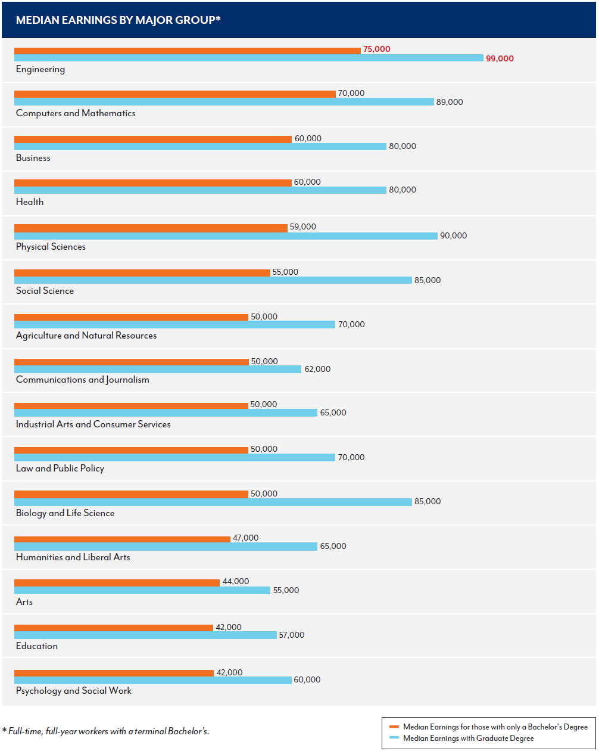

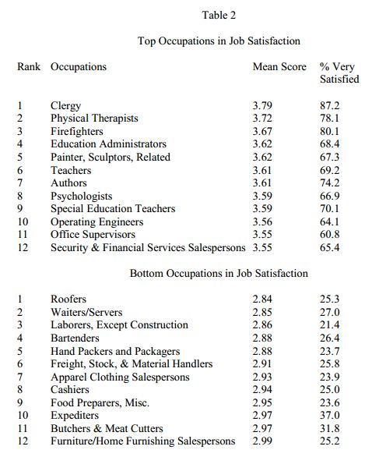
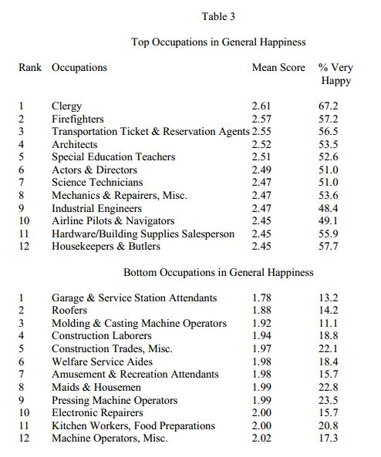

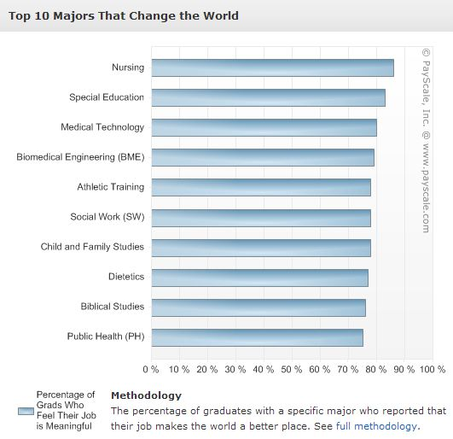
TABLE 4: Professions who believe their work is meaningful

