CRS-10 Major and Career Exploration Project

PART I: Career Shopping (20 minutes, in class)
In this section, you will choose 3 careers that interest you and research them on Big Future: https://bigfuture.collegeboard.org/majors-careers

To search for a specific career that you know you want to learn more about (ex: “astronaut”), use the search bar on the right hand side of the screen:


To check out different jobs in a field you’re interested in (ex: “Health and Medicine”), click the plus signs to the left of each “Career Category” to see specific roles for that field.
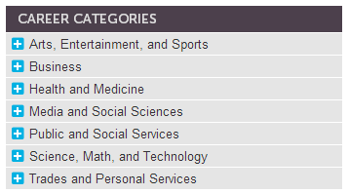

No idea where to start? Try exploring by interests/strengths here: https://bigfuture.collegeboard.org/explore-careers

Fill out page one of your Research Packet (attached) with information about each career. Your work should be neat and complete, but you do not need to write in complete sentences for every item. Bullet points are fine.

PART II: Major Shopping (45 minutes, in class)
In this part, you will research three related majors for each career you’ve chosen in Part I. You should research a total of 9 different majors (ex: if one of your careers is “Doctor” and another is “Engineer”, you cannot research Biology as a major for both of them. We want you to research as many different majors as possible!)

TIP: Wondering how to know which majors will prepare you for each of your chosen careers? Check out the “Related Majors” side bar on the right of each career profile page.
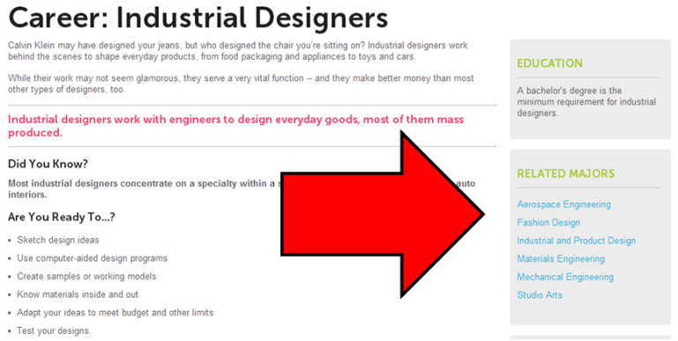

Complete pages 2-4 of your Research Packet with information about nine majors. Your work should be neat and complete, but you do not need to write in complete sentences for every item. Bullet points are fine.

PART III: Summary Report (30 minutes, in class and at home)
Compose a 1-3 paragraph report (150-250 words) in Google Drive that answers the following questions in concise, relevant, academic language:
- Which career are you currently most interested in pursuing and why?
- What is the highest level of education required for your career and how much money can you expect to earn each year?
- What do you plan to major in during college in order to prepare for this career? How will this major prepare you for the day-to-day of your job?
- How can you maximize your time in high school to prepare for this path?

DUE DATES:
- DUE: Monday, 11/18 by 6PM – Completed Research Packet
  - Submit by dropping off in folder outside 506
  - Homework grade – 24 points (completion and professionalism)
- DUE: Monday, 11/18 by 8PM – Summary Report
  - Submit by sharing with monicadebbeler@achievementfirst.org
  - Summative Grade – 20 points (rubric for answering all questions, professionalism, quality of writing)
  - Title: Block.LastName.Firstname.CareerReport
    - Example: Hoosier.Robinson.Marisa.CareerReport
    - Non-Example: Okra.Beyonce.Knowles.CareerReport
    - Non-Example: Ariella Career thing
    - Non-Example: Untitled Document

