Name: ______________________________ | Date: ___________________
College Readiness II – IA #2 | CH PRIDE!

Mock IA Review Packet
REVIEW: Find your notes from lesson 2.5. Mark each of the following as true or false. Correct false statements.
___________ | - People with master’s degrees generally earn more money than people with professional degrees (JD, MD, DDS, MBA…)
___________ | - You have to get your graduate degree at the same college you earn your bachelor’s degree.
___________ | - Earning an MD takes the same amount of time as earning a bachelor’s degree.
___________ | - All colleges offer all types of degrees: bachelors, master’s and graduate degrees.
___________ | - You can become a lawyer or doctor with just a bachelor’s degree.
___________ | - It is possible to pursue a career that is unrelated to the major you studied in college.

REVIEW: For each box, give an example of a career that a person with that degree would be qualified to pursue.

REVIEW: Why do people go to graduate school? Give three specific reasons, including one example of a career path for each reason.

REVIEW: Give an example of a likely career for each of the following majors: Political Science, English, Biology. Briefly explain your answers.

REVIEW: Give an example of a less likely career for each of the following majors: Political Science, English, Biology. Briefly explain your answers.

REVIEW: Assume you are a college counselor and you have a student in 10th grade interested in working in law or criminal justice. What advice would you give about the type of coursework and activities she or he would need to prepare them to achieve that goal? Provide and defend your two recommendations for this student. One recommendation should address what the student should do in school. The other recommendation should address what the student is doing outside of school hours. Draw on your understanding of the range of opportunities available to students in the AF system to make your recommendations. (At least 4 sentences)

Assume that you are a college counselor. Your student wants to major in civil engineering in college. He has questions about the college coursework requirements.
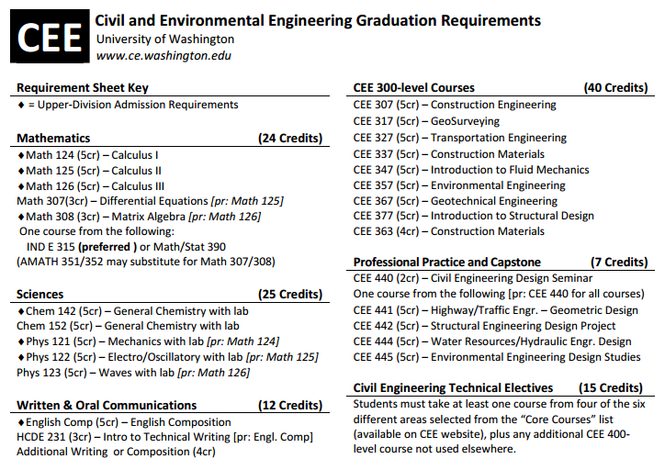
First, review the course requirements above to help you answer questions below.
Next, look at the student’s AF high school transcript. Using what you know about the civil engineering major requirements, what recommendations would you make to your student to better prepare for this major?

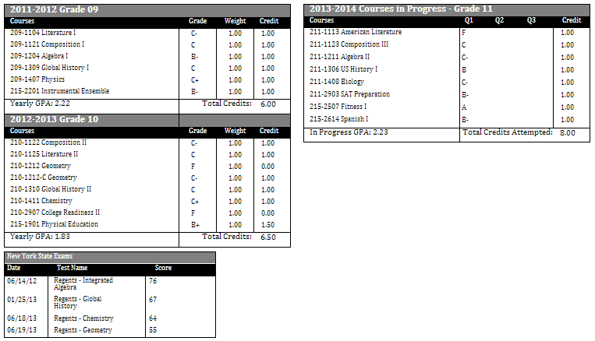
Recommendation #1:

Recommendation #2:

