Alumni Exemplar #1 - Travis
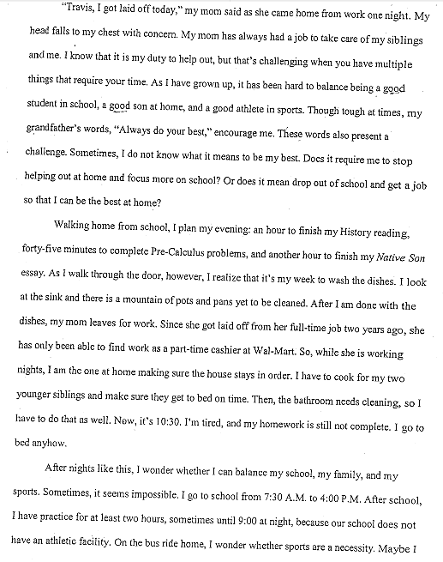

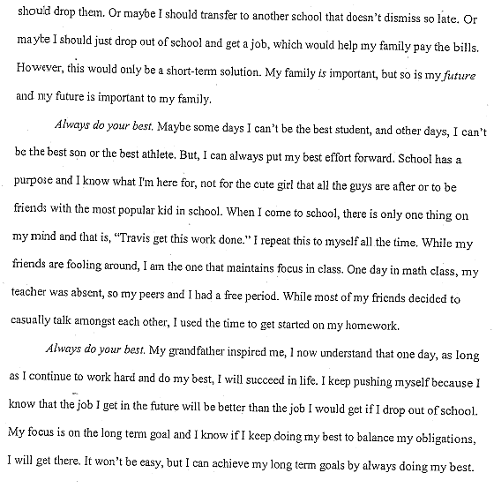

Alumni Exemplar #2 – Annabelle
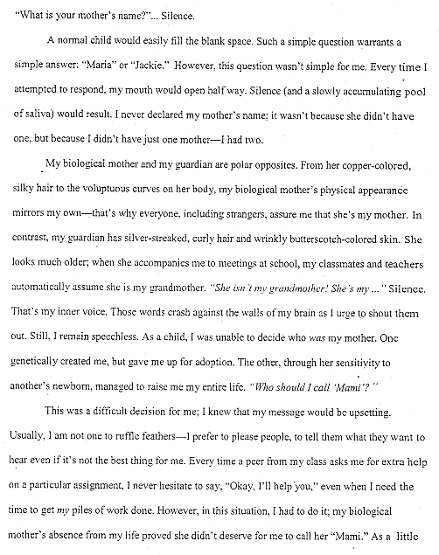

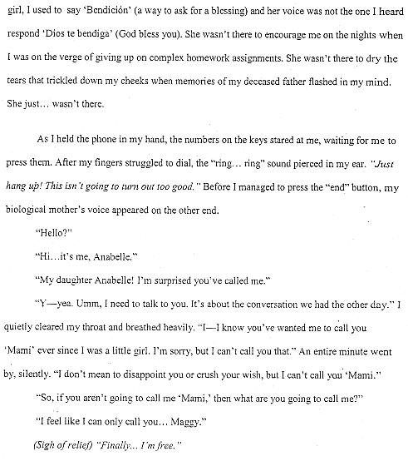

“Homeless”
by Anna Quindlen
Her name was Ann, and we met in the Port Authority Bus Terminal several Januarys ago. I was doing a story on homeless people. She said I was wasting my time talking to her; she was just passing through, although she'd been passing through for more than two weeks. To prove to me that this was true, she rummaged through a tote bag and a manila envelope and finally unfolded a sheet of typing paper and brought out her photographs.
They were not pictures of family, or friends, or even a dog or cat, its eyes brown-red in the flashbulb's light. They were pictures of a house. It was like a thousand houses in a hundred towns, not suburb, not city, but somewhere in between, with aluminum siding and a chain-link fence, a narrow driveway running up to a one-car garage, and a patch of backyard. The house was yellow. I looked on the back for a date or a name, but neither was there. There was no need for discussion. I knew what she was trying to tell me, for it was something I had often felt. She was not adrift, alone, anonymous, although her bags and her raincoat with the grime shadowing its creases had made me believe she was. She had a house, or at least once upon a time had had one. Inside were curtains, a couch, a stove, potholders. You are where you live. She was somebody.
I've never been very good at looking at the big picture, taking the global view, and I've always been a person with an overactive sense of place, the legacy of an Irish grandfather. So it is natural that the thing that seems most wrong with the world to me right now is that there are so many people with no homes. I'm not simply talking about shelter from the elements, or three square meals a day, or a mailing address to which the welfare people can send the check--although I know that all these are important for survival. I'm talking about a home, about precisely those kinds of feelings that have wound up in cross-stitch and French knots on samplers1 over the years.
Home is where the heart is. There's no place like it. I love my home with a ferocity totally out of proportion to its appearence or location. I love dumb things about it: the hot-water heater, the plastic rack you drain dishes in, the roof over my head, which occasionally leaks. And yet it is precisely those dumb things that make it what it is--a place of certainty, stability, predictability, privacy, for me and for my family.It is where I live. What more can you say about a place than that? That is everything.
Yet it is something that we have been edging away from gradually during my lifetime and the lifetimes of my parents and grandparents. There was a time when where you lived often was where you worked and where you grew the food you ate and even where you were buried. When that era passed, where you lived at least was where your parents had lived and where you would live with your children when you became enfeebled. Then, suddenly, where you lived was where you lived for three years, until you could move on to something else and something else again.
And so we have come to something else again, to children who do no understand what it means to go to their rooms because they have never had a room, to men and women whose fantasy is a wall they can paint a color of their own choosing, to old people reduced to sitting on molded plastic chairs, their skin blue-white in the lights of a bus station, who pull pictures of houses out of their bags. Homes have stopped being homes. Now they are realestate.
People find it curious that those without homes would rather sleep sitting up on benches or huddled in doorways than go to shelters. Certainly some prefer to do so because they are emotionally ill, because they have been locked in before and they are determined not to be locked in again. Others are afraid of the violence and trouble they may find there. But some seem to want something that is not available in shelters, and they will not compromise, not for a cot, or oatmeal, or a shower with special soap that kills the bugs. "One room," a woman with a baby who was sleeping on her sister's floor once told me, "painted blue." That was the crux2 of it; not the size or location, but pride of ownership. Painted blue.
This is a difficult problem, and some wise and compassionate people are working hard at it. But in the main I think we work around it, just as we walk around it when it is lying on the sidewalk or sitting in the bus terminal--the problem, that is. It has been customary to take people's pain and lessen our own participation in it by turning it into an issue, not a collection of human beings. We turn an adjective into a noun: the poor, not poor people; thehomeless, not Ann or the man who lives in the box or the woman who sleeps on the subway grate.
Sometimes I think we would be better off if we forgot about the broad strokes and concentrated on the details. Here is a woman without a bureau.
There is a man with no mirror, no wall to hang it on. They are not the homeless. They are people who have no homes. No drawer that holds the spoons.
No window to look out upon the world. My God. That is everything
"Salvation"
By Langston Hughes
I was saved from sin when I was going on thirteen. But not really saved. It happened like this. There was a big revival at my Auntie Reed's church. Every night for weeks there had been much preaching, singing, praying, and shouting, and some very hardened sinners had been brought to Christ, and the membership of the church had grown by leaps and bounds. Then just before the revival ended, they held a special meeting for children, "to bring the young lambs to the fold." My aunt spoke of it for days ahead. That night I was escorted to the front row and placed on the mourners' bench with all the other young sinners, who had not yet been brought to Jesus.
My aunt told me that when you were saved you saw a light, and something happened to you inside! And Jesus came into your life! And God was with you from then on! She said you could see and hear and feel Jesus in your soul. I believed her. I had heard a great many old people say the same thing and it seemed to me they ought to know. So I sat there calmly in the hot, crowded church, waiting for Jesus to come to me.
The preacher preached a wonderful rhythmical sermon, all moans and shouts and lonely cries and dire pictures of hell, and then he sang a song about the ninety and nine safe in the fold, but one little lamb was left out in the cold. Then he said: "Won't you come? Won't you come to Jesus? Young lambs, won't you come?" And he held out his arms to all us young sinners there on the mourners' bench. And the little girls cried. And some of them jumped up and went to Jesus right away. But most of us just sat there.
A great many old people came and knelt around us and prayed, old women with jet-black faces and braided hair, old men with work-gnarled hands. And the church sang a song about the lower lights are burning, some poor sinners to be saved. And the whole building rocked with prayer and song.
Still I kept waiting to see Jesus.
Finally all the young people had gone to the altar and were saved, but one boy and me. He was a rounder's son named Westley. Westley and I were surrounded by sisters and deacons praying. It was very hot in the church, and getting late now. Finally Westley said to me in a whisper: "God damn! I'm tired o' sitting here. Let's get up and be saved." So he got up and was saved.
Then I was left all alone on the mourners' bench. My aunt came and knelt at my knees and cried, while prayers and song swirled all around me in the little church. The whole congregation prayed for me alone, in a mighty wail of moans and voices. And I kept waiting serenely for Jesus, waiting, waiting - but he didn't come. I wanted to see him, but nothing happened to me. Nothing! I wanted something to happen to me, but nothing happened.
I heard the songs and the minister saying: "Why don't you come? My dear child, why don't you come to Jesus? Jesus is waiting for you. He wants you. Why don't you come? Sister Reed, what is this child's name?"
"Langston," my aunt sobbed.
"Langston, why don't you come? Why don't you come and be saved? Oh, Lamb of God! Why don't you come?"
Now it was really getting late. I began to be ashamed of myself, holding everything up so long. I began to wonder what God thought about Westley, who certainly hadn't seen Jesus either, but who was now sitting proudly on the platform, swinging his knickerbockered legs and grinning down at me, surrounded by deacons and old women on their knees praying. God had not struck Westley dead for taking his name in vain or for lying in the temple. So I decided that maybe to save further trouble, I'd better lie, too, and say that Jesus had come, and get up and be saved.
So I got up.
Suddenly the whole room broke into a sea of shouting, as they saw me rise. Waves of rejoicing swept the place. Women leaped in the air. My aunt threw her arms around me. The minister took me by the hand and led me to the platform.
When things quieted down, in a hushed silence, punctuated by a few ecstatic "Amens," all the new young lambs were blessed in the name of God. Then joyous singing filled the room.
That night, for the first time in my life but one for I was a big boy twelve years old - I cried. I cried, in bed alone, and couldn't stop. I buried my head under the quilts, but my aunt heard me. She woke up and told my uncle I was crying because the Holy Ghost had come into my life, and because I had seen Jesus. But I was really crying because I couldn't bear to tell her that I had lied, that I had deceived everybody in the church, that I hadn't seen Jesus, and that now I didn't believe there was a Jesus anymore, since he didn't come to help me.

“The Day and It’s Splendid Parts”
By TONI MORRISON
Uncle Green was late so that meant all the Blue Gums would be late too. He was up from Alabama for 20 days with a $500 bill which never broke because nobody – nobody – had change and so he had to borrow whatever he needed until the time he could get to a store big enough to handle it. Mama and Aunt Millie looked at his big bill, then at each other, then at the sky that stretched overhead with precisely the infinite patience they had lost.
The fish were already awake, the potatoes were sliced and simmering next to the onions, and this whole tribal effort to have a day-long fish-and-cookout at Turkeyfoot Lake in honor of the eldest member of the Alabama wing of the family was beginning to draw Mama’s and Aunt Millie’s lips together in annoyance. For one thing, the Blue Gums (the Akron group of the family) thought Uncle Green belonged to them more than to us because they were more his age and remembered Alabama the way he did long before the migration North had begun: the first day the general store down home sold light-bread; the farm of 88 acres when it was prosperous and could feed 17 people year round; and other family reunions which were never ever called cook-outs in spite of the fact that they roasted corn and skewered fish over pine-cone fires on days just like this one.
They were possessive about Uncle Green, and so were we. For in spite of the unbreakable $500 bill – a testimony to his ancient chinchy-ness – he carried with him, on those annual visits North, like the light from a communion cup, the spirit, the recollection, the character, I suppose, of the whole tribe. A grandeur, a cohesiveness, a constant reminder of what they had all done to survive and even triumph over during the last 141 years that they knew anything about first hand. He spoke the language in the old way: called white people buckras, spoke of java, and goobers, remembered when wakes were called settin’ ups, and referred to plat-eyes, and balongas, and the Big Raid of ’61.
And although he never buttered his own biscuits or poured his own coffee, he gave us the spark we needed to get up at 3 in the morning, pile into a 1935 Chevy and two Tin Lizzies and, loaded with eggs, milk, coffee, ham, green onions, bell peppers, tomatoes, potatoes, roastin’ ears, laid-out biscuit dough, graham-crackers-for-the-kids, and sugar-tit-for-the-baby, lard, butter, grapes, yellow cake, beer, ice, worms, poles, string, buckets, skillets, tablecloths, plates, U.S. Steel Company forks, and try to get to Turkeyfoot Lake before the fish woke up.
So when he did come, at last, in the Blue Gum’s car, Mama and Aunt Millie forgot the $500 bill, the smug grins of the Akron folk which showed their blue, blue gums. And daddy and the uncles forgot about the fish and the dying worms and stood up to greet with loud shouts the man who made them feel their manhood anew. The man who spoke the names of trains they too had ridden as though they were old friends; the man who had beat them all at hambone contests, who had married a girl named Sing and had seven sons, the man who carried his life-savings in one bill deep in his pocket to bear witness to a million sacrifices and tiny thefts and knew, as they did, that it must never be broken into mere “change.”
Mama stood and put her jealousy into the paper bag with the egg shells and began to whip the eggs with a slow, wide and generous beat. Aunt Millie turned the fried potatoes over, saying a little splash of beer over the frying ham would be good. Green always liked it that way.
He brought us together. He meddled in the cooking and baiting of hooks. Told the older girls how to bile the coffee proper and to get them roastin’ ears out of the sun. He directed the boys to the coolest part of the lake to sink the beer in.
The day moved then into its splendid parts: a ham, fried-potatoes, scrambled-egg, breakfast in the morning air; fried fish and pan-cooked biscuits on the hind side of noon, and by the time Mama – who had never heard of Gerber’s – was grinding a piece of supper ham with her own teeth to slip into the baby’s mouth, and the Blue Gums had unveiled their incredible peach cobbler, the first stars were glittering through the blue light of Turkeyfoot Lake.
Were were all there, All of us, bound by something we could not name. Cooking, honey, cooking under the stars.

