Name: ______________________________ | Date: ___________________
College Readiness II – IA #2 | CH PRIDE!
College Essay

Day 1: SWBAT explain how showing strong writing, a unique point of view and authentic voice in a personal statement can boost a scholar’s competitiveness in the college process. SWBAT identify experiences that naturally connect their past to their future by completing “The Bridge” exercise.

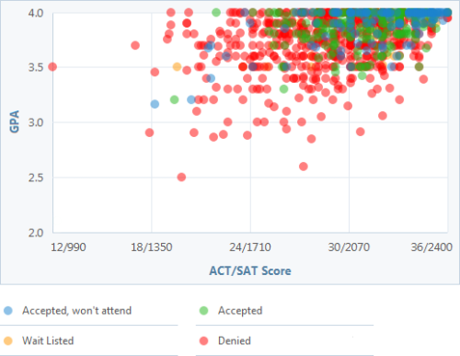
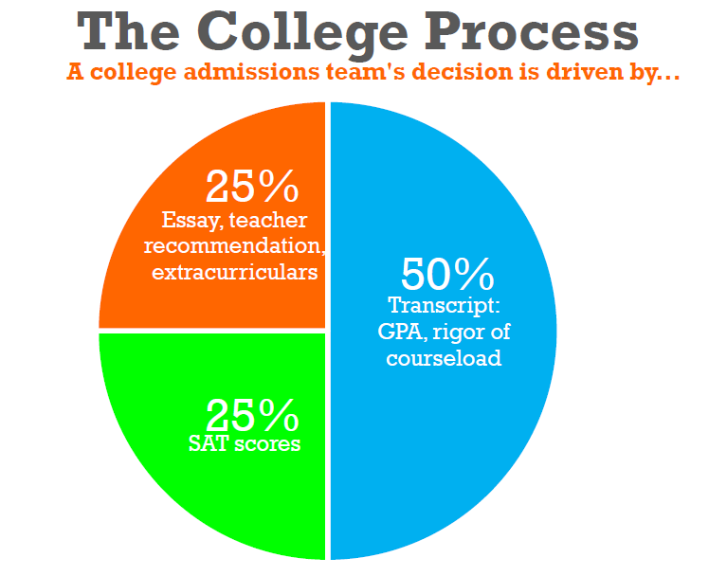
Notice the red dots in the top right quadrant of the graph. These represent students who had an almost-perfect score on the SAT and above a 3.5 GPA. However, they were still denied admission at Cornell. Based on the graph of the college process, why do you think these extremely talented students were rejected from this Ivy League school?

In a college essay, admissions officers are looking for:
- __________________________________________________________________________________________
- __________________________________________________________________________________________
- __________________________________________________________________________________________
In your own words, why would colleges want to pick people who demonstrate these over people with the highest SAT and GPA? Why not only base admissions on GPA and SAT scores?
What works in a PBA: | What works in a college essay:
- Argumentative structure  - Successful when facts support ideas and everything relates back to main point  - Logical, unemotional  - All ends tied up | - Narrative structure  - Successful when details and description draw reader in  - Emotionally moving  - Ends with reader wanting more

The Bridge
Today, right now, you are creating your story to somewhere. You are taking everything you have done in the past and making a credible case – a bridge – from your past to your future. College essays are your chance to show colleges who you will be in their communities by revealing parts of your character that do not show up on your transcript or resume.
Great essays are NOT about grades or test scores, they are NOT about academic or athletic or artistic achievements (those are all important and included in other parts of your application). Great essays reveal who you are as a person today, how you got to this place, and where you are committed to going in the future.
Activities: What have you done? What do you enjoy doing?
Attributes: What words would you use to describe yourself? Get past the obvious (e.g. ambitious and hardworking).
Influences: Which people have shaped who you are today? Who has touched your life in a way that made a difference? Which works of art, literature, or science have shaped you as a person?

Commitments: What difference do you want to make in the world?
Ambitions: What do you plan to study in college? What else will you do in college? What are you plans after college?
Aspirations: What is the purpose of your life?

What is the most important thing you want colleges to know about you that is NOT obvious from other parts of your application? First, write down a few sentences.

Then, take time and craft one sentence of 10 words or less.

Then, distill that sentence down to one word, the most important word, something that characterizes and defines you.

Now, think of 10 or more moments from your past or present that show this attribute – 10 things you have done, moments when you grew or learned or changed in some fundamental way, or people who have helped to shape that attribute in you.

Day 2: SWBAT distinguish between scripts (predictable, general writing) and stories (things only you can tell). SWBAT to generate a story portfolio by brainstorming 10 scripts, then opening up 3 scripts into specific moments that reveal nuance behind the scripts.

Scripts and Stories:
- Scripts are general. They apply to everyone, in a general sort of way, but they say nothing specific about you.
- Scripts are predictable. Everyone uses them. If you have just a few seconds to capture someone’s attention, the last thing you want to be is predictable.
- Scripts can be off-putting. They aren’t true about real people. They are too good or too simple to be true, like a fairy tale.
Examples of scripts:
- I’ve wanted to be pre-med since…
- My mother says I’m…
- I’m a first-generation college student…
- I’m Black (or Jewish or Latina or multiracial…)
- That was the day I learned…
- I’m a leader…
- I showed a lot of determination when I…
What are the scripts your family tells about you?

What are the scripts your friends tell about you?
Pause here for a second – if these are different, that’s an interesting place to start paying attention.
Star the scripts that don’t match up well.
What are the scripts you tell about yourself?
Do you tell different stories to different people?
That’s interesting too; honor these complexities and make a note of them.

What scripts do you think will get you into college? Be honest.
Break:
Your Brain on Stories

Transforming Scripts into Stories:
Scripts: | Stories:
- Interpretations are judgments about what you are describing (“It was the worst day of my life”).  - Internal Dialogue is what you are thinking (“I was thinking about my father”).  - Emotion is your feelings explicitly stated (“I felt sad”). | - Actions are events that take place in the world (“My father drove home from Albany”).  - External Dialogue is the exact words that people say (“My sister said, ‘Get your nose out of your homework, Jerry. Daddy is coming today’ ”).  - Description includes sensory details and other specific information (“He had a purple rash on his face, his stomach was bloated, and his breath smelled rancid.”)

Use the following 3 questions to pick out your top 3 scripts.
- Which of my scripts feels more important or urgent to me right now?
- Which of my scripts is the most important thing I want colleges to know about me? (Check The Bridge.)
- Which one of my scripts reveals something about me as a member of a college community?
Write your top 3 scripts below. For each script, write 5 stories that relate to this story, or show how this script is or is not true about you.
Script #1:
Type of script (circle one): interpretation emotion inner dialogue
1.
2.
3.
4.
5.

Script #2:
Type of script (circle one): interpretation emotion inner dialogue
1.
2.
3.
4.
5.

Script #3:
Type of script (circle one): interpretation emotion inner dialogue
1.
2.
3.
4.
5.

Day 3: Given the specific moments generated in 2.9, SWBAT choose the story that has the best potential for an impactful college essay and expand the details surrounding that experience.
Experiences Moments Defining Moments
Go back to The Bridge exercise. Ask yourself “What is the most important thing I want colleges to know about me?”

Then, review your stories above. Which of your stories reveals some aspect of how that came to be your most important thing? Put a box around the number next to that story.
EXAMPLE: Experience Moments Defining Moment
Experience: I started my school’s Modern Dance Club.
Moments:
We found a faculty advisor and got the club approved by the Director of Student Life.
Diana, Jerome and Sadie danced on stage with the rest of the group.
I choreographed a new dance.
We all danced my piece in the school’s Winter Awards Show.
Defining Moment:
I dedicated the dance to my grandmother, who had danced with Alvin Ailey but left dancing to raise my mom.
When the dance was over, I asked all the moms and grandmas in the audience to come on the stage and stand
with us.

Your turn:
Experience:
Moments:
Defining Moment:

Four Types of Defining Moments:
- Change: Significant moments make a change in you of the world.
- Achievement: You overcome an obstacle to make something happen in your own or someone else’s life.
- Risk: You do something that is challenging or uncomfortable.
- Dilemma: You are forced to make a hard choice.
Where is change present in my defining moment?

Where is achievement present in my defining moment?

Where is risk present in my defining moment?

Where is dilemma present in my defining moment?

Day 4: Given an inquisitive interview with a partner and recording equipment, SWBAT transcribe a first draft of their “Defining Moments” story.
Expand the moment:
Who? Who was there? Were any of the people more important than others? What were their names?

What? What did the look like? What did they say? What did they wear? Was there anything unusual that a stranger/Spike Lee/Ms. Debbeler would have noticed if she were there?

When? What season was it? What time of day?

Where? What city, neighborhood, block, building were you in? Inside or outside? Was it a public place or a private place?

Why? This question tends to bring up interpretations. Once you figure out why, can you find story details that bring out the why without using the word because?

Tell Your Story
You have three minutes to tell your story out loud. Using your phones, take turns timing and recording your defining moment story with your partner. While you are telling your story, trade packets with your partner so that person can take notes.
What did you learn about this person from this story? Pretend that you do not know this person already.

What memories did this story trigger while you were listening?

What are you most likely to remember? Write down the details that stick out the most.

Write It Out
STEP ONE: Listen to your whole story one time, uninterrupted. Keep a tally of all of your likes and um’s in this box:

STEP TWO: What was your experience of listening to your story in your own voice?

STEP THREE: Listen to your story again. In a Google Doc, type what you hear, word for word, exactly as you told it. That means the transcription should include every “like” or “um” and everything else exactly as you said it out loud.
Your College Essay should:
- Be titled in the convention “Block.Lastname.Firstname.CollegeEssay”
- Be shared with monicadebbeler@achievementfirst.org
- Have a standard 10th grade heading
- Be double-spaced and in Arial or Times New Roman size 11.
IF you finish transcribing word-for-word before class ends, you may go back and start pruning likes and ums.

