College List Process Overview

Goals
Vision
Key Players & Timeline
Key Messages
Norms
Appendix

Goals: (back to top)
- 100% of juniors will complete college interest in-take form about college preferences
- 100% of juniors will complete a preliminary 'best-fit' college list by the end of June
- 100% of seniors apply to at least 8 'best fit' colleges by January 1st
- Seniors will be accepted to at least 60% of the colleges on their list
- 90% of junior parents attend at least one college office workshop
- 100% of "College list contracts" are submitted by parents/seniors by end of October

Vision: (back to top)
In order to achieve the mission of ensuring our scholars go to and graduate from college, the college list process is a pivotal period to reaching that goal. It is a carefully calculated process that considers the needs and interests of scholars and their families, while simultaneously ensuring that the process follows the guiding principles of creating a list. We believe:
- Scholars should have a list that meets their academic, social/emotional, and financial needs aka the “best fit.”
- Scholars should apply to schools that meet the criteria of reach, probable, and very probable framework.
- In creating a list, college counselor must consider the family’s income in order to maximize opportunities for special programs, scholarships, or schools that meet 100% of need.
- Scholars should be the “owner” of their list with the strategic, thoughtful, and heavy guidance from the college counselor.
- Parent/families are key players in this conversation and decision-making process.

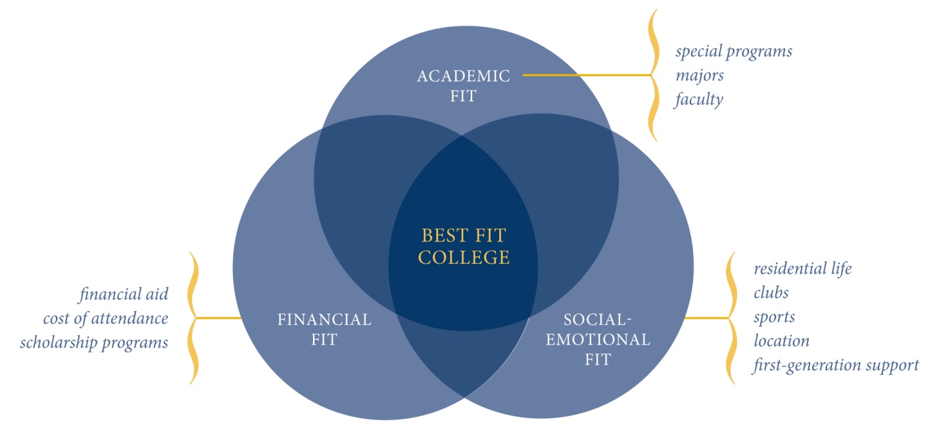

Key Players & Timeline (back to top)
Key Players:  (back to top) |  | Timeline:
- College Counselor  - Juniors via CRS III (Spring)  - Seniors (Summer & Fall)  - Senior Parent/Guardians  - Alumni Counselor |  | - See timeline below
O | College Counselor | Materials Needed/Supporting Documents  - College List Rubric  - Individual College List by Student  - Admissibility Grid – CT/NY  - Naviance Report – Applications by Students  - Naviance Report – Applications by College  - Junior College List Meeting – agenda  - Senior College List Meeting – agenda  - College List Meeting Tracker  - Financial Aid Intake Form  - Annual report on college acceptances
A | Dean of College
P | College Counselor
I | Alumni Counselor, Network Director of College, Network Director of Alumni Programs & Partnerships
C | Alumni Counselor, Network Director of College, Network Director of Alumni Programs & Partnerships, Principal
S | All students will get a college list advised by the college counselor
Policies:
- When and how do we determine whether or not a scholar gets a fee waiver for a college application?
- What is the number of colleges we’re recommending scholars apply to? Is there a maximum?
- Are there any schools that we will not recommend? What is our philosophy or rationale for this?

Key Messages: (back to top)
- Scholars should have a balanced list which include the Reach/Probable/Very Probable framer and accounts for their Academic/Socio-Emotional/Financial fit/(R/P/VP and A/S/F fit)
- Scholars should attend the best school to which they are accepted.
- SCHOOL SHOULD INSERT ANY ADDITIONAL KEY MESSAGES

Norms: (back to top)
- We do our best not to advise schools that meet <50% of aid.*
- We consider the entire cohort of seniors when we advise colleges in order to ensure that our scholars don’t “cancel” each other out in the applicant pool.
- We consult with the alumni counselor before advising lists in order to consider data & results of our alumni when advising new lists.
- We consult with the Network Director of Alumni Programs & Partnership before advising partnership schools to scholars and families.
- SCHOOL SHOULD INSERT ANY ADDITIONAL NORMS
Key Deadlines: (back to top)
- In-take results (April )
- Preliminary plotting on college list (Late April)
- Partnership planning (Late April)
- Schedule all junior college list meeting (Late April/Early May)
- Due date for getting financial forms from parents (May 31st)
- First round of junior college list meetings (June)

 | College Counselor | CRS III | Parents | Key Meetings
March | - Cohort audit & tiering based on rubric | - College Tour prep
April | - Create preliminary lists for top quartile and bottom quartile  - Communicate w/parents re: AP/SAT II | - Scholars identify preferences re: Size, Distance/Location, Majors, Selectivity (In-Take google doc form) | - Communication | - Preview Partnership Schools & Determine who will attend May visits to schools
May | - AP course advisement  - SAT II coordination  - Host Jr parent meeting  - College list meetings with students | - Research colleges | - Creating the college list family meeting | - Partnership Scholars: Visit schools in May
June | - College list meetings with students | - DL: First draft college lists |  | - Preview 1st draft lists for top and bottom quartile
July | - Cohort re-audit & tiering (jr yr final grades @ sr courses  - College list meetings with students  - Diversity Overnight communication |  | - Visiting colleges  - Researching colleges  - Meeting w/college counselor  - Sign college list contract | - Partnership review for seniors & preview juniors (matching & matriculation)
August | - Identify and meet all ED/partnership applicants (15th) |  | - Visiting colleges  - Researching colleges  - Meeting w/college counselor  - Thematic coffees (Diversity Overnights, Selectivity, ED apps)  - Sign college list contract | - Preview 2nd draft of lists
Sept |  | - DL: Final College list | - Sr college meeting  - DL: College list contracts
Oct | - Review HF lists w/updated SATs  - Sign-off on final lists |  |  | - Receive final lists

