Behavior Intervention Plan Data Tracker
This document is a quick introduction to the behavior intervention plan tracker. In this document, you will find information on how to:
- Set up the document
- Enter Data
- View the data

1. Set up the document
When you open the document, you will come to a home page where you will be able to enter in the goals you have set for the student.
- Enter the Student’s name and student ID at the top of the document.
- Then hit ‘Enter Goal 1’ to open a form where you will be able to enter the goal and benchmarks.
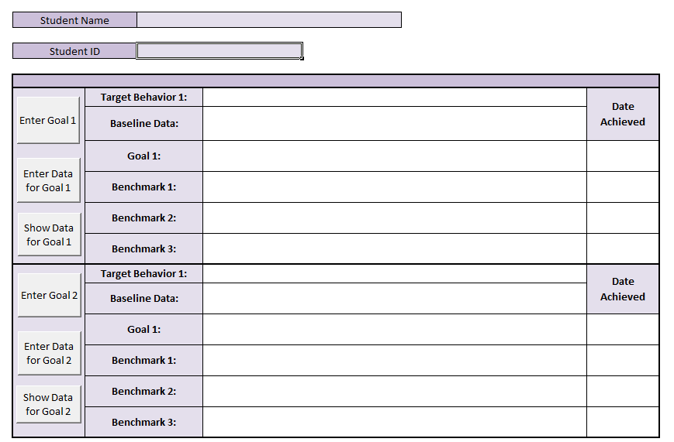
2
1
After you hit the button, you should see this form:
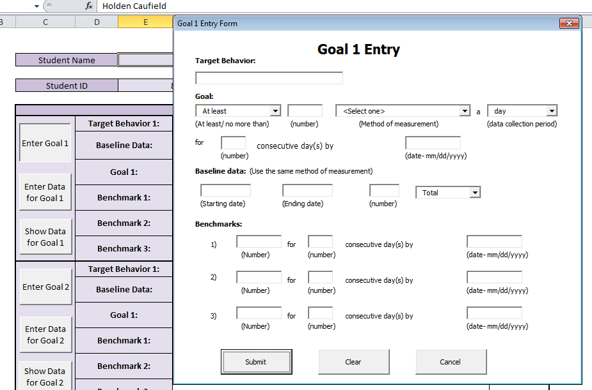
In the form, you will enter in:
- The target behavior for the goal
- The goal
- Baseline data for the behavior
- Benchmarks of progress towards the goal
Target Behavior and Goal:
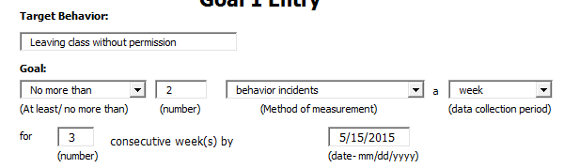
3
2
1
5
4
6
Target Behavior: This is a short statement about what behavior you are targeting with this behavior intervention plan.
Goal: You will have to enter in 6 fields for each goal to let the program know what you are measuring-
- At least/no more than: This lets the program know whether to use “greater than/ equal to” or “less than/ equal to” when computing goal mastery. Use “At least” when you are measuring desirable occurrences, like earning incentives, points, stickers, etc., and use “No more than” when measuring undesirable occurrences, like removals, detentions, etc.
- The number is the specific goal you are trying to achieve. This should match your method of measurement. i.e. 4 removals, 28 CICO points, 8 stickers, etc.
- The method of measurement is a drop-down menu. If you see items missing, contact Alex. We can add new ones really easily.
- Data collection period is how frequently you will be entering in data. The options are daily, weekly, or every 2 weeks.
- The next number identifies the number of consecutive trials necessary to meet the goal.
- Finally, the last number is the terminal date of review, by which the student should meet the goal.

Baseline Data:
Next, you will enter in the baseline data for the scholar:
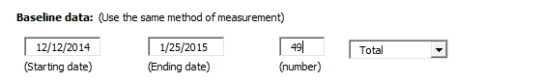
The baseline data will use the exact same format as the goal. The method of measurement should be identical to the goal. For example, if you goal is measuring removals, then your baseline data should be removals.
For the baseline data, enter in the range of dates the data was collected. Then enter in the number of incidents/removals/ behaviors/points/stickers etc. earned during that time. If you leave the dropdown as “total” the program will automatically calculate the baseline data based on the period of measurement you indicated in the goal.
For example, with the data above, the program calculated that the student had 11.7 behavior incidents a week.
If you have an average, rather than the total (like the average number of CICO points earned) you can use the dropdown menu to select average.

Benchmarks:
The benchmarks should be progressively more difficult intermediate steps that will be met before the goal is achieved. These are your small wins.
Enter the benchmarks just like the goal. The method of measurement and period of data collection will be the same as in the goal, but you can change the number, the generalization rule and the goal date.
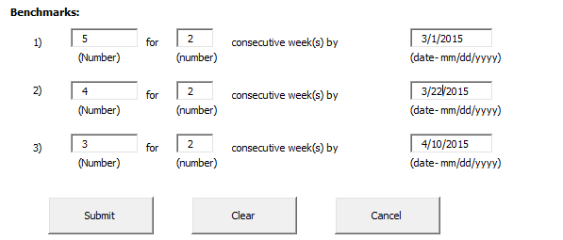
Then hit submit and get going!

2. Enter Data
After you hit submit, the goal should automatically populate on the home page. If you see any errors in the goal, just hit “Enter Goal 1” again to edit the goal. The box will come up with all the information you have already entered. All you need to do is fix the sections that need fixing.
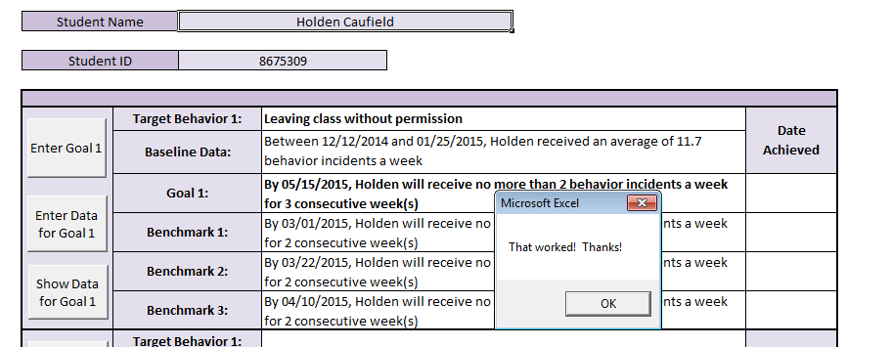
Hit this to enter data

To enter data on the goal, hit ‘Enter Data for Goal 1”. Once you do, a box will pop up with the target behavior and goal at the top.

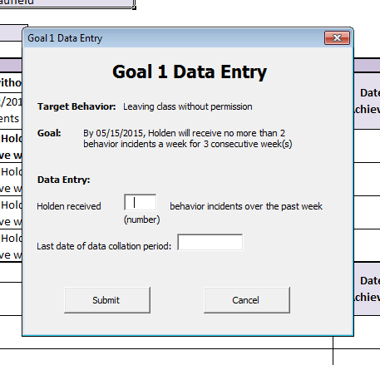
In this box, enter the number from the last data tracking period. For example, the number of removals over the past week if you are measuring removals over weeks.
Then enter the last date of the collection period. If you are entering information daily, this will just be the day the data was collected. If you are collecting over a week or 2-week period, this will be the last day of the period.
Hit submit and the data will be recorded.
FYI: After you enter in the first data point, the sheet will automatically generate the next date it expects to see data. This date is based on the period of collection you identified in the goal. Warning: While the program anticipates weekend dates, it does not always anticipate school vacations. If you are coming back from school vacation, make sure you adjust the date.
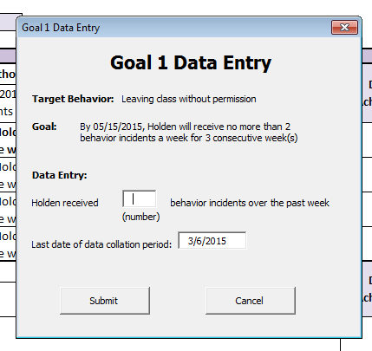
You can enter in as many data points as you need (If you exceed 300 data points, the program will lose the oldest points). Also, try to enter the data points in order.
As you enter the data points, the home screen will update when benchmarks are met:
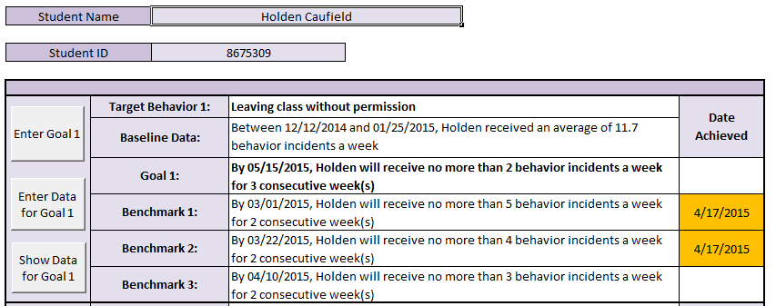
If the benchmark or goal is met before or on the target date, the cell will highlight Green. If the benchmark or goal is met after the target date, the cell will highlight Yellow. And if the goal or benchmark is past due and has not been met, the cell will be Red.

3. View the data
To view the data, hit the “Show data for goal 1” button. On this screen, you will see the target behavior, the goal, last 30 data points, and a graph of the data.
The graph will show a line for the goal, the aim line, and a line for the behavior entered. Note: You must have at least 2 data points entered for the graph to show data.
On this screen, you can also clear the last entry, if you made an error with your data entry. FYI: If you want to clear the entire goal and all the data, go to the home screen, click on the “Goal Entry” form, hit clear, then hit submit. This will completely reset the goal.

