Congratulations on completing your estimated 2013-2014 FAFSA!

However, this is not the end of the financial aid process. Later this winter, all alumni and families completing their FAFSA with 2011 tax information will need to update their FAFSA with completed 2012 tax information.

In order to avoid the verification process, which requires significant additional student work, alumni are strongly encouraged to update their FAFSAs using the IRS Data Retrieval to input 2012 tax information.

Instructions to Update Your FAFSA with 2012 Tax Information:
- Once you have submitted your 2012 tax return to the IRS, before immediately updating your FAFSA manually with 2012 information, if you wait according to the times in the table below, you can utilize the IRS Data Retrieval Tool:
Electronic Tax Filers | Data will be available within 2 weeks of filing
Paper Tax Filers | Data will be available within 6 – 8 weeks of filing

- The IRS Data Retrieval will be available after February 1, 2013
- Go back to www.fafsa.ed.gov:
  - Login
  - Click on 2013-2014
  - Click on the “Make FAFSA Corrections” link
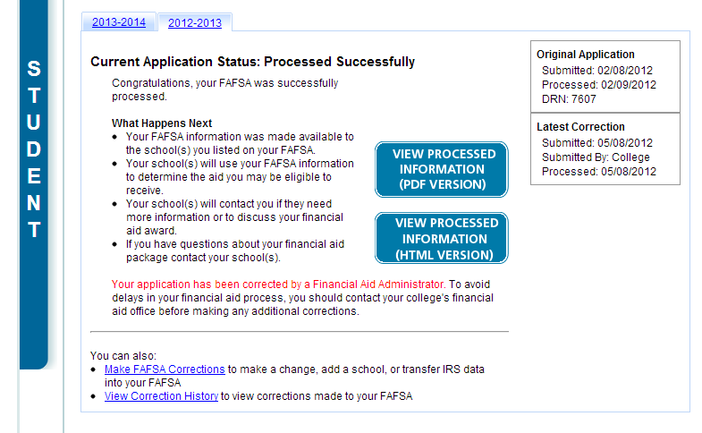
  - Follow instructions to use the IRS Data Retrieval Tool:

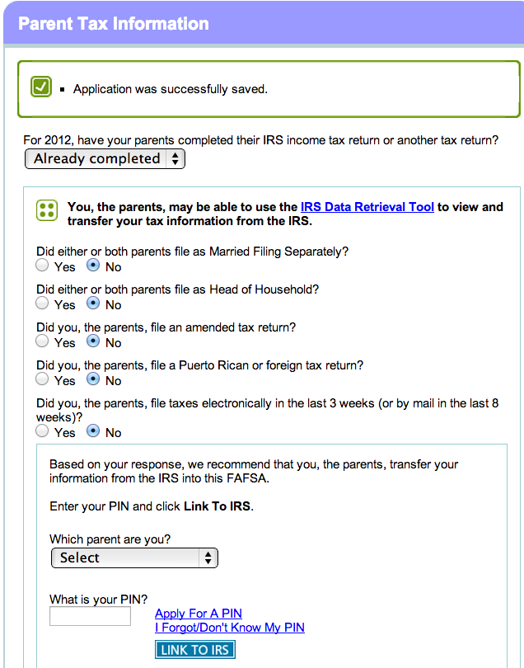
- When prompted, enter the Student and/or Parent PIN to begin the IRS Data Retrieval:

- When inputting demographic information into the IRS, ensure that the address on the FAFSA matches the address used on the tax return:
