Alumni Program Overview

Contents

- Overview
- Goals
- Key Messages & Mindsets
- Key Strategies (Shared Practices)
- Roles & Responsibilities
- Calendar of Key Dates
- Road Map for the Year

1. Overview

Only 8.3% of students from low-income families earn bachelor’s degrees by their mid-20s. Family income is historically one of the strongest predictors of a student’s college success, far outweighing the impact of high school performance as measured by GPA or SAT scores. High-achieving, high-income students are more than 2.5 times more likely to graduate college than are high-achieving students from low-income backgrounds. Even the lowest-performing students from high-income backgrounds graduate college at a higher rate than the highest-performing students from underserved communities.

Achievement First high schools work to realize our mission by ensuring that scholars reach college prepared to take on the academic work and independence they will face there. Our college access team helps our scholars choose colleges that are strong matches where they are likely to persist and graduate. The AF Alumni Program supports this work and is a critical piece of achieving our mission of ensuring our scholars graduate from college. Like many other CMO alumni programs, the AF Alumni Program is here to level the playing field for our high school graduates, giving our alumni and families the access to resources that their more affluent peers have.
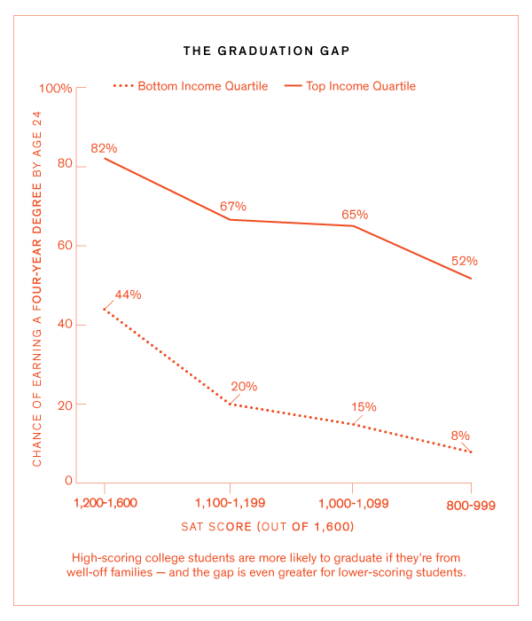

The AF Alumni Program supports three phases of AF scholars’ paths toward college graduation through key initiatives and practices leading up to and during our alumni’s college years:

2. Goals
We have set reasonable and measurable goals to define the success of the AF Alumni Program, which are reflected in the College and Alumni Report Card:

- At any point in time, 85% of AFAHS alumni are enrolled in college

- 75% of alumni graduate from college in six years

- 100% of alumni are engaged in the alumni program

- 100% of alumni receive appropriate interventions/support for their tier

- 100% of seniors complete the Matriculation Binder

- 85% of AF AHS alumni participate in the Book Scholarship initiative

- 50% of parents or families of alumni engage in alumni related workshops, events and meetings with the alumni counselor

- 80% of alumni have an on-campus champion

These are shared network-wide goals that the Alumni Program at each AF high school will work toward. Individual AF high schools may elect to set additional school-specific goals.

3. Key Messages & Mindsets
Every member of the alumni support team believes that:

- Every student will exhibit unique needs for support in college. We differentiate our support by tiering and re-evaluating each semester to reflect and support our alumni’ varying college performance and progress towards degree completion.

- We do not recreate the wheel, but rather fill in the gaps for what alumni need on their various college campuses. We encourage and coach alumni to utilize available resources on their college campuses and liaise with colleges and families whenever possible. We are resource connectors and gap fillers, not one-stop-shopping for any need.

- Everyone (colleges, families, AFAHS staff, alumni and the alumni program) is a major player in ensuring that students achieve college success.

- Families are critical partners in ensuring college success. Proactive, open and clear communication is key to fostering strong partnerships with families.

- All AFAHS staff and faculty can support the alumni program by notifying alumni counselors of relevant family and alumni updates. (Example: If an alum has a younger sibling at AFAHS and AFAHS staff learn of family information that may impact the alum’s persistence, sharing that information with the alumni program is critical.)

- Alumni should be encouraged to use their resources on campus first at all times.

- Alumni counselors are like coaches: They work with our alumni and families to problem-solve in order to build the skills of our alumni.

- Alumni may turn up unexpectedly at AF high schools unannounced and at unscheduled times; alumni counselors should make every effort possible to maximize time with alumni (which may include last minute schedule changes and/or use of a waiting room for alumni visitors).

- AFAHS staff should update alumni counselors when they are in communication with alumni and provide all substantive updates to alumni counselors. (Examples: enrollment status, academic performance, request for academic assistance, social/emotional/health updates)

- The Alumni Program shares alumni academic data through the annual persistence report and through subject specific academic reports three times each year as a resources from which schools can evaluate their effectiveness and learn from our data on alumni performance.

- Alumni academic data shared with AH high school staff is confidential; we do not discuss it beyond the school team or distribute it publicly.

Alumni support team members work to share these messages and mindsets with key stakeholders, including school leaders and faculty so that we can work effectively to strengthen our collective support of our students pre- and post- college matriculation.

4. Core Strategies (Shared Practices)
Seven core strategies comprise the shared practices that alumni programs at each AF high school include. These proven shared practices seek to help each transitioning AF graduate and alumnus in the ways that they most need our support while at the same time building each student’s capacity to be resourceful and leverage the on-campus resources and support structures at their disposal at their respective colleges. Our seven core strategies are:

- Matriculation support
- Tiered support
- Alumni events
- Book scholarship initiative
- Funding support and FAFSA guidance
- Alumni academic data collection and sharing
- Support of 5th year seniors

Each of these strategies is detailed in the summary documents in the individual strategy folders under the Alumni Programs lever. Broadly, different alumni have different needs, which we identify using a needs assessment that twelfth grade faculty complete each spring. We tier alumni according to levels of support that we anticipate they will need from the Alumni Program in order to have a successful college experience. We recognize three tiers:

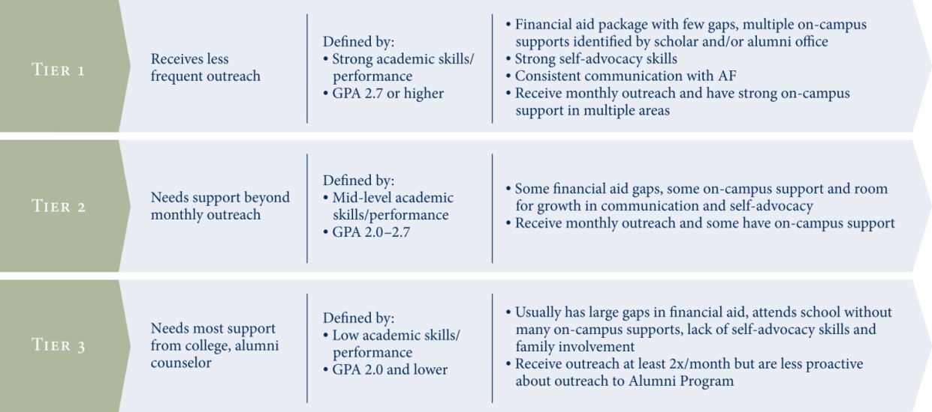

This approach best enables our Alumni Counselors to target their support of each alumnus while serving all alumni. Different alumni will access and lean on the structures and support systems delivered through our seven core strategies to varying degrees based on their profiles. Finally, because we know we must be disciplined in how we devote resources to best support our alums, only AF high school graduates participate in alumni support programming.

5. Roles & Responsibilities
Successfully and consistently implementing these strategies will require teamwork and the shared investment and execution of both internal and external stakeholders. The table below illustrates how the alumni counselor will work with key partners and stakeholders to support our students.

Owner | AF Alumni Counselor(s) | Drives all school-based work and directly supports caseloads of alumni; plans and executes all programs and events.
Approves | Network Director of Alumni Programs & Partnerships | Supports Alumni Counselor by providing frequent advice, support with trouble-shooting, direction, and accountability.
Participant(s) | AF high school-based staff, scholars, families, alumni, college campus-based staff
Informed | Principal, Dean of College, College Counselor(s) | Keeps apprised of alumni support work through routine updates from Alumni Counselor; supports Alumni Counselor to invest other stakeholders (staff, families, etc.)
Consulted | Network Director of Alumni Programs & Partnerships, Dean of College

Task-specific roles and responsibilities and corresponding deadlines for planning and execution each month are detailed in the CARC. Each month, the Alumni Counselor and the Network Director of Alumni Programs & Partnerships and Dean of College meet to discuss program progress versus the execution timeline and deliverables delineated by the CARC. This protocol ensures a clear routine for assessing ongoing progress and will help the team support, prioritize, and problem-solve.

6. Calendar of Key Dates
Because our graduating students and alumni are dwelling in a universe of forms, processes, applications, and deadlines on which access to funding and continued enrollment depend, the alumni counseling world is highly deadline driven. Key deadlines and windows include:

- May 1: National College Deposit deadline
- Mid-May: 12th grade faculty tiering for graduating seniors
- May – June: matriculation paperwork due to colleges
- June – August: various college orientations
- Early August: Send off to college BBQ
- August – September: college start dates, orientations and move in
- Mid-Sept: “Supporting your child in college” workshop for alumni families
- Sept – Dec: Alumni Counselor visits to new colleges to the network & state schools
- January: Alumni Homecoming
- Mid-January: FAFSA workshop
- January – February: FAFSA/CSS Profile renewal
- End of February: CRS IV: Transitions course begins
- Mid-March: Senior dinner
- April : Tier 3 decision meetings

7. Road Map for the Year

AUGUST | SEPTEMBER | OCTOBER | NOVEMBER
First Year Students:  - Matriculation  - Sendoff BBQ  - Orientation  - Course registration  - Move-In preparations  - Fall Book scholarship  Returning Students:  - Course registration  - Move-In preparations  - Fall Book Scholarship | Alumni areas of focus:  - Time management  - Asking for assistance from advisors and professors | Alumni areas of focus:  - Study skills | Alumni areas of focus:  - Midterm exams  - Course registration for spring term
Alumni Counselors:  - Sendoff BBQ  - Confirming matriculation  - Course registration counseling | Alumni Counselors:  - Campus visits  - Monthly outreach/meetings  - Parent workshop “Supporting Your Child in College” | Alumni Counselors:  - Campus visits  - Monthly outreach/meetings (focus on transferring/re-enrollment)  - CRS IV: course revisions | Alumni Counselors:  - Campus Visits  - Monthly outreach/meetings  - Family newsletter  - Finalize CRS IV course revisions  - Alumni Academic Data Report #1
DECEMBER | JANUARY | FEBRUARY | MARCH
Alumni areas of focus:  - Final exams  - Bill for spring 2013 Term  - Spring Book Scholarship  - Resumes (3rd Year+)  - Reminder of FAFSA renewal  - Alumni Homecoming | Alumni areas of focus:  - Spring Book Scholarship  - Personal Organization  - File taxes  - FAFSA/CSS Profile renewal | Alumni areas of focus:  - Career Services (3rd Year+)  - Summer opportunities and/or summer course registration  - FAFSA/CSS Profile renewal | Alumni areas of focus:  - Time Management refresher  - Midterm exams  - Financial Aid Verification
Alumni Counselors:  - Campus visits  - Monthly outreach/meetings  - Homecoming & FAFSA workshop planning | Alumni Counselors:  - Alumni Homecoming  - FAFSA/CSS Workshop  - Monthly outreach/meetings  - Senior Dinner planning | Alumni Counselors:  - Monthly outreach/meetings  - FAFSA/CSS follow up  - Begin teaching CRS IV: Transitions  - Alumni Academic Data Report #2 | Alumni Counselors  - Monthly outreach/meetings  - Final month for FAFSA/CSS filing  - Senior Dinner  - CRS IV: Transitions
APRIL | MAY | JUNE | JULY
Alumni areas of focus:  - Fall 2013 course registration  - Summer opportunities and/or course registration follow-up  - Financial Aid Verification | Alumni areas of focus:  - Study skills  - Final Exams | Alumni areas of focus:  - Support as needed  - Main focus on current seniors | First Year Students:  - Matriculation  - Sendoff BBQ  - Book Scholarships  - Bridge Programs  - Orientation  - Course Registration  - Housing Information  Returning Students:  - Summer  - Fall semester bill
Alumni Counselors:  - Monthly outreach/meetings  - Financial Aid verification  - Graduation planning  - CRS IV: Transitions  - Senior college decision meetings  - Alumni Academic Data Report #3 | Alumni Counselors:  - Monthly outreach/meetings  - Graduation planning  - CRS IV: Transitions  - Senior matriculation  - Faculty tiering of seniors | Alumni Counselors:  - Monthly outreach/meetings  - Graduation  - Senior matriculation  - Graduation awards | Alumni Counselors:  - Monthly outreach/meetings  - College matriculation  - Orientation attendance  - Placement tests

