2013 – 2014 Classroom Set-up Checklist and Criteria for Success (Expanded Checklist)
Grades/Rooms | Item/Area | Checklist | Notes
K – 3  Homerooms  LS  Specials | Furniture Placement | - All furniture has been placed intentionally by ops in order to create a consistent flow from room to room. Please do not move any furniture.  - If you find a problem with furniture placement that will make it impossible for students to learn effectively in your room, please reach out to a Dean for problem solving and we will collaborate with you and Ops to work it out.
K – 3  Homerooms  LS  Specials | Student Desks | - Pencil Holder on top center of desk  - Student name tags: place just below pencil holder; first and last name for all students who use desk (i.e. reading room and homeroom in K – 2, all sections in 3rd grade).  - Arrow indicating which way students turn in desk to rug transition. Arrow should be the same color as the student’s carpet row and located to right of name tag.  - Inside of desk should be organized according to desk common picture (see attached). Each desk will need folders and 1 pencil pouch with crayons, scissors, and a glue stick. Scholar first and last name should be written in sharpie on all materials.  - K – 1 Folders: Green is Writing, Blue is Bright Work, Red is Class Work, Purple is Student Work (stays in backpack at all times)  - 2nd Grade Folders: Green is Boston, Blue is Mizzou, Red is SHU, Yellow is Bright Work, Gray is Student Work (stays in backpack at all times)  - 3rd Grade Folders: Green is Spelman, Blue is GW, Red is Brooklyn College, Yellow is UW, Gray is Student Work (stays in backpack at all times) | See Resource #1 for more detailed guidance
K – 2  Homerooms | Student Hooks | - All student hooks labeled with student first name (and last initial if multiple students have the same first name)  - Labels should be laminated or covered with packing tape to ensure that they are durable
K  Homerooms/LS | Alphabet and Number Lines | - Alphabet line and Number Line should hang at front of board over white board
K – 2  Homerooms  LS | Math Meeting Areas | - Each room needs two math meeting areas. We have ordered additional sets from Everyday Counts to accommodate this.  - One area should be at the front of the room near the rug, and the other should be at the rear of the room near the U-Table.  - Note: It is OK to reduce the size of visuals for the smaller area given that there will be fewer students who will be seated closer. Just ensure that all students will be able to adequately see all materials.  - Please use the attached agendas for August/September as a reference for what you will need on your Math Meeting Wall. You can find the materials for most components in your Everyday Counts boxes.  - Note: Keep in mind that the math meeting area will grow as the year progresses, and leave extra space around the area for this purpose.  - Note: See sample photos at end of doc and in PPT
K – 3  Homerooms  LS  Specials | Daily Schedule and Friday Schedule | - Should be posted in print large enough to be read around the room. May be done in teacher handwriting or with computer.  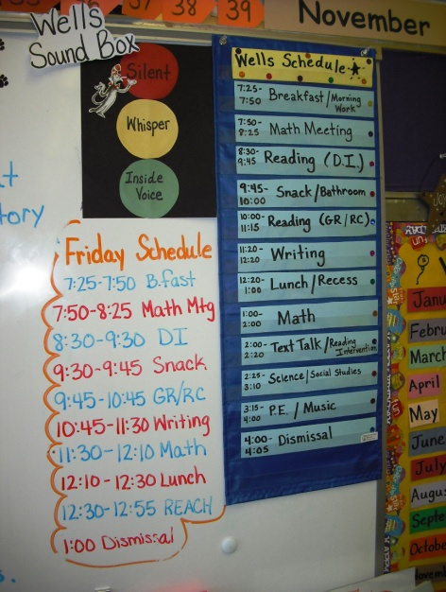
K – 1  Homerooms  LS | Sight Word Wall | - Beginning of year: All letters should be posted on colorful card stock or index cards. Consonants should be 1 color and vowels a second color.  - Beginning of year: All student first names (clearly printed on card stock or sentence strips) should be on word wall  - Word Wall should be large enough to have 5 – 10 words under each letter. Sight words will be added at the beginning of each week.  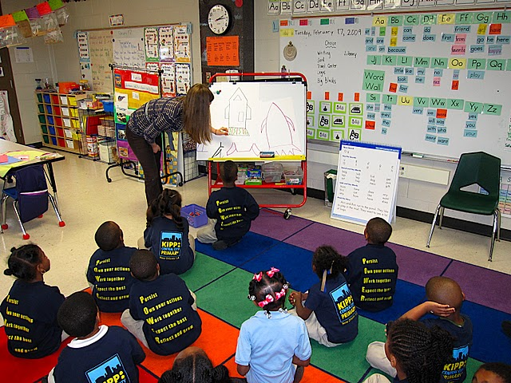
K – 2  Homerooms | Vocabulary Word Wall | - Vocabulary Word Wall should be approximately as large as sight words wall  - Vocabulary Words will be added each week during vocabulary lessons  - Vocabulary Word Wall will be organized by text  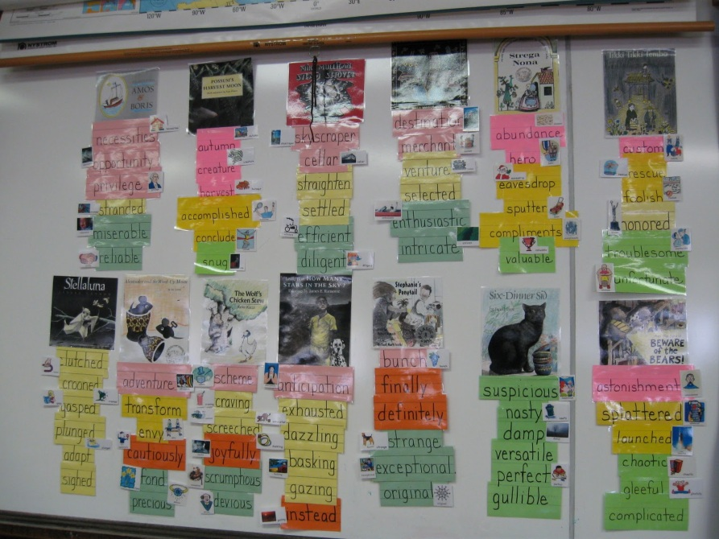
K – 3  Homerooms  LS  Specials | Rules Poster | Each classroom should have School Rules posted in a place that is easily seen from the rug.  For Kinder and First it is recommended to have a visual representation to demonstrate each rule.  Kinder/First - Be safe. - Stay in your seat. - Raise your hand. - Be a good friend. - Do all of your work Second/Third - Be safe - Be a team player - Do all of your work - Take care of your materials - We do the right thing, no matter what.
K – 3  Homerooms  LS  Specials | HALL Poster  SLANT Poster  Hand Signals | Hall Poster should be posted by door  SLANT poster should be visible from rug and desks  Hand Signals & Emergencies Poster should be visible from rug and desks
K – 3  Homerooms  LS | GR Library | GR Libraries are set up by ops. Please be very careful to keep these libraries in order over the course of the year! Reach out to Shelley ASAP if you need to order books that are missing from bins.
K – 3  Homerooms | Genre Libraries | Genre Libraries are set up by ops. Please be very careful to keep these libraries in order over the course of the year!
K – 3  Homerooms | Independent Reading Libraries | - Independent Reading Books can come from several places. There is a baseline collection of books in each classroom. You can get more books by printing from Reading A – Z, swapping for a short time with other classes at different grades/levels, and by leveling books from your genre libraries (www.scholastic.com/bookwizard).  - IR books should be organized into 4 large bins per room (these have been ordered for you). Each bin should have a label on the front that has the F&P levels & STEP Levels of the books inside. Each book should have a sticker with the independent F&P and/or STEP Level.  - Bins should be placed near a U-Table so they can be spread out during IR for students to choose new titles and easily put away once IR is complete  Kindergarten Bins Red Bin Blue Bin Yellow Bin Green Bin  A, B, C (STEP Pre – 2) C, D (STEP 2 – 3) D, E, F, G (STEP 4 – 5) H, I, J, K (STEP 6 – 7)  First Grade Bins Red Bin Blue Bin Yellow Bin Green Bin  D, E, F, G (STEP 4 – 5) H, I, J, K (STEP 6 – 7) K, L (STEP 7 – 8) M, N (STEP 9+)
K – 3  Homerooms  LS  Specials | College Door | - Exterior of all classroom doors are decorated with items that will help teach scholars about the college for which the classroom is named.  - Each college door should have, at a minimum, the following:  - Name of college  - Location & fun facts about the college (i.e. how many students, most popular major, pictures and short bios of notable graduates, mascot)  - Graduation picture of teacher who attended the college and a short explanation of what they majored in, etc…  - Optional: fun items such as a pennant  - Laminate: Any paper items will look best and hold up well if they are laminated. To achieve the some of the same decorative appeal of covering the door in paper, items can be mounted on colorful paper before laminating.  - Individual Student Names: If you want to have individual student names on doors, please make sure you make 5 – 10 additional name tags and keep these updated as rosters change.  - College doors should not: Be fully covered in paper: this has been a problem with the fire marshal and these doors have not held up over time.
K – 3 Homerooms | Breakfast & Lunch Materials | - Large Backpack Bin (Grades 1 – 3, provided by Ops)  - Breakfast Area stocked with:  - Sporks  - Paper towels  - Wipes  - Lunch Bin for student lunches near door
K – 3  Homerooms  Shared Bathrooms | Bathroom Visuals | - Student bathrooms are a place where scholars have a high level of independence, and will need significant support in order to keep the bathrooms clean for their peers. Kindergarten teachers should post in their classrooms and grade level interns will be responsible for posting bathroom signage for the hallway bathrooms (K=First Floor, 1=Second Floor, 2=Third Floor, 3=Cafeteria).  - The following visuals need to be created and posted  - On soap dispensers & hand sanitizer dispensers – 1 squirt  - On hand dryers – do not use (circle with red line through it)  - On toilet tissue – 5 squares  - Over toilets and urinals – Please be neat
K – 1  Homerooms  LS | Computers | - Individual student log-in information will be printed by grade level interns  - Teachers need to tape the labels right next to computers so it can be moved easily when reading groups change  - Computer visual of student behavior should be hanging at each station  - Headphones are free of tangles and hanging on the monitor  - Computer area is dust free and wiped down at least 2x per week  - Book bin and bin of spare headphones are located near the computer area
K – 2  Homerooms  LS  All reading rooms | DI Area  Reading Easel | - Each DI area will have an easel or board area to organize Reading Mastery Materials  - Space should be present for me/you game and dictation words  - All materials for DI should be organized in the easel  - Presentation Books  - Storybooks  - Sight Words Flash Cards (K and early 1)  - Dictation Lists, Phonological Awareness Plans  - Take Home Packets (including phonological awareness or dictation pages)  - J-Factor Items (sparkly pointer, finger puppets, stickers, etc…)  - Extra Student Materials (pencils, etc.)  - Tissue  - Hand Sanitizer
K – 2 Homerooms  LS  All reading rooms | GR Area | - Mastery Trackers are posted  - Conferring binder for all groups is set-up and ready to go  - U-Table is labeled with student names for both groups  - Each teacher has a bin/basket for needed materials (daily books, extra books, pens, sticky notes, etc…)
K – 3  Homerooms  LS  Specials | REACH Letters | - Each room where scholars learn (homerooms, pull-out rooms, the gym) should have a large, teacher-made visual anchor of the REACH letters (see examples below).  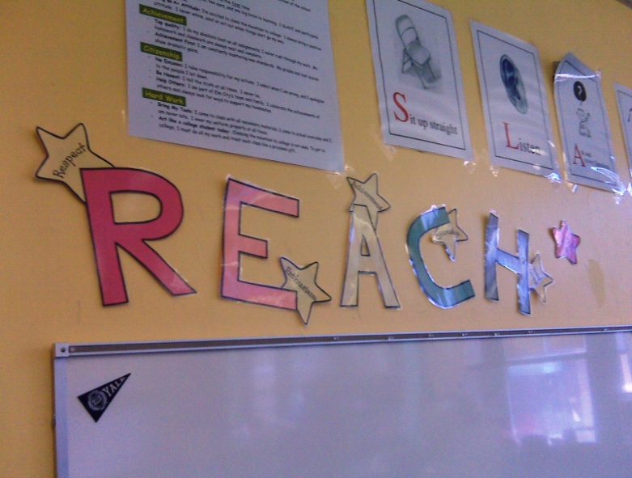
K – 3  Homerooms  LS  Specials | Math Manipulatives  Curriculum Storage  Cooperative Play | - Math Manipulatives should be organized in plastic tubs and clearly labeled in teacher handwriting.  - All curriculum (Handwriting Without Tears, Lucy Calkins, Math Investigations, etc) should be stored in the classrooms on shelves or credenzas. Materials should not be removed from the classroom, except for lesson planning, and will be inventoried at the end of the year.  - Cooperative Play Materials should be in labeled bins in a set area of the classroom so they are easy for student helpers to set up and clean up each day. Classroom play structures (doll houses, etc.) should only be used during cooperative play. They should not be out during the day or taking up space in the classroom during instructional time.
K – 3  Homerooms  LS  Specials | Bulletin Boards | - Student Work should be posted and rotated every 3 – 4 weeks. Work should be hung securely on boards and stapled at least on top two corners.  - All posted work should have a teacher-created summary of the project: objective, criteria for success, any rubric that was used, standards addressed, etc…  - Work should be hung for the following content areas:  - Writing: Large boards outside of classrooms are reserved for writing. All students must have a current writing piece on the writing board, with their first and last name and date clearly written on the top page of the assignment. For multiple page pieces, it is a best practice to photocopy and shrink down student work so that all pages can be displayed.  - Math: All homerooms and LS classrooms should have a math board where student work is displayed. Work on these boards should be no more than 4 weeks old.  - Reading: All homerooms and LS rooms should have a reading board where student work is displayed. Work on these boards should be no more than 4 weeks old.  - Science/Social Studies: Each grade level should have a science/social studies board (hallway space for K - 1). Work should be posted on these boards for each unit of study. (at least every 4 weeks)  - Specials: Each specials teacher should update a bulletin board either with examples of student work or photographs of student performance pieces for each unit. (at least every 4 weeks)
K – 3 | Systems for Organizing Student Work | All classrooms/teachers should have a comprehensive system for organizing student work:  - Organizing Handouts: Each teacher should have a clear system for organizing the handouts they will use in lessons. Some teachers like a system where they have a bin for each subject with work for each day of the week clipped and arranged by day. Other teachers like a system where they have a bin for each day of the week with work for each subject clipped and arranged by subject. Either way, all teachers need to have a system that ensures that papers will be easily accessible and ready to go during instruction. NOTE: When copying materials for your colleagues each week, you should make 5 – 10 extra copies of all materials so there will be an adequate supply for scholars who need to redo or make-up work and for scholars who are sent out of class and need work to take with them.  - Organizing Collected Work: For each subject, teachers should have a clear and consistent for organizing completed work. There should be a clear place in the classroom to place work that is ready to be graded, work that needs to be redone, and graded work that is ready to be returned to scholars.  - Returning Student Work: All student work should be graded (sometimes for completion, sometimes for correct answers) and returned to students within 1 week. Teachers should have a clear system for filing and organizing student work that is graded and ready to be returned to students. At a minimum, all scholar work should be sent home 1x/week on Fridays. This includes graded exit tickets and IP (for all subjects) , completed writing pieces (except the one piece per unit that scholars publish and post on the class bulletin board), Sight Words/Spelling Assessments, any other assessments that scholars have taken.
K – 3 | Student Mailboxes | Student Mailboxes will be placed in your room. All mailboxes should be labeled with student first/last names. Since kids will likely be filing work, it is a best practice to alphabetize mailboxes by student first name and add new scholars to the end as they come in.
K – 3 | REACH Bars | - REACH Bars will be provided  - Each student should have a clip with their first name (and last initial if needed) clearly printed.  - Reading Room color (based on accent wall) should be colored on end of clip  - Homeroom first initial should be written in sharpie over reading room color
K – 3 | Pick Sticks | - Pick sticks or some other system for cold calling students should be in place for homeroom, reading room, and small groups
K – 3 | Seating Charts | - Seating charts should be laminated and posted at the front of the room and in individual areas. Seating charts should be present for:  - Homeroom rug seats and desk seats  - Reading room rug seats and desk seats  - DI seats  - GR seats  - Computer seats
K – 3 | Line Order | Line Order should be posted by the classroom door
K – 3 | Aims Boards | Daily Aims should be posted for all core content lessons at Endeavor (anything that is TCP observable)  - K – 2 Homerooms and LS: Leave a labeled space (Today’s Aim) on the white board or right next to it for the current lesson aim. We will type a student friendly aim into LP packets for teachers to pull out and post at the beginning of each lesson.  - Specials, 3rd Grade, and Departmentalized Subject: Have an aims and agenda board in your room to post the aim and agenda for your daily lessons.  Math Block 1 Math Block 2 Science Block 1  Aim: Aim: Aim:  Agenda: Agenda: Agenda:
K – 3 | Timers | Each classroom should have 3 timers placed around the room  - 1 for each teacher/reading area  - 1 for time out
K – 3 | Scholar Dollar/Restroom Roster | Each class will have a roster of scholars that will travel with them. This roster will serve a dual purpose – tracking restroom visits and scholar dollars. Teachers may laminate this roster and place it on a clipboard with a dry or wet erase marker. Also need to post a copy of rosters for all groups of kids you teach near the door for fire drills.
K – 3 | Scholar Dollars | Make sure you have a home for scholar dollars!
K – 3 | Classroom Supplies | - Tissues: several boxes should be placed around the room  - Pencils: there should be 2 baskets for pencils (dull and sharp) in a central location in the room  - Biological Spills: Drawers in each homeroom with uniforms bagged, alphabetized and clearly labeled; spare gallon bags to send home soiled uniforms; baby wipes
K – 3 | Classroom Technology | Classroom Technology should be set up in such a way that it can be used easily and without creating down time  - Document Camera is on a stable surface with clear area for paper placement. Paper placement area is taped.  - Computer Speakers, Projector Connector, and a space for teacher laptop are all reserved near the front of the classroom so these items may be used easily during lessons
K – 3 | Teacher Desks | In spaces where there are teacher desks, these areas should be well-organized and clutter free.

Classroom Set-up Condensed Checklist
- Furniture in place (not moved)  - Desks: Pencil holder, name tag, arrow  - Desks: Interior organization  - Student Hooks Labeled  - ABC Line and Number Line (K)  - 2 Math Meeting Areas  - Daily Schedule, Friday Schedule  - Sight Word Wall (K – 1)  - Vocabulary Wall (K – 2)  - Posters: Rules, HALL, SLANT, hand signals & emergencies  - Independent Reading Library  - College Door  - Bathroom Visuals  - Computer Login Cards  - Computer Visuals  - DI Area/Reading Easel  - REACH Letters  - Math Manipulatives  - Curriculum Storage  - Scholar Dollar/Restroom Roster  - Cooperative Play Materials  - Writing Board  - Math Board | - Reading Board  - Content Area Boards  - System for organizing handouts  - System for organizing collected work  - System for organizing/returning corrected work  - Student mailboxes  - REACH Bar  - Pick Sticks  - Seating Charts  - Line Order  - GR Mastery Tracker & Conferring Binder  - GR Seats Labeled on Table  - Breakfast Area (sporks, wipes, & paper towels)  - Space for large lunch bin  - Lunch bin  - 3 timers  - Scholar Dollars  - Pencil Bins: Dull and Sharp  - Tissues – several locations around the room  - Spare Uniforms, Baby Wipes, Spare Gallon Bags  - Doc Cam, Speakers, and Projector Set-up

Resource 1: Desk Organization Common Picture
- Papers
  - Put all current writing work in your red folder.
  - Put all current math and science work in your blue folder.
  - Put all old work in your purple folder to take home.
- Pencils, crayons, glue sticks, scissors
  - All scholars should have one pencil pouch that has their crayons, glue sticks, and scissors.
  - One pencil should be in the pencil holder on the desk for each scholar.
- Desk organization
  - All folders should be stacked on top of each other on the left side of the desk.
  - The pencil pouch should be on the right side of the desk.
PENCIL HOLDER
Student Name #2
Student Name #1

Sample desk exterior
Sample desk interior

Resource 2: Math Meeting Photos and Agendas
Kindergarten Math Meeting Agenda – AUGUST/SEPTEMBER
Materials Needed:
- Calendar
- Clip Collection
- 100 chart
- Counting Tape
- Number Cards 1 – 10 (make these on large index cards – will be placed in order each day)
- Shapes: triangle, circle, square, rectangle (make these and have labels for them so students can match shapes to labels)
- Picture Graph (save space about the size of chart paper for this – details will come in lesson plans)
Monday  Calendar  Pattern  Date tag (today)  Full date  Days-of-the-week song  Months-of-the-year song  Counting Tape, Clip Collection, 100 Chart  Add one more, count all (paper hands for groups of 10)  CC: group by tens and ones  Number Sense  Order numbers 1-10  Shapes  Identify triangle, circle, square, rectangle  Measurement  Arrange objects in size order (increasing and decreasing) | Tuesday  Calendar  Pattern  Date tag (today)  Full date  Days-of-the-week song  Counting Tape, Clip Collection, 100 Chart  Add one more, count all (paper hands for groups of 10)  CC: group by tens and ones  Number Sense  Order numbers 1-10  Graph (picture)  Add more votes to the pictograph  Describing words: over, under, below, on , beside, next to, between  Identify most  Measurement  Arrange objects in size order (increasing and decreasing) | Wednesday  Calendar  Pattern  Date tag (today)  Full date  Days-of-the-week song  Months-of-the-year song  Counting Tape, Clip Collection, 100 Chart  Add one more, count all (paper hands for groups of 10)  CC: group by tens and ones  Number Sense  Order numbers 1-10  Shapes  Identify triangle, circle, square, rectangle  Graph (picture)  Add more votes to the pictograph  Describing words: over, under, below, on , beside, next to, between  Identify most | Thursday  Calendar  Pattern  Date tag (today)  Full date  Weekday and Weekend days  Days-of-the-week song  Months-of-the-year song  Counting Tape, Clip Collection, 100 Chart  Add one more, count all (paper hands for groups of 10)  CC: group by tens and ones  Number Sense  Order numbers 1-10  Shapes  Identify triangle, circle, square, rectangle  Measurement  Arrange objects in size order (increasing and decreasing)

First Grade Math Meeting Agenda – AUGUST/SEPTEMBER
Materials Needed:
- Calendar
- Tens Grid
- 100 chart
- Counting Tape
- Number Builder
- Clock
- Counting Jar (can use baggies): benchmark set of 10, benchmark set of 20, additional bag for estimation jar
- Picture Graph & Bar Graph (save space about the size of chart paper for each of these – details will come in lesson plans)
- Shapes: circle, square, rectangle, triangle, hexagon, parallelogram, rhombus, trapezoid
Monday  Calendar  Pattern  Date tag (today)  Full date  Days-of-the-week song  Counting Tape and Tens Grids  Add one more, count all  CT: decade pattern (1-9, 10-19, 20-29)  TG: count by 1s, 5s, 10s  Number Sense  Count by 2s, 5s, 10s, 25s, to 100  ID the nearest 10 for numbers on the 100 chart  Number Builder  Combinations of 5  Record with a number sentence  Graph (bar and picture)  Student birthday month data (add a few)  ID most and least/fewest | Tuesday  Calendar  Pattern  Date tag (today)  Full date  Days-of-the-week song  Counting Tape and Tens Grids  Add one more, count all  TG: count by 1s, 5s, 10s  TG: how many until another 10?  Number Sense  Name numbers before, after, and between  Start, stop, and switch by 1s, 2s, 5s, 10s  Number Builder  Add to/take from result unknown- tell +/- number stories  Record with a bar model  Clock  ID time to the hour  Measurement  Arrange objects in size order (increasing and decreasing) | Wednesday  Calendar  Pattern  Date tag (today)  Full date  Months-of-the-year song  Counting Tape and Tens Grids  Add one more, count all  TG: count by 1s, 5s, 10s  TG: how many tens/ones?  Number Sense  Estimation Jar:  Use a benchmark set (bag of 10/20) and estimate  Count by 2s, 5s, 10s, 25s to 100  Number Builder  Put together/take apart total or both addends unknown- tell +/- number stories  Record with a bar model  Graph (bar and picture)  Student birthday month data (add a few more)  ID how many altogether and how many ____ | Thursday  Calendar  Pattern  Date tag (today)  Full date  Months-of-the-year song  Counting Tape and Tens Grids  Add one more, count all  Number Sense  Estimation Jar:  Actual and compare estimates  Count back from 20  ID the nearest 10 for numbers on the 100 chart  Geometry  ID attributes of 2D shapes: sides, vertices, shape
Second Grade Math Meeting Agenda – AUGUST/SEPTEMBER
Materials Needed:
- Calendar
- Number Line
- 100 chart
- Counting Tape
- Computations and Connections (need space for recording and bar models)
- Clock
- Counting Jar (can use baggies): benchmark set of 10, benchmark set of 20, additional bag for estimation jar
- Picture Graph (save space about the size of chart paper for this – details will come in lesson plans)
- Shapes: circle, square, rectangle, triangle, hexagon, parallelogram, rhombus, trapezoid
- Coin Counter
Monday  Calendar  Pattern  Date tag (today)  Full date  Counting Tape, Hundred Chart, Number Line  CT & HC: count by 10s and 1s  NL: compare and order up to 4 numbers using <, >, = to 100  HC: Count back by 10s, 5s, 1s, starting at any number up to 100  Computations & Connections  Solve 1-step add to/take from story problems with unknown in all 3 positions  Record with a bar model and number sentence  Graph (picture)  Graph student birthday data  Interpret data: how many in all, how many x, how many more/less  Geometry  Group 2D shapes by like properties | Tuesday  Calendar  Pattern  Date tag (today)  Full date  Counting Tape, Hundred Chart, Number Line  CT+HC: count by 10s and 1s  NL: identify numbers before, after, between to 100  HC: skip count by 25s to 100, 5s/10s to 500, and 100s to 1,000  Mental Math: add 2-digit numbers within 100 & subtract multiples of 10  Computations & Connections  Compose and decompose 2-digit numbers with expanded notation and non-standard partitioning  Coin Counter  Identify coins and their worth  Find the value of a collection of pennies, nickels, dimes, or quarters and record with cent and dollar notation  Count mixed coins up to 50₵ | Wednesday  Calendar  Pattern  Date tag (today)  Full date  Counting Tape, Hundred Chart, Number Line  CT & HC: count by 10s and 1s  NL: compare and order up to 4 numbers using <, >, = to 100  HC: Count back by 10s, 5s, 1s, starting at any number up to 100  Computations & Connections  Solve 1-step add to/take from story problems with unknown in all 3 positions  Record with a bar model and number sentence  Coin Counter  Identify coins and their worth  Find the value of a collection of pennies, nickels, dimes, or quarters and record with cent and dollar notation  Count mixed coins up to 50₵ | Thursday  Calendar  Pattern  Date tag (today)  Full date  Counting Tape, Hundred Chart, Number Line  CT+HC: count by 10s and 1s  NL: identify numbers before, after, between to 100  HC: skip count by 25s to 100, 5s/10s to 500, and 100s to 1,000  Mental Math: add 2-digit numbers within 100 & subtract multiples of 10  Computations & Connections  Compose and decompose 2-digit numbers with expanded notation and non-standard partitioning  Graph (picture)  Graph student birthday data  Interpret data: how many in all, how many x, how many more/less
** Story Problem Share**
Begin MMtg Monday-Thursday with a story problem share.

