2015-2016
OPERATIONS MANUAL

Table of Contents

Team Operations 4
Meet Team Operations 4
Roles and Responsibilities 4
Physical Space 5
Shared Space Expectations 6
Refrigerator and Microwave Guidelines 6
Classrooms Layout & Upkeep 6
Classroom Deep Dives 7
Maintenance/Custodial Requests 9
Trash & Recycling 9
Resources 10
Available Resources 10
Scholar Passes 11
Office Supply Requests 11
Curricular Materials Requests 12
Information Technology (IT) 12
Using the Shared Calendar 12
Installing a Printer on your Laptop 16
IT Trouble Tickets 16
Accessing the AF Shared Server 16
Using the Poster Printer 17
Phone & Voicemail 19
Classroom Electronics 19
Accessing E-mail from Home 20
Social Networking 20
Main Office 20
Staff Mailboxes 20
Packages 20
Commonly Used Forms 21
Lost & Found 21
Staff Expectations 21
Attendance & Absences 21
Family Communication Expectations 27
Staff Dress Code 31
Staff E-mail Norms 32
Benefits & Payroll 34
Payroll 34
Reimbursements & Team Budgets 34
Benefits 38
Scholar Attendance 40
Interim Assessments 43
Scholar meals/snacks 43
Breakfast/Lunch 43
Snacks 43
Emergency Procedures 43
Fire Drills, Evacuations, Lockdowns, and Shelter-Ins 43
Accidents/Injuries & School Nurse 44
School Safety 45
Appendices 46
Appendix I: Tax Exempt Letter 46
Appendix II: Supply Request Form 47
Appendix III: Custodial Repair Request Form 48
Appendix IV: Staff Timesheet 49
Appendix V: General Response Protocols Timesheet 50
Appendix VI: Team Norms 51

Updated August 21, 2015

Team Operations
Meet Team Operations
Operations at AF Brownsville Middle this year is a five-person team:
- Erin McGonegle Crespi, Director of School Operations (DSO), erincrespi@achievementfirst.org x29603
- Nate Skaggs, Student Services Manager – Culture (SSM-C), NateSkaggs@achievementfirst.org x29600
- Ryan Neill, Student Services Manager – Academics (SSM-A), ryanneill@achievementfirst.org x29609
- Daisy Aulet, Principal’s Executive Assistant (PEA), daisyzhangallimbay@achievementfirst.org x29608
- Andrea Chestnut, Ops Assistant (OA), andreachestnut@achievementfirst.org x29611

Roles & Responsibilities

Unless an issue is time-sensitive, email is the best way to communicate with Team Ops. If you need help with a project, feel free to make an appointment at a time open on the staff member’s Outlook calendar. Depending on the need, different members of Team Ops should be contacted. If you need to contact members of Team Ops, this can be done so by e-mailing: BrnMS_Ops@achievementfirst.org

The below table outlines the roles and responsibilities of each member of Team Ops for the school year. Note that this list is not intended to be exhaustive, just to highlight primary R&R.

DSO - Erin McGonegle Crespi | SSM – C - Nate Skaggs |  | SSM – A - Ryan Neill
AF Platinum Owner (oversees TCP student & peer surveys and comprehensive observations) | Student enrollment (waitlist calls, letters to current 4th graders) & SchoolMint owner |  | Data setup, integrity & reporting (IC and ATS owner)
Federal accountability (renewal; per pupil invoicing; audit; FRPL) | Kickboard owner and daily auditor; Kickboard Parent Portal owner and trainer |  | Lead for IT maintenance and troubleshooting; IT liaison
Onboarding & paperwork maintenance | Daily: Attendance |  | IA management and implementation
HR (dress code, leaves, & attendance) | Weekly: Family newsletter creation |  | Produce bi-weekly progress reports & report cards
Budget management & payroll | Weekly: Produces Culture Dashboard |  | TS Links owner
Staff certification | Busing and transportation |  | Liaison to Team BIS & A Team
Weekly Blast (The Screech) | Student withdrawal owner - data collection and submission |  | Field Lesson planner and logistics owner
Procurement (day to day and large scale) | Weekly: Produces & verifies Scholar Dollar reports |  | Manages F&P Testing logistics and data completion
Staff appreciation planning & implementation | Coaches OA |  | Report Card night owner
Special events logistics & support | Scholar Dollar trips planner & logistics owner |  | Campus Portal owner and trainer
Testing (purchasing, logistics, aggregation of results) | Advocacy Point Person (APP) |  | School Messenger owner
Maintenance of school calendar & schedule | IC Culture data owner (suspensions, withdrawals, attendance) |  | Draft & edit academic event documents
Board relations & compliance | Liaison to school-based facilities team, student health services, and Culture Team |  | Bi-weekly: Produces Accelerated Reader reports
Leads Operations Team Meetings ; Coach/Manage SSMs & OAs; Coach PEA | Daily: Main office maintenance |  | Weekly gradebook audits
Liaison to Building Council, co-located schools, and School Safety | Parent session owner for new enrollments: Donuts with the Deans, FCMs, orientations |  | Weekly: Academic Dashboard
Weekly payment of invoices; creation of fiscal sandwiches | Draft & edit culture event documents |  | Student technology owner
PEA - Daisy (Zhangallimbay) Aulet |  | OA - Andrea Chestnut
Daily: Food services tracking |  | Daily: notes distributed to scholar mailboxes
Family outreach for upcoming events & tracks parent responses and attendance (events, surveys, etc.) |  | Daily: Mail pick-up and sorting
TCP observation scheduling and family survey lead |  | Daily: Receive & distribute packages
Creation & notification of staff coverages (advance notice) |  | Daily: Food services tracking
Creation and distribution of special schedules |  | Daily: delivers scholar snacks to homerooms
Maintains withdrawal prevention tracker |  | Daily: Pass checks (M: 5, T: 6, w: 7, Th: 8)
Maintains Principal's weekly and monthly calendar |  | Weekly: Achievement packet/scholar dollar check collation & distribution
Parent session logistics owner (Donuts for Dad, Muffins for Mom, Pastries with the Principal) |  | Weekly: monitoring & order requests for supplies
Prepare reimbursements, collect & label credit card receipts |  | Weekly: refill supply carts & shelves in classrooms
Coordinates external visits (funders, board members)
Order food & supplies for staff PD and events
Manage special projects as assigned by Principal
Marketing & Publications (owner of social media)
Weekly: Invoice submission

Physical Space
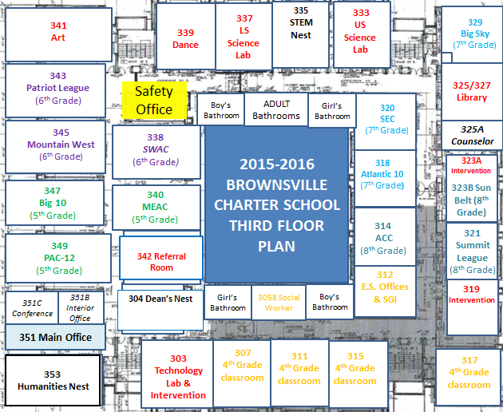

Shared Space Expectations

Keeping the Humanities, STEM, and Dean’s Nests in good working order is your responsibility as a resident of the Nest. In order to ensure that all shared spaces are maintained, each Nest Team should work together to assign roles to individual team members. These roles may include: fridge/microwave cleaner, break room restocker, supplies restocker, break room surface cleaner, work room surface cleaner, paper recycler, etc. These jobs can be rotated monthly to ensure equal opportunity.

On a daily basis, please ensure you leave shared areas looking better than you found them. Clean up after yourself and respect your teammates.

  - Throw away used K-cups, tea bags, and stir sticks
  - Wipe down tables after you’ve eaten using paper towels or Lysol wipes
  - Clean out your mug/Tupperware and return it to your desk for storage between uses
  - If you empty something, please refill it. Extra K-cups, paper plates, napkins, etc. are stored in closets (STEM Nest) or cabinets (Humanities Nest). If you use the last of something or notice a container is running low, please take a moment to refill it.
  - Recycle any papers no longer needed in a recycling bin or return blank paper to its shelf
  - Clean up and recycle or trash clippings from paper cutters and laminators
  - Be aware of what others are doing in the Nest and respect the current volume level whenever possible. The Nests are dual-purpose rooms, so it’s important to be sensitive to the work others may be doing while you’re having lunch. Nest residents are encouraged to establish their own shared space norms at the beginning of the year.

Refrigerator and Microwave Guidelines
The refrigerator should be emptied every Friday by 4:45pm by the assigned team member form the Nest team. If you don’t want your food thrown out, please make sure you remove it from the fridge by that time or clearly label it with your name and a dated note to not throw it away. Everything left unlabeled/over a week old will be thrown out – including containers.

The microwave, toaster, and blenders are for staff use and we encourage you to heat, blend, and toast away! Please clean up after each use, especially if you food spills, splatters, or crumbs.

Classroom Layout & Upkeep

Classrooms are also shared spaces and should be treated with care. Team Ops, along with our building custodial team, spends a great deal of time over the summer cleaning up, organizing, and prepping rooms for the next school year. We do a lot of work to ensure our classrooms are scholar-ready, and it’s important that our instructional staff works to keep our classrooms scholar-ready each and every day. Please ensure you always check the following before leaving a room:
  - Furniture is returned to its original formation in orderly rows
  - Any spills are cleaned up (or Team Ops has been contacted if custodial assistance is required)
  - Any garbage or supplies on the floor are picked up and placed in the garbage can or their proper place
  - The front desk with technology items is clear of papers and supplies

Classroom Must-Haves:
Team Ops will prepare all of these items prior to the beginning of the school year. As a classroom teacher, it is your responsibility to reach out if anything is missing or damaged so it can be repaired or replaced. The following materials/visual anchors will be prepared in every homeroom by Team Ops:
- College corner (includes name of conference, map, and slide for each school)
- Bulletin boards with border for Stellar Work and Math/Lit/Writing/History labels on bulletins boards
- SOARR Signage
- Supply cart in back of classroom with labelled drawers for pencils, pens, glue sticks, and highlighters
- Whiteboard with: blocked off space on whiteboard for “Library” and “School Store”, SOARR Points poster (for 5th and 6th grade rooms) and labelled magnets, Organization visual anchors: Morning materials check (includes planner for 7th and 8th grade rooms) and inside desk (only for 5th, 6th, and 7th grade classrooms), HW tracker (5th and 6th grade HRs), Scholar Dollars poster (5th and 6th grade HRs)
- Shelves with: History/Writing/Math/Literature bins along with dictionaries, protractors/calculators bin, and rulers bin; Supplies shelf (Lysol wipes, paper towels, tissue boxes, disinfectant spray, first aid kit, band-aids), Math manipulatives, Demerit concern bin, DEAR bin, and empty red bins for guided reading/reading clubs
- 2 bean bags and 2 picnic chairs
- Desks and coat hooks numbered
- 32 white boards & 32 markers w/ erasers on top of mailboxes
- 5 white boards, 5 markers w/ erasers, and 5 packs of colored pencils on intervention table
- Number line above closets (at least -20 to 20)
- 2 pencil sharpeners
- Paper towel holder near front right corner of board
- 2 erasers, 4 whiteboard markers, and 1 container of Expo whiteboard spray on ledge of whiteboard
- Classroom tech set up at front of classroom (speakers, doc cam, cord box with surge protector)
- Lunch bin (labelled on lid and side of bin) near mailboxes
- Calculator holder with number labels on calculators ( 5th have five function calculators on math shelf)
- U-table with 5 chairs in back corner of classroom
- Laptop cart with 32 laptops (each shelf labelled and each laptop labelled) plugged in at back of room
- Passes (outlined below) on magnetic hooks with room for scholars to write their name

Classroom Deep Dives:
Team Ops will conduct classroom deep dives to evaluate the cleanliness and order of classrooms. The below rubric will be used to evaluate classrooms. Please note that these ratings are not intended to be punitive, but rather to provide support in maximizing learning time by ensuring our learning spaces are favorable for student achievement. Any and all support will gladly be provided by Team Ops – just ask!
Classroom Deep Dive feedback for the 2015-2016 school year will be sent the following dates:
- Friday, August 14 (beginning of school year to ensure classrooms are scholar ready)
- Friday, September 11 - Friday, October 23
- Friday, December 4 - Friday, February 5
- Thursday, April 31 (this will include a check to ensure classrooms are NYS exam ready)
- Friday, June 20 (classroom closeout)
Who are classroom owners?
- Classroom owners are generally HR teachers (exceptions are HR teachers who also own another room – i.e. Art, Science, etc.). They are listed below for your reference.
Classroom | Owner(s)
PAC-12 | Sun, Valentine
MEAC | Joseph, Whyte
Big 10 | Holmes, Bryant
Mountain West | Shimko, Glickman
Patriot League | Goller, DeVille
SWAC | Ahokas, C. Williams
Big Sky | Cortiella, Smith
SEC | Pendleton-Knoll, S. Fox
Atlantic 10 | Gannon, Rodriguez
ACC | Laird, Cardenas
Sun Belt | Martin, N. Williams
Summit League | Uwalaka, Atkinson
Intervention (319) | Crawford, Trotman
Intervention Space (323) | Gladstone, Buffington
Art Room | Singh, Acharya
Dance Room | Goller, McCune
LS Science Lab | H. Fox, Chervin
US Science Lab | Witt, Uwalaka
Tech Lab | Duggan, Belsky

What does a classroom owner do?
- Classroom owners will receive an email from a member of team Ops with their rubric rating, glows, and suggested next steps. Being a classroom owner does not mean you are responsible for completing the next steps, but it does mean you’re responsible for overseeing that they get done – i.e. delegating and supporting follow-through.

How are classrooms assessed?
INDICATORS
CLASSROOM FEEL
- College corner present/ college paraphernalia visible throughout the classroom.
- Classroom is warm, inviting, inspirational, and colorful.
- Everything hung (walls, doors, from the ceiling) are cleanly affixed; classrooms show a "museum-like" attention to detail.
- Walls are clean and free of stray marks, graffiti, left over sticky tack or tape.
- Bulletin boards creatively decorated. Borders and fabric do not have holes or other evidence of vandalism. All work posted are exemplar, dated, and current with teacher feedback.
CLASSROOM ORGANIZATION
- Window ledges, closets, shelves, drawers and cupboards are well-organized and are litter-free.
- Every item in the classroom has a place where it belongs.
- Floors & behind doors clear of boxes, stray papers and trash.
- Lunch storage bin is clearly marked, accessible, and free of wrappers & crumbs.
- Door bin empty of all old detention/ARC rosters and is firmly attached to door
- Chairs and desks are clean and in good condition.
- Interior desk storage tidy – papers are neatly stacked, free of food items.
- There are trash receptacles for both recycling and regular garbage.
- Garbage receptacles are not overflowing. Recycling bin contains only paper (green) or aluminum (blue).
STUDENT & STAFF SAFETY
- Blue file holder contains classroom Emergency Binder with student rosters for evacuations.
- All classroom doors are easily accessible and functional. Drop-down window covers are attached above each door window and are functional.
- Classroom lights are operational and bright.
- Classroom has adequate ventilation – heating/air conditioning systems are in working order.
TECHNOLOGY
- Classroom phone is operational (easily accessible, ringer/speaker is loud enough to be heard in case of emergency).
- Phone list is posted near classroom phone.
- Projector, document camera, and speakers are present and working.
- Cords are neat and electronics are turned off when not in use.

Maintenance/Custodial Requests
Any non-urgent custodial requests should be submitted to a member of Team Ops using the Custodial Repair Request Form (see Appendix V, the shared server, or the Main office). For urgent needs (i.e. scholar vomits in class, toilet is leaking causing a small lake in the hall), please contact the SSM-C in the Main Office and he will locate a custodian for you.

The Head Custodian is named Bob, and the second in command is Jesus. The day custodian for the 3rd floor is named Abraham. Please adhere to the following guidelines to maintain good relations with our custodial staff:

- Do not dispose of liquids in the trash cans. Please use the bathroom sinks or water fountains.
- Be careful when disposing of food. Ensure that any food is fully inside plastic bag liners.
- Use the correct receptacles (see the section below)
- Have students place chairs on top of desks at the end of the day to facilitate sweeping.
- When you leave at the end of the day, you should turn off your light, all electronics, and turn off your AC(s).

Trash & Recycling
Each classroom is equipped with a trash container (gray/black), a paper recycling container (green), and an aluminum recycling container (blue). Guidelines for recycling in school are similar to NYC’s five boroughs and are outlined below. Please do not dispose of any liquids in the trash receptacles. All soluble materials should be disposed of at the nearest sink.


GREEN RECYCLING BINS:
- newspapers, magazines, catalogs
- white and colored paper (lined, copier, computer, staples OK)
- mail and envelopes (any color, window envelopes OK)
- paper bags
- wrapping paper
- soft-cover books, telephone books (paperbacks, comics, etc.)
- smooth cardboard (food and shoes boxes, tubes, file folders, cardboard from product packaging)
Large cardboard boxes should be flattened and left in the hallway each evening.
Do NOT include the following with your paper recycling:

- hardcover books
- napkins, paper towels, tissues, or paper/plates soiled with food or liquid
- paper with a lot of tape and glue
- plastic- or wax-coated paper (candy wrappers, take-out containers, etc.)
- photographic paper

BLUE RECYCLING BINS:
- metal cans (soup, pet food, empty aerosol cans, dried-out paint cans, etc.)
- aluminum foil wrap & trays
- household metal (wire hangers, pots, tools, curtain rods, knives, small appliances that are mostly metal, certain vehicle license plates, etc.)
Please empty and rinse containers before recycling.
Do NOT include the following with your metal recycling:
- single-serve food and drink squeezable pouches (yogurt to go pouches, etc.)
- 3-ring binders (if separate the metal rings, can recycle the metal)
- batteries and electronics (computers, TVs, and related devices)
- extension cords and Christmas tree lights

Resources
Available Resources
The lists below include all of the materials that are readily available on an ongoing basis. These items are refilled weekly. Please do not take more than you need at a given time to ensure they are always available for anyone who may need them. If at any time you week need a large quantity of an item listed sbelow (i.e. 30 D batteries for science class), please submit a separate supply request (see below).
Dean’s Nest | Humanities Nest | STEM Nest | Big Sky Closet | Tech Cabinet
EOY Trip Items | School supplies (i.e. Pencils, glue sticks, etc.) | School supplies (i.e. Pencils, glue sticks) | Sternos/Wire racks/Aluminum pans | Cameras  Tripods
Scholar Incentives | Paper towels/facial & bathroom tissue | Paper towels/Facial & Bathroom Tissues | Plates/Cups/Napkins/Utensils | Timers
Academic Incentives | Ink/Toner | Ink/Toner | Paper Towels/ Toilet Paper | Laptop Locks
Honor Society Awards | Cleaning Supplies (i.e. Lysol wipes, hand sanitizer, gloves, etc.) | Cleaning supplies (Lysol Wipes/ Sprays/Soap) | Cleaning Supplies (i.e. Lysol wipes, hand sanitizer, gloves, etc.) | Headphones  Extra Chargers
School T-Shirts | Folders: Hanging/File and pocket | Bathroom supplies (Air freshener, Feminine products | First aid supplies | Extra Projector, Doc Cam
Games/Game Consoles | Clip boards, Index cards | Coffee, Tea, Sugar, Creamer | Garbage Bags | Speakers
PE/Recess materials | Food supplies (i.e. cups, bowls, plates, etc.) | Fabric/Bulletin Board Border | Extra Coffee, Tea, Sugar, Creamer | Wireless Presenters

Scholar Passes
Each homeroom will be equipped with the following scholar passes:
- 2 pink Emergency Bathroom passes
- 1 yellow Main Office pass
- 1 purple Medical Main office pass
- 1 green room-to-room pass – to be filled in with room numbers using wet erase marker.
- 1 blue Library pass

These passes will include the classroom number and will be hanging on magnetic hooks on the side of the whiteboard nearest the windows. Places for scholar names will be taped off above each pass so there is always a record of which scholar(s) are in the room and which are in other locations. This is incredibly important from a safety perspective (if we have an evacuation or lockdown, we need to know which scholars are where), but also helps us to cut down on the number of passes lost over the course of the year. When a scholar takes a pass, he/she should write his/her name above the empty hook and place the pass around his/her neck before leaving the room. If at any time you notice that a homeroom has lost one of the above passes, please contact the SSM-C via e-mail for a replacement pass. Please be sure to include the type and number of passes that need replacement.

Office Supply Requests
When you require office supplies, you should:
- First, check the appropriate closets for your supplies (see lists above). Most of your office supplies will be available here. Please only take the amount of supplies that you truly need. These materials will be replaced on a regular basis, so there is no need to worry to hoard supplies because of concern that they will disappear.
- If you don’t see the item you need, please complete a Supply Request Form and e-mail it to the Director of School Operations. Be very specific (quantity, description, color, etc.) Failure to be specific may delay your order. Please see Appendix III for the Supply Request Form (also available in the Main Office and on the shared server).

Note that W.B. Mason (www.wbmason.com) and Amazon Prime (www.smile.Amazon.com) are our preferred vendors. Selecting items from these two vendors will ensure your materials can be delivered in as timely a fashion as possible.

If the item you requested is stored within the school, you will receive the item within 24 hours. Items that need to be ordered from our preferred vendors typically take 3 days to be delivered. If you select another vendor or an item that is backordered, a member of Team Ops will notify you and provide an estimated delivery timeframe.

Curricular Material Requests
Teachers who require instructional materials (textbooks, novels, manipulatives, etc.) should submit all requests to their coach for approval. Please send an e-mail (including coach e-approval or written approval) to the Director of School Operations for order to be placed.

All written curricular resources (i.e. workbooks, Teacher’s Guides, etc.) are stored in the PD Library in room 351C or the Intervention space in 323. Feel free to move a regularly-used resource to live at your desk while in use, but please return to the PD Library or Intervention space once you’re finished using it.

Information Technology (IT)

Using the Shared Calendar
All important deadlines, dates, and documents live on the AFBRMS shared calendar. You will receive an invite to the calendar from the DSO at the beginning of the school year. The calendar will take a few minutes to load the first time you use it.

In order to ensure you’re always seeing the most up-to-date version of the shared calendar (and, accordingly, most up-to-date version of schedules, minute-by-minutes, etc.), please ensure you shut down your computer nightly (as a bonus, this is also better for the life of your computer!) Outlook calendars that are connected to an internet-based calendar need to reload fully in order to update.

To access the shared calendar, follow the directions below:

- In Outlook, click on “Calendar.”
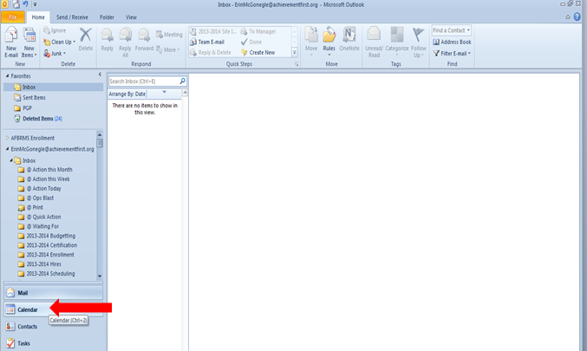

- Find “Brownsville Middle School – Calendar – SharePoint Lists” and click to check it off (turn it on).
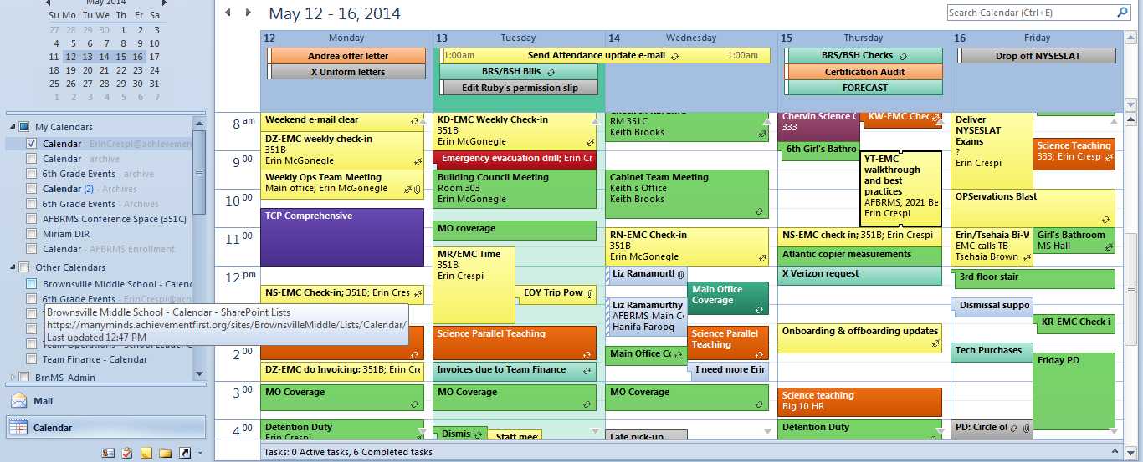

- You can adjust how your view the shared calendar by closing other calendars you have open (click on the “x”). Alternately, you can overlap two (or more) calendars by clicking on the arrow.
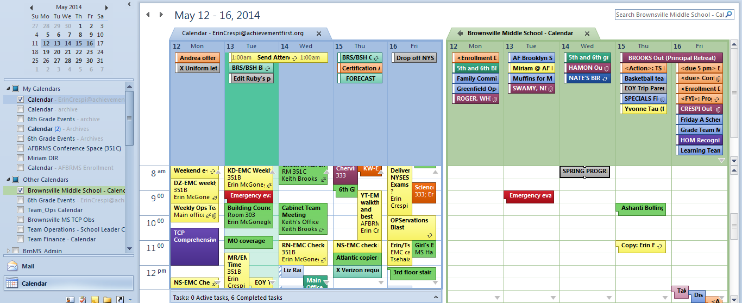

- To access details of any event (for example, a staff absence), double-click on the event.

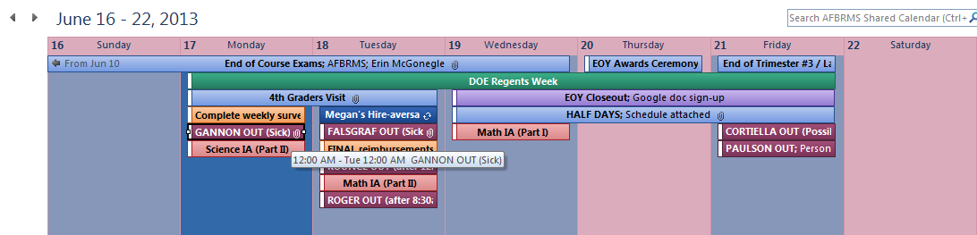

- When you open the event, you will see details of the event.
Note: In the case of a staff absence, every individual who is covering for the absent staff member will receive an individual email with the coverage. Teachers taking over lead-teaching a class will also receive a phone call or text from the absent teacher. For events, all details will be included in either the weekly GLC blast or The Screech. The shared calendar is just intended to “house” everything in one location, not to be the source of communication about events/coverages.

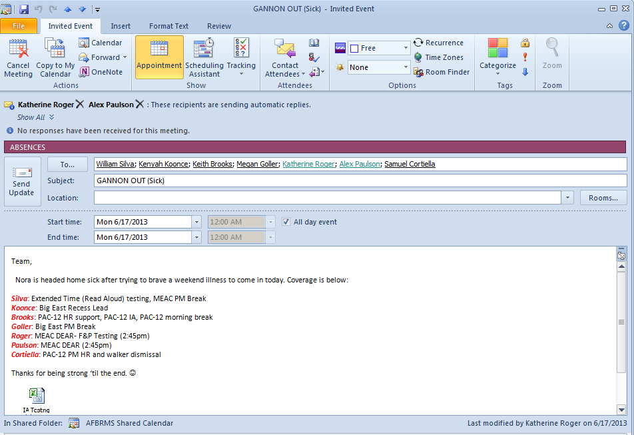

- To access alternate schedules, just click on the event description. An excel document/pdf document containing the alternate schedule will be available within the invite.
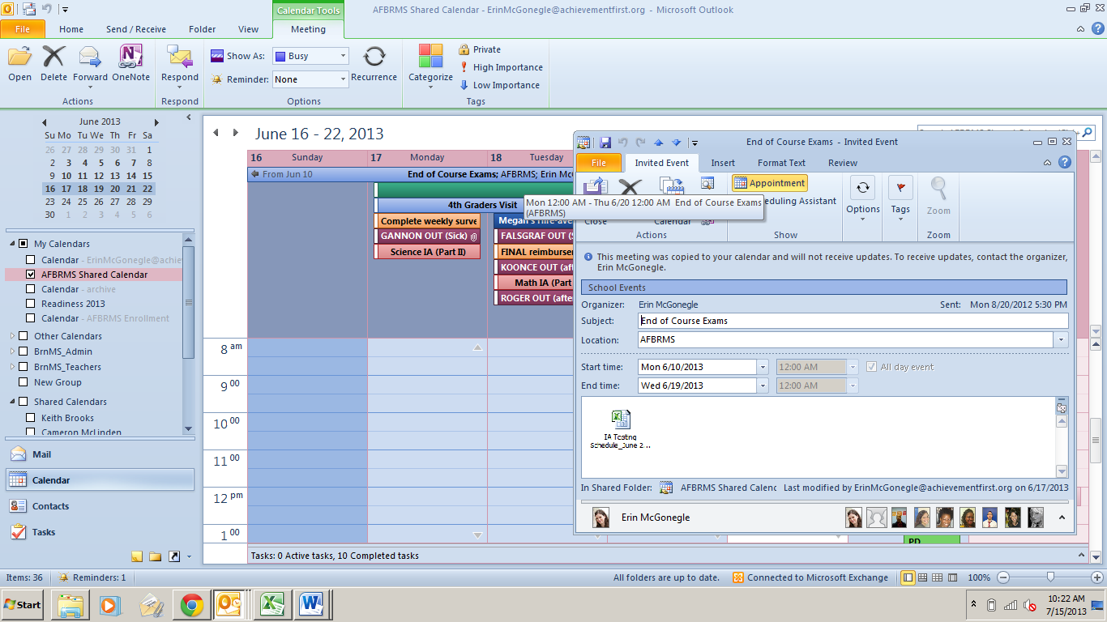

Installing a Printer on your Laptop or Submitting an IT tickets
Go to the Many Minds Homepage: https://manyminds.achievementfirst.org/ . Click the “Ticketing system” link.

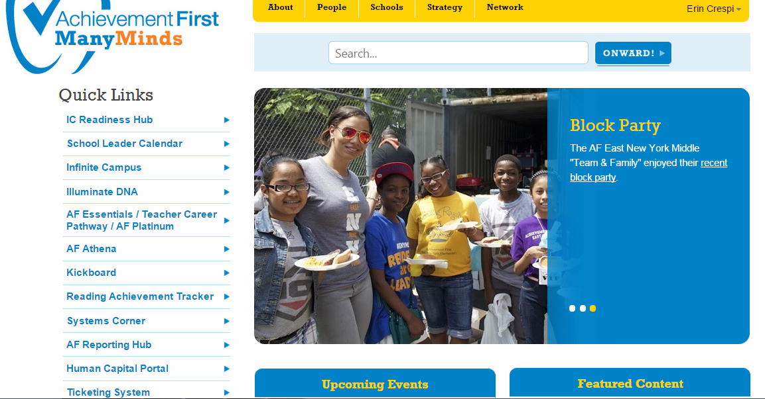

Click on the correct section of the Technology Corner - “Create a Ticket” for a technology problem or “Connect to AF Printers” to add a printer. (Note: to add a printer, you need to be working in Internet Explorer.) Technical issues will be resolved by our in-house tech staff. Vergel Mendoza is the IT team lead at AF Brownsville Middle.

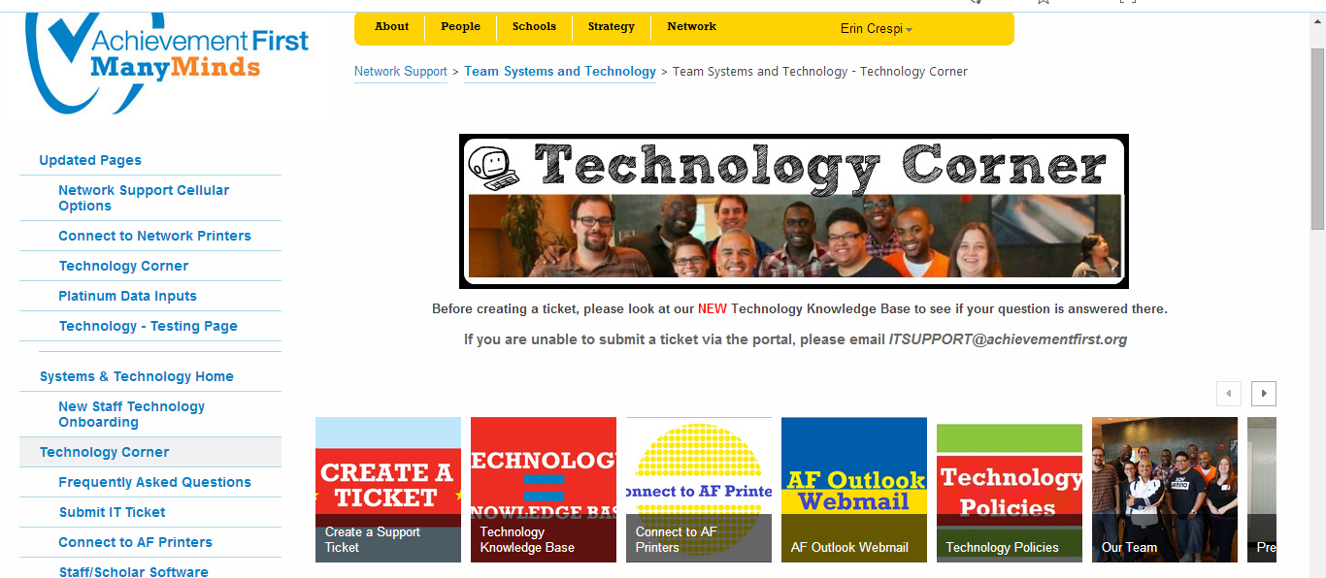

There are network printers available in the Main Office (351A), Referral Room (342), Technology Lab (303), STEM Nest (335), and Humanities Nest (353). Additionally, there is a poster printer in 335.

There are also color printers located in the Interior Office (351B) and Dean’s Nest (304) that have limited access. Color ink is EXPENSIVE (we’re talking $1,200 for a complete toner swap out) so these printer should be used SPARINGLY. You should email your color printing request to your coach or all of Team Ops (using the BrnMS_Ops@achievementfirst.org email) for printing.

Using the Poster Printer

  - To use the poster printer (located in the STEM Nest), please first ensure your file is in powerpoint format. (If you have created the file in word, excel, or another program and are not sure how to create it in powerpoint, please reach out to your coach or a member of Team Ops.)
  - When you are ready to print, select BRMS_Poster_Printer_Rm 335
  - Click on “Printer Properties” and set to “ISO A1”
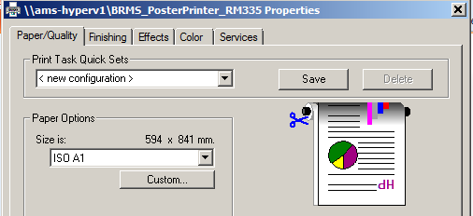

  - Click on “Full Page Slides” and click on “Scale to fit paper”
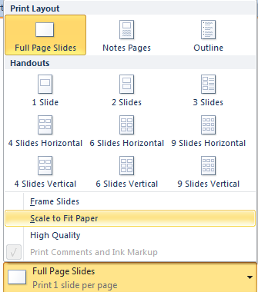

If you need any assistance with the Poster Printer (i.e. changing paper or toner), please reach out to all of Team Ops (using the BrnMS_Ops@achievementfirst.org email). In some cases, such as technical errors or jams that are difficult to remove, please put in an IT ticket (see section below for directions on doing so).

Copy Machines
Staff at AF Brownsville Middle are given full access to copiers. There are four copy machines available for staff use, one in the STEM Nest (335), one in the Humanities NEST (335), one in the Intervention Room (323), and one in the Main Office (351A). The Intervention Room copier is intended for smaller copy jobs, and so it should not be used for classroom copy jobs.

- Supplies, such as toner, waste toner bottles, and staple cartridges for the copiers are located in closets or on the shelves near each copier. To replace the toner, just follow the directions indicated on the toner box. Place the used toner cartridge in the box from the new toner cartridge and place it next to the garbage can for disposal.
- Please be courteous to others and clear all paper jams before leaving the copier. In the event of a paper jam, please follow the instructions on the LCD screen. Trying to remove the jam without following the instructions usually results in tiny bits of ripped paper hiding inside the machine, making it inoperable until they are discovered. If you don’t have the time to unjam the copier, please find a teammate to help you or contact Team Ops.
- Please do not leave your copies in or on the copy machine. There are “Copy Machine Left-Behinds” located next to the copy machines for convenient locations for you to keep your papers if you don’t want to take them with you right away. Any sheets of paper/copies left at the copy machine at the end of the day may be recycled.
- Please plan your copy jobs in advance! This avoids lines at the copier.
- If an “error code” is indicated on the machine, please first turn the machine completely off by the Main Source switch. While it is off, open all compartments and inspect the machine to remove all papers jammed. Some may be hard to see or hard to reach, but clearing the machine before turning it back on will equate to a higher likelihood of getting the machine up and running sooner. After the machine seems to be clear, turn the switch back on. At times it may take more than one attempt, but should not take many. If the error code persists, please email BrnMS_Ops@achievementfirst.org or call the main office and include the error code indicated. Once you’ve contacted Ops, please flip the sign.
- If there is an issue with the copier (you made a mistake while changing toner/staples or jam you cannot fix), please email BrnMS_Ops@achievementfirst.org immediately unless you see an “out of order” sign already posted (this indicates a service request has been placed and someone should be in to service the machine within the next few hours.) Once you’ve contacted Ops, please flip the sign.

Accessing the AF Shared Server
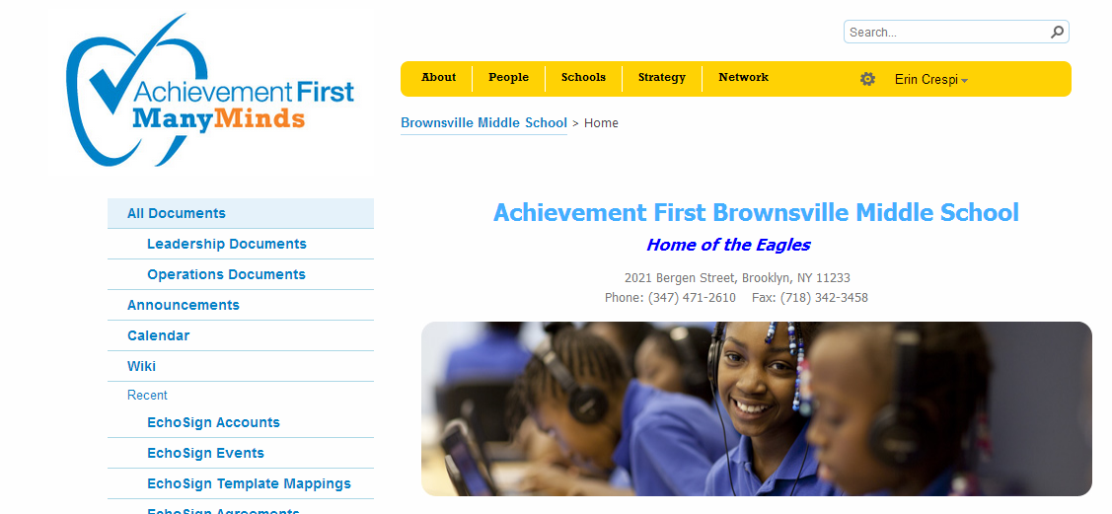
The AF Brownsville Middle Shared Server site is a great resource for Operations-related information and frequently used forms. Teachers are also encouraged to use the Shared Server to save documents. Team Operations will also keep hard copies of important forms in the Main Office.

The AF Brownsville Middle School shared server can be accessed from https://manyminds.achievementfirst.org/sites/BrownsvilleMiddle/Pages/SchoolHome.aspx.

Clicking on “All Documents” on the left side will bring you to the shared folders.

Phone & Voicemail
Each staff member is assigned a voicemail account. Teachers are expected to check their voicemail daily and their email twice each day. Phone calls and emails from families should be responded to within 24 hours on business days.

Accessing Voicemail from an AF Brownsville Middle Phone:
- Press MESSAGES (Mailbox symbol) key or dial 60000.
- Press * star key.
- Enter your ID (5-digit mailbox number) and #.
- Enter your password and #.
Setting up your Voicemail as a New User:
- Pick up any black phone (in any of our classrooms)
- Press the MESSAGES key or dial 60000.
- Press the * star key.
- Enter your ID (5-digit mailbox number) and # (these are at the bottom of this e-mail.)
- Enter your password and #.
AS A NEW USER, your default password is: 1234 #
- A new user tutorial will instruct you how to:
Record your name for the directory (which parents will be able to use when they call the Main office)
Record your standard greeting (short and sweet is perfect)
Example: You’ve reached Erin McGonegle Crespi, Director of School Operations at Achievement First Brownsville Middle School. Please leave a message with your name, contact number, and purpose of your call and I’ll get back to you as soon as I’m able. Thank you.
Enter a new PASSWORD (Minimum is 3-digits.)

Accessing voicemail outside the building/at home:
- Dial the main number of the school (718-235-2647).
- When the greeting answers, press * (star) key.
- Enter ID (your mailbox number) and #.
- Enter password and #.

NOTE: To dial an outside line, dial 9 + 1 + area code + number.

Classroom Electronics
All classrooms at AFBRMS are equipped with a document camera, projector, set of speakers, two pencil sharpeners, and wall-mounted telephone. Each teacher will be provided a portable video camera, wireless presenter remote, and timer with her/her name on it at the beginning of the school year. Like your AF laptop, it is your responsibility to keep this technology safe. These items must be returned in working condition during end of the year checkout or you will be charged for their replacement.

There are additional technology items available in room 351B including:
- Handheld video camera for higher quality video
- Extra wireless presenters - Loaner document camera
- Cameras - Loaner projector
- Loaner laptops - Loaner speakers
- Extra CAT5E cords /extension cords and surge protectors

If you are in need of any of these items, please come to 351B and a member of Team Ops can help you sign them out. Please ensure that when you return the items, a member of Team Ops signs them back in. You will be expected to reimburse the school for lost or broken items, so please be gentle with borrowed items.

Accessing E-mail from Home
See the link below to access your email from any computer: https://mail.achievementfirst.org/

You’ll need to enter your username (example: af\erincrespi) and password (the one used to log in to your computer) to gain access.

Social Networking
While using social networking websites and blogging, please be incredibly respectful and thoughtful as to what you post about AF Brownsville M.S., our scholars, and our families. It is not acceptable to post photographs of scholars and families, and it is not acceptable to post scholar work on the Internet.

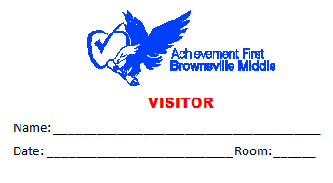
Main Office
All school visitors must stop by the Main Office to sign in after signing in and receiving a visitor badge from School Safety at the front door. If you see a guest in the hallway and do not see their Visitor’s badge, please ask them if they’ve had a chance to stop in the Main Office to sign in and receive a Visitor’s badge.

Staff Mailboxes
Staff mail boxes are located next to the Main Office in the Humanities Nest (Room 353). Mail boxes are not to be utilized as a means of storage – please remove items daily.

Please note that your personal mail should not be sent to the school. A member of Team Ops may open all envelopes and packages that are mailed to the school, unless the item is marked “Confidential.”

Packages
In the event that you need to have a package sent to the school, please make sure that the address includes the name of the school (specifying “Middle”), third floor, as well as your first and last name (please see the format below). Any packages will be placed in your mailbox or a note will be placed in your mailbox indicating the package’s location if it is too large to fit in your mailbox.
The school’s mailing address is:
AF Brownsville Middle School
C/O Your Name
2021 Bergen Street, 3rd Floor
Brooklyn, NY 11233

Commonly Used Forms
Staff can find Commonly Used Forms in the white shelf organizers above the SSM desks in the Main office, as well as on the shared server. They are also included in the Appendix of this handbook for your reference. These include:
- Tax exemption letter
- Supplies Request Form
- Timesheets
- Custodial Repair Requests

Lost & Found
The Lost & Found is located in the Main Office. Parents are welcome to come by and retrieve lost items during normal school hours. If a lost item is found in a classroom and is not claimed by a scholar, please bring it to the Main Office to be added to the collection.

Staff Expectations

Attendance & Absences

Staff Attendance Policies and Procedures
Given that we hold our students to high attendance standards, it is critical that our staff members are here every day, as well. Our AF school report card goal is that we average over 98% staff attendance. This means that almost all staff members are absent three or fewer school days and/or required professional development days, with the majority of staff missing two or fewer days.

Each AF employee is expected to maintain a 98% individual attendance goal. This equals no more than three days off per year (personal and sick days combined). When an educator is out, it creates inconsistencies and stress for students and colleagues. Because AF Brownsville knows how important staff attendance is, we offer an attendance bonus to staff members (see below for details).

Planned Absences
(Personal Days, Religious Holidays, Jury Duty, and off-site Professional Development)
Expectations
- We want to respect your personal lives and commitments, so we understand the need to take personal days. Accordingly, each teacher (and other non-summer employees) is entitled to up to three personal days per school year. Personal days cannot be requested the day before or after vacations or long weekends, except for extenuating circumstances (ie. an emergency).
- Religious holiday observances, jury duty, and approved off-site professional development do not count as an absence towards your attendance bonus. However, all should be requested as far in advance as possible to ensure the appropriate coverage for classes. For jury duty, please include a copy of your jury summons to the personal day form.
  - For example, if you observe Rosh Hashanah or Yom Kippur, please communicate with the Director of School Operations ASAP so that we can arrange coverage for you. These days are considered excused absences.
- We want to ensure that we are prepared to cover the classes and duties of absent staff members at all times. Accordingly, an absence request must be submitted to the Director of School Operations at least two weeks in advance and then approval will granted by the principal. Please note that multiple personal day requests will likely not be granted for the same day, so please ensure you submit your requests in advance. The absence request procedure is included below.
- The link to log-on to the eTime site is https://etime.achievementfirst.org/1/navigator/logon.

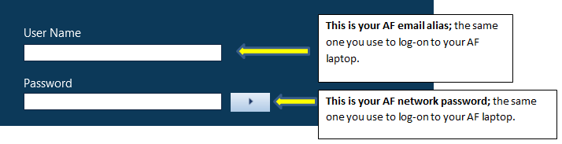
- From the “My Information” window, click on the gear shift icon next to “My Calendar” and select “Pop-Out”
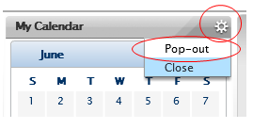
- The drop down menu will default to “Current Pay Period”. Next to the drop down menu, click on the Calendar icon.
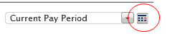
- You will be prompted to enter a range of dates. Entering dates in the future will allow you to request time-off beyond the current pay period. After entering a range of dates, click “OK”.
Example: We’re currently in the month of July, but you would like to request a day off in September.
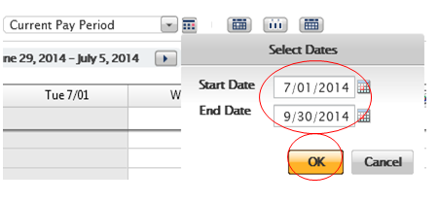

- Click on “Request Time Off”. A window will appear on your screen; enter the information as described below.

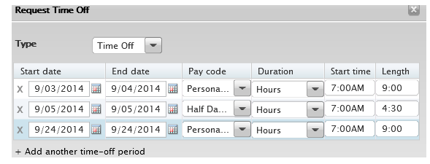
Start Date & End Date: You may enter a single date or a range of dates if you are requesting multiple days in a row. If you are requesting a time-off period that includes a half-day, you must select “Add another time-off period” and complete a separate row for the half-day. You may also enter multiple time-off requests that are unrelated.
Pay Code: Select the appropriate pay code from the drop down menu. A majority of time-off requests—weddings, graduations, family obligations—should be classified as “Personal Unexcused” or “Half-Day Personal Unexcused”.
Half-day absences: If you need to arrive after 9:00 or leave before 1:30 (Fridays included), these absences will be counted as half-day absences. The half-day policy will also apply if a staff member needs to leave work for more than 3 hours in the middle of the day. If you are requesting a half-day absence, be sure to select a code that begins with “half-day”
Tardy or Early Departures: Select this pay code if you need to arrive late or leave early for a doctor’s appointment. Before selecting one of these codes, ensure you are not taking a half-day per the guidance above.
If you are uncertain about how to classify a request, you should indicate “Personal Unexcused” or reach out to your DSO.
Duration: This will default to “Hours”.
Start Time: Enter the time you typically start your school day (round to the nearest hour).
Length: When you're entering any type of absence, you must enter a number of hours into the system so that it may translate this information into a full- or half-day.
For Full-Day absences you must enter 9.0.
For Half-day absences, regardless of the amount of time you are taking, you must enter 4.5. (Half days are counted if you arrive after 9:00am or leave before 1:30pm, Fridays included.)
For Tardies or Early Departures, you may enter a variable amount of time using a time format or decimal (i.e. 30 minutes should be entered as 0:30 or .5).
- Enter a detailed description of your request in to the “Notes” field
  - The “Notes” should include a detailed description of the nature of the request (i.e. “I need to schedule an appointment with a specialist who only works on Thursday afternoons and the medical issue cannot wait until February break” or “My mother will be getting married Friday evening in Mexico, so I need to leave Friday morning to fly to the wedding.”)
- Click “Submit”. This will send an email automatically. Once the Principal/your manager has reviewed the request, you will then receive an email approving or denying your request.
- Once approved, the absence will be added to the Shared Calendar and the Principal’s Executive Assistant will create and send out the coverage schedule. It will also be included on the AFBRMS shared calendar.

Unplanned Absences
Expectations
- If you need to call in sick in the morning or you are running late, you must call or text the Director of School Operations (Erin), the Principal (Keith), Principal’s Executive Assistant (Daisy), the Dean who oversees your content area (Math/Science – Emily, History – Kristen, Literature/Writing – Natalie, PE/Spanish/Dance – Will, Art – Cam), your coach, and the person who will be covering your classes by 6:30am (see below).
  - Erin: (773)727-3416
  - Keith: (917) 635-0726
  - Daisy: (646) 533-3574
Content-area Deans and Coaches:
  - Natalie: (216) 387-0200
  - Emily: (917) 584-8649
  - Kristen: (704) 839-1390
  - Cam: (917) 626-9480
  - Will: (917) 635-0728
  - Peter: (347) 633-5072
  - Jess: (434) 444-1459
  - Megan: (516) 435-8085
If one co-teacher is absent (either Learning Specialist or content teacher), the other teacher teaches the full class without a second teacher. In the case of History/Science/Specials (where the co-teacher is the lead teacher for another grade), the grade level Teacher in Residence (TIR) will teach the classes.
Person Absent | Subject (Grade) | Person who Teaches
Holmes | Lit (5th) | Bryant
Sun | Writing (5th) | Bryant
Bryant | Lit (5th) | Holmes
Bryant | Writing (5th) | Sun
H. Fox | Science (5th) | Valentine
Whyte | History (5th) | Valentine
Crawford | Spanish (5th) | Valentine
Joseph | Math (5th) | Duggan
Duggan | Math (5th) | Joseph
Duggan | Math (6th) | Shimko
Ahokas | Lit (6th) | Acharya
C. Williams | Writing (6th) | Acharya
Acharya | Lit (6th) | Ahokas
Acharya | Writing (6th) | C. Williams
Chervin | Science (6th) | DeVille
Glickman | History (6th) | DeVille
Goller | Dance (6th) | DeVille
Shimko | Math (6th) | Duggan
Paulson | Librarian | Falsgraf, Crespi
Pendleton-Knoll | Lit (7th) | Trotman
S. Fox | Writing (7th) | Trotman
Trotman | Lit (7th) | Pendleton-Knoll
Trotman | Writing (7th) | S. Fox
Witt | Science (7th) | Smith
Gannon | History (7th) | Smith
McCune | PE (7th) | Smith
Rodriguez | Math (7th) | Gladstone
Gladstone | Math (7th) | Rodriguez
Gladstone | Math (8th) | Belsky
Laird | Lit (8th) | Martin
N. Williams | Writing (8th) | Martin
Martin | Lit (8th) | Laird
Martin | Writing (8th) | N. Williams
Uwalaka | Science (8th) | Atkinson
Cardenas | History (8th) | Atkinson
Singh | Art (8th) | Atkinson
Belsky | Math (8th) | Gladstone
Buffington | Math Interventionist | Smith, Marzulli, Silva

For breaks, duties, homerooms, and clubs, the sub will take over for the absent individual’s duties. SUB 1 will be assigned first and then SUB 2 (when it exists) if more than one person is absent and has a break/duty/homeroom/club during that time period.

- The DSO (Mondays, Wednesdays, and Fridays) or Principal’s Executive Assistant (Tuesdays and Thursdays) will create and send out the coverage schedule. It will also be included on the AFBRMS shared calendar.
- Since all lesson plans are always uploaded onto the shared server, the covering teacher will print these for their own use. In rare circumstances (i.e. when multiple unplanned absences occur at the same time), a substitute may be called to the school. In this situation, the SSM-A will prepare the necessary lesson plans and coverage schedule information to provide to the substitute upon his/her arrival to the school building.

Helpful Rules of Thumb
  - In the event that you wake up feeling ill, but you do not have a fever or require medical assistance, it is strongly encouraged that you come to school. This helps to ensure our scholars have consistency on a day-to-day basis and helps to ensure that you are able to meet our 98% attendance goal.
- We will help provide coverage for you if you need to leave mid-day. Part of a day’s learning with you for your students is better than none of a day’s learning with you. In the event that you need to leave mid-day, please notify the Principal’s Executive Assistant and Director of School Operations as soon as possible. If you are leaving just before a planned class/duty, please take the initiative to speak with the person who will be covering for you, as well.
- We ask that staff try to schedule routine doctor appointments and other appointments on days that school is not in session – Winter break, Mid-Winter break, Spring break, and school holidays. In the rare event that this cannot happen, you need to request the time off as a personal day at least two weeks in advance (see above). If you know ahead of time that you will be out, it is your complete responsibility to prep for the lesson(s) you are missing and meet with the person providing coverage for you prior to you leaving.
- If you need to arrive after 9:00 or leave before 1:30 (Fridays included), these absences will be counted as half-day absences.
- For the purposes of attendance policies and the attendance bonus, two half-days will add up to one full day.

Because school culture is a collective responsibility and we realize that having an external substitute will impact the entire community, we have a strong preference for "internal" substitution – and we have a collective responsibility to ensure that we miss class only in rare circumstances and that we help when our colleagues are out.

Tardiness
- If someone arrives at the school after 7:10, he or she will be counted as tardy for attendance purposes. Similar to our scholar attendance policy, five tardies will result in one absence.
- AF Brownsville Middle School employees report to school by 7:10am.
  - It is highly recommended that you come to school between 6:30 and 7:05am, to make sure you are all set for your scholars and day.
- Schedules are followed tightly. Small things matter.
  - Make sure you are prepared to move to the next part of your schedule a minute before it is supposed to begin. For example: be in your arrival position no later than 7:14. (You should not be moving towards that spot at 7:15, you should already be there.)

Accountability
The most important accountability mechanism is the job itself – missing teammates in the morning make for a more hectic arrival for our scholars. If you are running late at any time – even if just by a couple of minutes or even if you think you might be able to make it on time – please contact the team to let us know. This prevents the chaos associated with last-minute coverage requests or unfilled posts.
- If an issue of tardiness or absences – especially unannounced tardiness or absences – occurs, it will be addressed by a coach or member of Team Cabinet via email or in an in-person conversation.
- Additional incidents within a trimester will lead to an increased accountability system and/or support plan for the individual. Repeated failures to meet professional expectations may results in consequences up to and including termination.

Attendance Bonus
At the end of each academic year, AF awards attendance bonuses to all full-time school-based staff members (teachers, operations staff, and all other full-time employees) to recognize individuals who have been in attendance during regular school days and professional development days. The bonus system rewards excellent attendance based on the following formula:

Days missed | Bonus
0 | $1,000
1 | $750
2 | $500
3 | $250

Attendance bonus payments are made after the end of the academic year (generally on the August 15 payroll cycle). Note these bonuses may be subject to different taxes, per IRS regulations on bonuses. The attendance bonus is based on total days missed during the regular school year, including absences accumulated from half-days and tardies. The regular school year is defined as all school days plus required professional development days. If a staff member is absent due to pre-approved, school-related business (e.g. attending a conference, visiting another AF School, etc.), the absence will not count as a day missed. Other allowable absences include paid disability and childcare leave, military leave, jury/witness duty, bereavement leave, religious holidays, and principal-approved professional development. In exceptional circumstances, a Principal has discretion to allow a missed day not to count against the attendance bonus.
Staff members who join AF after the start of the academic year and meet all the other requirements to be eligible for the attendance bonus shall receive an attendance bonus pro-rated by the portion of the academic year they worked at AF. If a part-time staff member becomes full-time during the academic year, he or she is eligible to receive an attendance bonus pro-rated by the portion of the academic year the staff member worked full-time
Only full-time staff members or staff members on flexible work arrangements are eligible for the attendance bonus. The bonus listed above is based on a full-time staff member working at least 40 hour work week. Staff members eligible for the attendance bonus and working less than 40 hours (on a flexible work arrangement) shall be paid a pro-rated attendance bonus, as per the following formula: Percentage of the workload multiplied by the earned bonus amount for the number of days missed. For example, a social worker, who works 30 hour per week, and was absent on three (3) school days, would be eligible for a bonus of $187.50 (30 hours/40 hours x $250).
Staff members who leave AF before the end of the academic year are still eligible for the attendance bonus; however, any remaining work days in the academic year will count against the attendance bonus calculation. For additional details on the AF attendance bonus (especially as it relates to non-instructional staff) and updates attendance policies, please review the AF Employee Handbook in the Personnel folder on the Shared Server, which supersedes this handbook.

Family Communication Expectations
At AF Brownsville MS, we have an open door policy.
- This means that families are permitted to visit the school and are warmly welcomed to observe in classrooms anytime the school is open. We ask that families make an appointment 24 hours in advance for observations, but in some circumstances, we allow families into classrooms without prior notification.
- During instruction, meetings and conversations with families should not occur, because it detracts from instructional time for the other scholars. Families are notified of this expectation via the Family Handbook at the beginning of the year.

Phone Calls, Texts, Emails, and In Person Conversations
- We do not require that teachers or any other staff member outside of the Cabinet Team give families their cell phone number. However, this is a best practice, and it will help you build stronger relationships with your families.
- Please do not give out any colleagues’ personal phone numbers without their consent (it is absolutely fine to provide their voicemail extension to a parent or family members.)
- Families and AF Brownsville sign a contract that states all conversations will occur with a collegial tone. For any conversation that violates this, we reserve the right to terminate that conversation. If you have communication with a family member that violates this commitment, please contact your coach and principal immediately to problem-solve next steps. If the problem continues, Keith will help you establish further steps with the family.
- If you hear a compliment from a family member about a colleague, please pass it along. We all receive many a day, and it “refills everyone’s buckets” to hear them shared.
- If you get the sense that a family member is feeling frustrated with their experiences at school, contact your coach and Principal’s Executive Assistant immediately and encourage the family member to speak directly with the source (please take both action steps). Setting up a meeting with a school leader to find good solutions helps tremendously to build a culture of Team & Family with our families.
- Our families are best supported by AF Brownsville when they can see, hear, and feel that everyone on staff is rowing together.
  - Please refrain from gossip or encouraging divisiveness when building relationships with families.
- Staff members are expected to check their voicemail daily and their email twice each day.
  - Phone calls, texts, and emails from families should be responded to within 24 hours on business days (Monday-Friday with the exception of holidays).

Sharing Academic and Behavior Information with Families
- Staff members with the strongest family relationships hold 3 times as many positive conversations as negative.
- Staff members with the strongest classroom culture share both academic and behavior information consistently. Additionally, they “land the plane” in difficult conversations and make sure to follow up with positive reports once the problem is fixed.
- Staff members should make a strong effort to get to know families personally, especially at the beginning of the year.
- Our staff intervenes and provides extra support to individual students constantly. Families love to hear when this is provided for their child. Please be sure to pass along this information to them.
- If a scholar is referred in our class, it is your responsibility to call the family THAT DAY whenever possible to discuss what happened (and always within 24 hours).

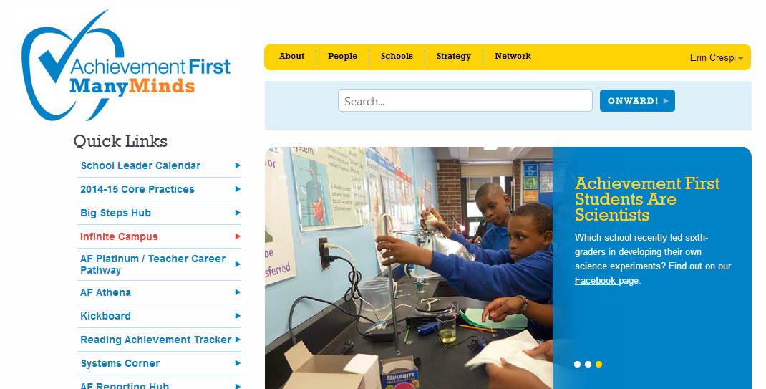

Logging Family Communications
All communication with families (whether over the phone, via e-mail or text, or in-person) should be logged in IC within 24 hours of the conversation. To log a family communication into IC, please follow the steps below.

- Go to the Achievement First staff member home page at https://manyminds.achievementfirst.org/ and click on “Infinite Campus”.

- After logging in to IC, click on the triangle next to “Student Information” to expand the selections. Click on “PLP” and then “General”
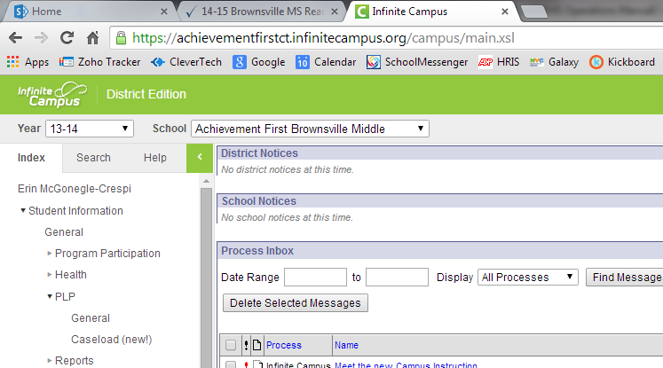

- In the search bar, type in the LAST name of the scholar you are searching for. (If for any reason you cannot remember the scholar’s last name, you can type in “,FIRST” to search by first name. For example, I could search for Justin Jones either by searching “Jones” (see image on the left) or “, Justin” (see image on the right).
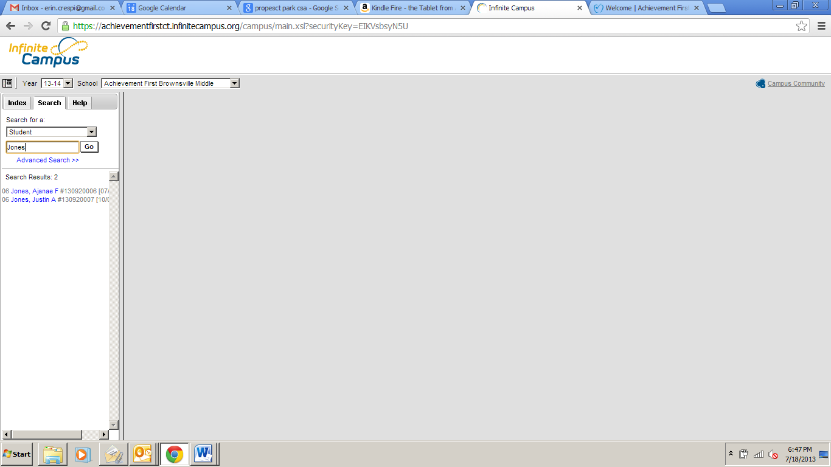
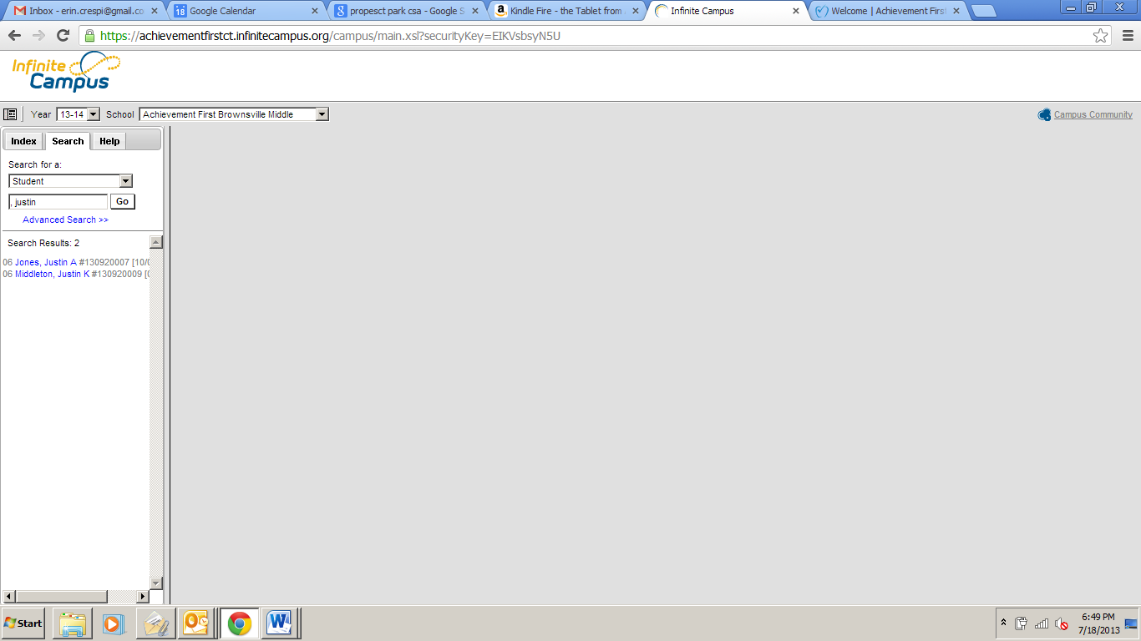

- Once you have found the scholar you are looking for, click on his or her name. This will open the scholar profile. Click on “Contact Log” along the top tabs.
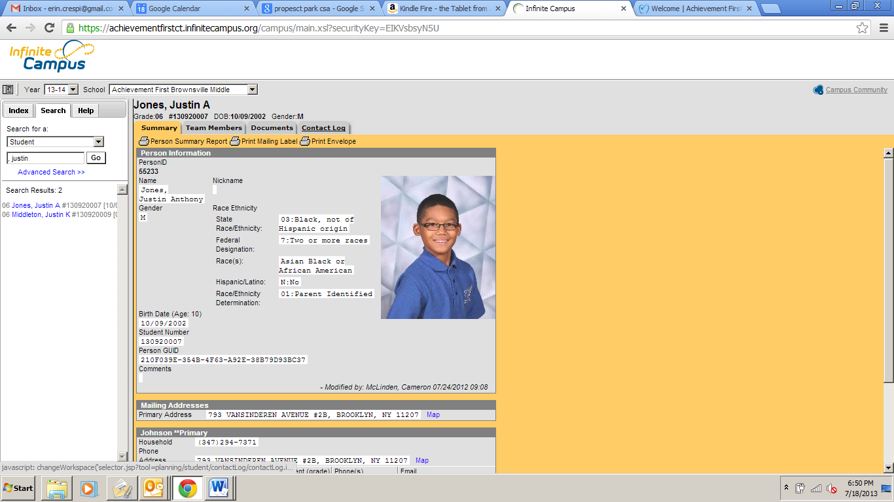

- When the contact log opens, click on “new” to add an additional contact.

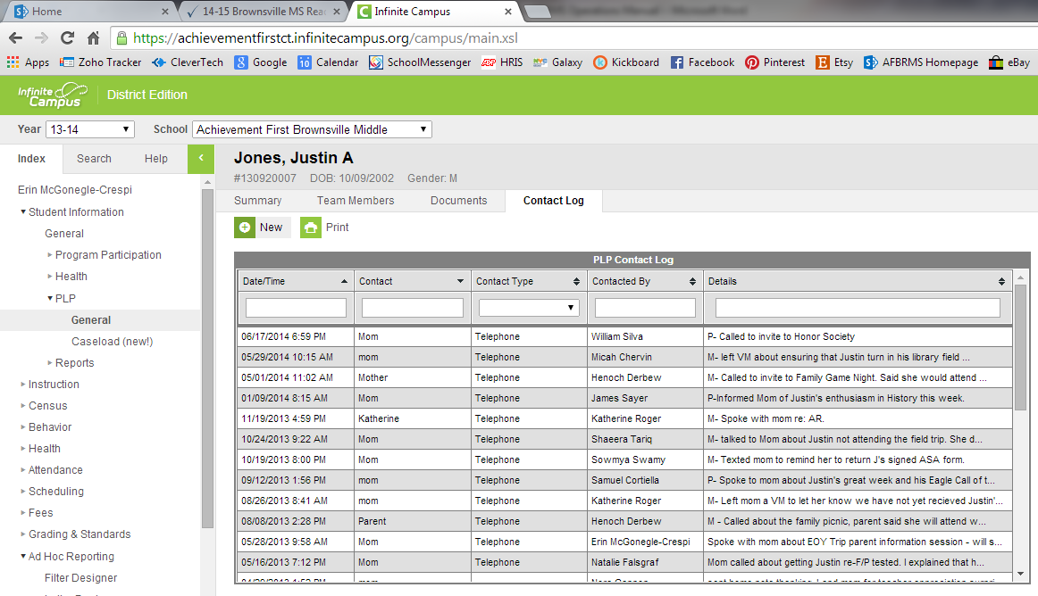

- Fill in the contact details and click “save.”

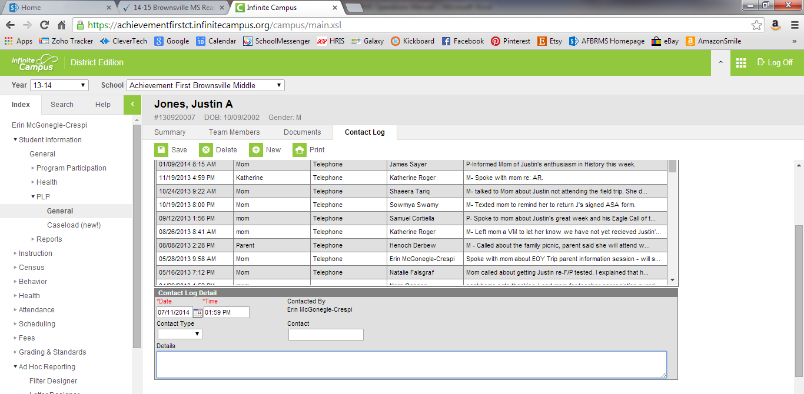

If you are making a positive contact, in the “text” box please type the letter “P” before describing the contact.
If you are making a maintenance contact, in the “text” box please type the letter “M” before describing the contact.
If you are making a negative contact, in the “text” box please type the letter “N” before describing the contact.

Staff Dress Code
All employees are expected to dress appropriately and professionally. This sets a tone of respect and professionalism for students, families, and visitors. We ask our scholars to dress professionally to show that they are part of an academically-focused team. As part of the Brownsville Middle School Team and Family, we promise our parents, scholars, and future teammates that we are a school where staff presents themselves in the most professional and respectful of manners.

Monday through Thursday
- Men should wear a shirt, tie, belt, and dress pants/slacks or nice khakis.
  - Jackets are not necessary, but are welcome (especially on “suit Wednesdays” )
- Women should wear dress slacks, nice khakis, or a dress or skirt with either a button down shirt, blouse sweater or other professional top.
  - Women may also wear dresses or suits.
- On School Pride Mondays (every Monday ), you can also elect to wear your AF Brownsville Middle School royal blue (LS) or red (US) polo shirt with professional bottoms. All black pants/skirt and shoes are nice to complete the look, but not mandatory. Black sneakers are also permitted on Mondays, or your three year hiriversary converse.
- Staff members who engage in a lot of physical activity during the day (i.e. Dance/Fitness/ Physical Education teachers) will have slightly different dress codes due to the expectations of their role.
Monday through Thursday Attire to Avoid
All employees should not wear
- denim (tops, bottoms, or overalls) unless it is a special dress-down day (see below)
- shorts
- sneakers, sandals, or heels without a back strap or that are open toed. Additionally, canvas shoes are considered too casual for regular professional attire. Staff members who teach Dance/Fitness/Physical Education may wear sneakers to work.
- leggings as pants, or any other tight fitting pants. (A good rule of thumb is that if you have to think twice when you’re getting dressed for work, it’s best to save it for a non-work event.) Leggings are acceptable, if they are combined with a skirt or dress that goes to approximately an inch or two by the knee.
  - During the day you will be doing a lot of moving around, reaching, and bending. Before coming to work, please make sure that your clothes do not become revealing or too short in any of these positions.
- “loud” clothing that may distract from learning.

- Please tuck in shirts on all outfits that are meant to be tucked in.
- Skirts and dresses should be no shorter than two inches above the knee.
- Corduroy, sweatpants and casual fabrics commonly associated with relaxation gear should not be worn. Staff members who teach Dance/Fitness/Physical Education may wear fitness clothing so long as it is not overly tight.
- Spaghetti straps shirts should be avoided or covered during the school day.
- Hats and sunglasses should not be worn inside of the building.
- If students or families are in the building, remain in professional dress (eg. arriving at school in flip flops is certainly okay, but by 7:14, shoes are exchanged for the professional version).
  - After school, there are many events and student programs. Family members are present during these events, so professional dress should be followed after school as well. Please feel free to change into more comfortable, casual gear immediately before leaving the building, but not if you are planning to stick around in the building longer.

Fridays and Field Trip Attire
The difference in clothing on these days is not about being more casual; rather, the goal on these days is to promote college-awareness and to enjoy AF or grade-team pride. Please note that the bullet points above regarding tight or short items of clothing, and other overly casual attire pieces, apply on these days, as well.
- Staff may wear an Achievement First or college t-shirt, college polo shirt, or college sweatshirt with professional pants, khakis, or corduroys.
- Staff members may wear sneakers or canvas shoes on these days.

Staff Only Days (i.e. Data Days, Professional Development)
- Since scholars are not in the building, staff may wear casual gear on these days.
- Please ensure that the guidelines above regarding overly tight and short clothing are still followed.

Accountability
- If you are not adhering to the dress code, it will be addressed by a coach or member of Team Cabinet via email or in an in-person conversation.
- Additional incidents within a trimester will lead to an increased accountability system and/or support plan for the individual. Repeated failures to meet professional expectations may results in consequences up to and including termination.

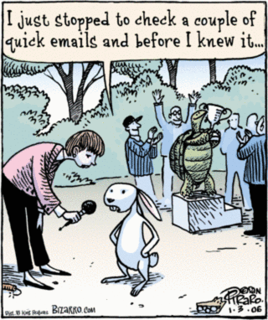
Staff E-mail Norms
E-mail is a wonderful way for us to communicate logistics for upcoming events, ask questions, and assign or follow-up on action items. However, a full Outlook inbox can quickly become our worst enemy. In order to ensure everyone in our building has time to focus on what’s ultimately most important – student achievement and character development – we have a few e-mail norms that we ask you work to uphold.

- Avoid one-off group e-mails when possible. If you
want to communicate the details of an upcoming Field Lesson or send a reminder to
homeroom teachers about having scholars bring in shoeboxes for science class (or any one of a number of other things), we ask that you use one of our established e-mail blasts.
E-mail Blast | Sent | Sent by
Culture Blast | Daily before school | Dean of Students (Will)
The Screech | Friday afternoon | Director of School Operations (Erin)
Special Services Blast | First Monday of month | Dean of Special Services (Kristen)
Grade Level Blast | Wednesdays | GLC (5th – Steph, 6th – Megan,  7th – Jess, 8th - Alli)

If you would like to submit information to go out in one of the above blasts, please send it to the person sending the blast at least 24 hours in advance. Please use the e-mail subject <Name of Blast Item>: Description of Item (i.e. <The Screech>: Updated IA schedules)
- E-mail should only be used when our expected response time is 24 hours or more.
While e-mail is a great way to communicate with our Team & Family, it should not be used for emergency situations or urgent requests. Anything requiring a day-of response should be communicated in person. (Note: the one exception to this rule is our Team Ops, who generally is able to handle in-the-moment requests. However, if you send an e-mail requiring an immediate response to a team member and do not receive the needed response, please see them in person to ensure your request is met.)

- Always include a deadline and expected action with your e-mail. Whether you need a response in exactly 24 hours, or are sending a thought to be discussed in 24 days, ensure this is clear in the subject and body of the e-mail (see examples below). Additionally, the receiver should know without even opening your e-mail whether he or she has to complete an action within a certain timeframe. Examples of subjects that meet these criteria:
<Action Requested by 7/18 EOD>:
<Review Requested by 8/2 @ 10am>:
<Reply Requested by 9/19 @ 8am>:

Examples of “special case” subjects:
<FYI >:
    - An FYI indicates to the receiver that no action is necessary. This is best used when sending an e-mail with information you’d like to review during a check-in or later meeting but do not expect the receiver to review in advance.
<Quick Action Requested >:
<Quick Question>: or <QQ>:
Both of the above should be used sparingly and only where the action or questions are actually quick to complete/answer (i.e. less than 2 minutes). The request is that the receiver gets back to you with the information or confirmation that the task is complete as soon as they are able, but remember that they have up to 24 hours based on our norms.
- Use e-mail conventions to help teammates navigate your e-mail.
  - Questions should be in BOLD font
  - Action requests should be BOLD and highlighted
  - Whenever possibly, use bullets instead of long strings of text.

Example of an e-mail that makes for happy teammates:
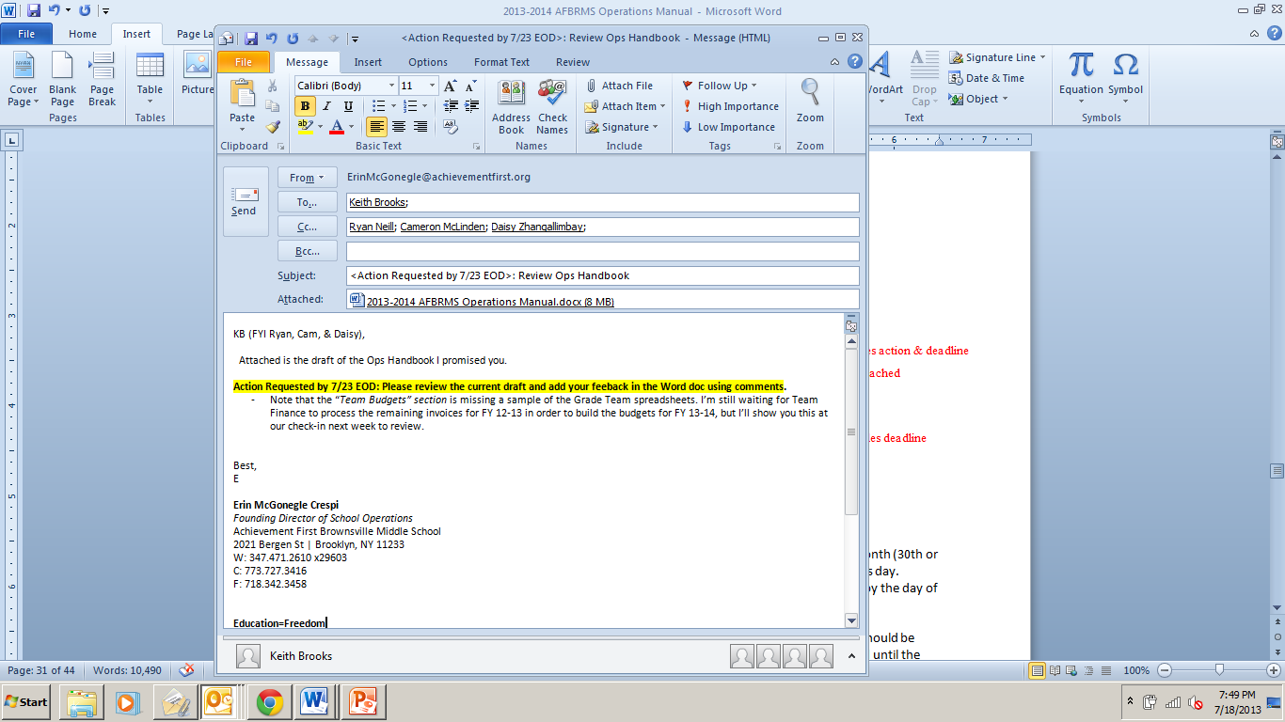
Clear subject indicates action & deadline
Necessary document attached
Clearly addresses one person and purpose of copying others
Action step in bold and highlighted; includes deadline
Anticipated question addressed.

- Avoid the “reply all” and “!” button.
Need we say more? Nothing ruins a good e-conversation quite like an unnecessary reply all or a misused panic-inducing red exclamation point.

Benefits & Payroll

Payroll
Paychecks are given twice per month and are dated for the 15th and the last day of each month (30th or 31st). In cases when those dates fall on a weekend, payroll occurs on the preceding business day. Paychecks are placed in staff mailboxes by the day of each payroll. Note that if you are receiving direct deposits, you will receive only one hard copy of your pay stub. To access your paystubs online, follow the directions below:
- Go to https://ipay.adp.com .
- Click on “First Time Visitor? – Register Now”. On the next screen, please choose “Register Now” again.
- Enter the Registration Pass Code which is: ACHIEVE-123 (case sensitive).
- Enter your information on the “Verify Your Identity” screen.
- Enter your contact information.
- Select security questions and answers.
- Your username will then be displayed. Please make note of this for your records.
- Create a password and click “Submit.”

For hourly employees, timesheets (see Appendix VI) should be submitted to your supervisor every two weeks for approval. Late timesheets will not be paid until the following payroll cycle.

Reimbursements & Team Budgets
Before using personal funds for work-related expenses, staff members should consult with their Grade Level Chair to ensure that the expense is included in their Team Budget (see below) or with their Coach for expenses not related to grade level teams. Whenever possible, all purchases should be made by the Director of School Operations.

Please remember the following when making work-related purchases.
- AF Brownsville Middle is a tax exempt organization and cannot reimburse for taxes. Please make sure to use AF Brownsville’s tax exempt letter and number (26-2243094) when making purchases in order to avoid being taxed on your purchase. Our tax exempt letter can be found on the Shared Server, in the Main Office shelf organizers, or in Appendix I.
- Please make sure to keep all your receipts and attach them to your reimbursement request. Reimbursements cannot be processed without itemized receipts (receipts that list each individual item purchased).

Reimbursements should be submitted within 2 weeks of the purchase. Staff members will be reimbursed for approved expenses through an additional payment direct deposited into their account following receipt of the reimbursement on Concur. The reimbursed amount will not be subject to payroll tax. Reimbursements typically take 2 weeks to process. In order to submit a personal reimbursement, please follow the steps below.

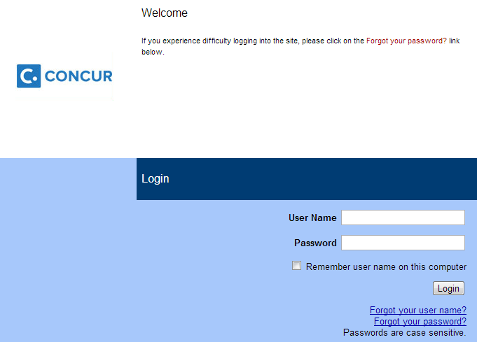
Set up your own Concur account
- Open concursolutions.com
- Sign in using the username (email including @achievementfirst.org) and password (welcome).

- Update your profile:
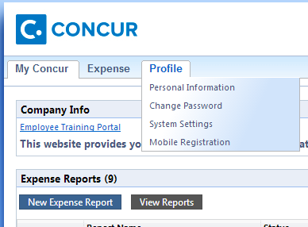
  - Change your password:
    - At the top of the My Concur page, hover over Profile.
    - On the drop-down menu that appears, click Change Password.
    - Follow the prompts to change your password and click Submit.

Create your new expense report
Create the report:
  - On the My Concur page’s Expense Reports box, click New Expense Report. 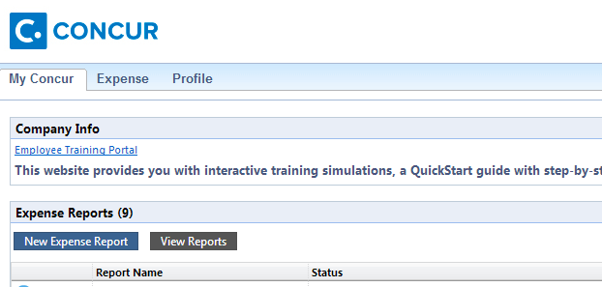
In the Report Name field, enter a name for the expense report, e.g., Feb-March 2014 Expense Report.
  - In the Business Purpose field, enter the business purpose for the expense report.
    - In general, it is recommended that you submit one report per month, so you might fill in Business Purpose with “August 2015 expenses”
    - Sometimes you may wish to fill out an expense report for a specific set of transactions. For example, you may need to send a PD trip expense report. In those cases, your Business Purpose should reflect that (e.g., “Oct 2015 NSTA Trip”).
  - Complete all required fields. Required fields are indicated with a red bar.
- How do I know what my Function is? The default value is Program Non-Specific. You can leave this as is.
- Should I fill out the Comments? You should fill out the comments to specify what the expense was for (i.e. “5th grade EOY team dinner).
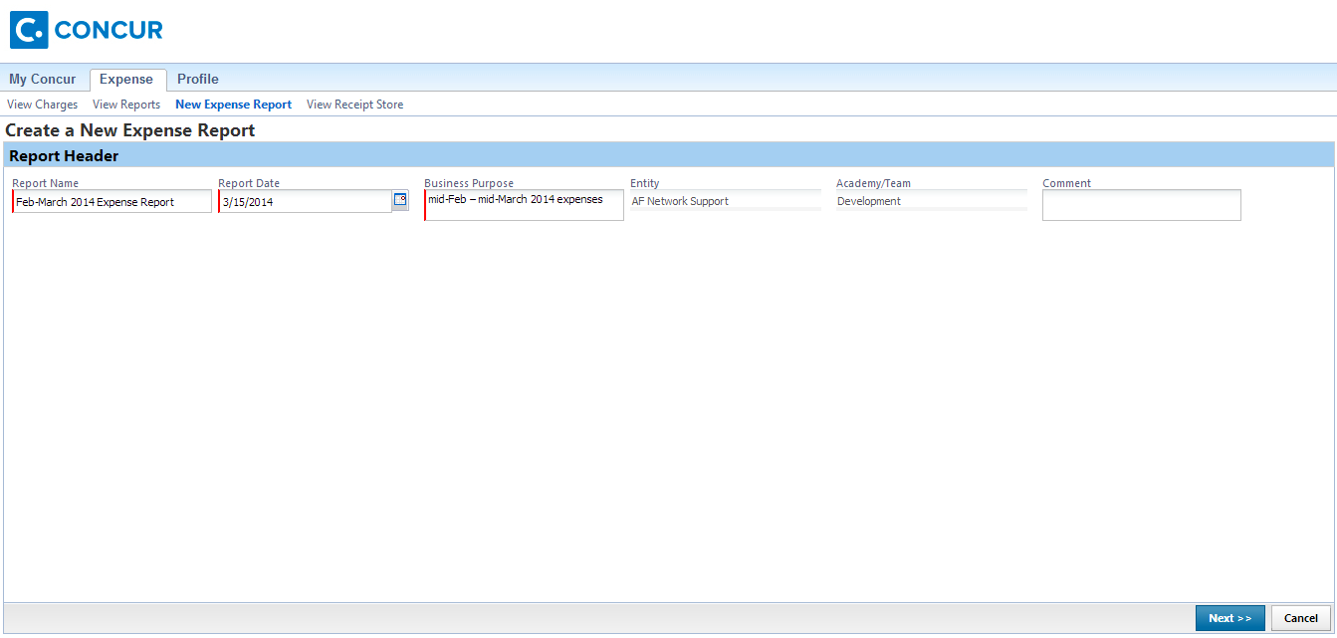
  - Click Next.

Add any out-of-pocket expenses:
  - On the New Expense tab, select the appropriate expense type.
  - Click the Transaction Date field, and then use the calendar to select the date of the transaction. This field is always required.
  - In the Amount field, enter the amount spent on the expense. This field is always required.
  - Attach the receipt. You may submit files of these types: .png, .jpg, .jpeg, .pdf, .html, .tif or .tiff. There is a 5MB limit per file. Click Save.
  - Repeat these steps for each out-of-pocket expense.
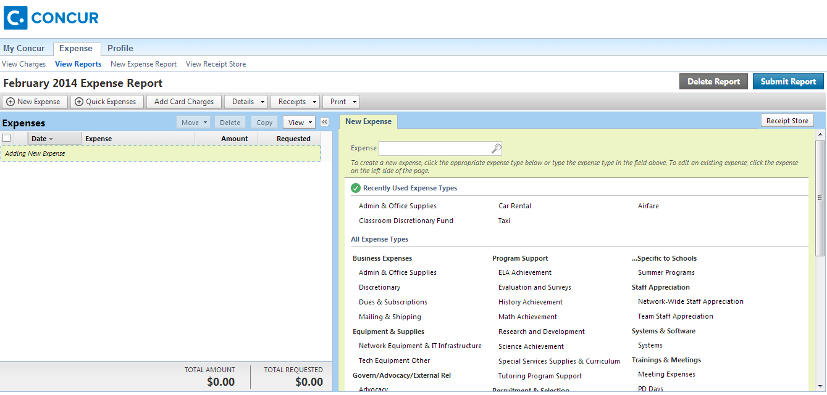
- Return to My Concur or Submit your report: If you are ready to submit your expense report for approval, click on Submit Report at the top right. If you would like to add more expenses later (e.g., more out-of-pocket expenses from later this month), you may return to the My Concur screen; all expenses are saved in your draft report.
Before you submit an expense report, you may edit it or add to it. You should also review any exceptions.
- From the My Concur page, click on the desired expense report.
- Make any necessary changes to this page.
- If you need to change any information the Report Header (including the Report Name, Report Date, Business Purpose, and Comments), use the Details drop-down menu to navigate to it.
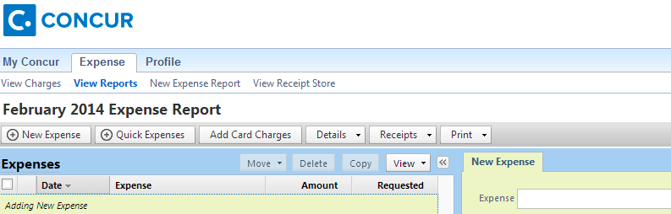

- If Concur has found an exception in a transaction in your expense report (e.g., a field is missing), that exception will be listed in the Exceptions box. You must review any exceptions before submitting the expense report
  - Click the exception that you want to review.
  - Fill in all required fields.

Submit your expense report
- From the My Concur page, click on the expense report you wish to submit.
- At the top right, click on Submit Report.
  - Concur now sends a notification to your approver. If your approver has any questions, he or she can send you a message within Concur or via email as usual.
  - You will receive a notification when your expense report has been approved.
Note that Concur also has a fairly user-friendly app that allows you to submit your expenses in real time (taking pictures in the moment of your receipts using you phone and uploading directly into the Concur app). If you are likely to have a lot of personal reimbursements (i.e. GLCs, Deans), it is recommended that you download and use the app to simplify the process of submitting reimbursements
Each Grade Level Team has its own budget, which covers grade-level Field Lessons, Scholar Dollar trips, EOY trips, other grade-specific student incentives, and staff appreciation items. Grade Level Chairs oversee spending and tracking of grade level expenses and will receive training from the Director of School Operations. A sample grade-level budget is included below.
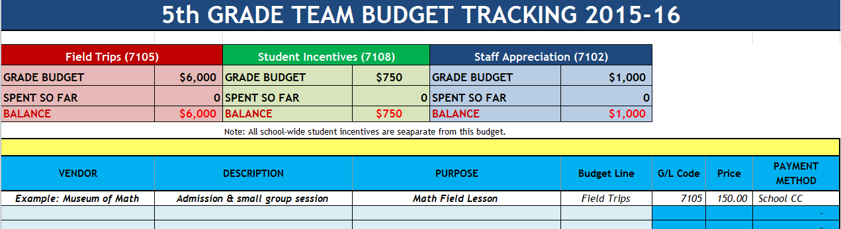

Benefits

Health
Achievement First offers a wide array of benefits to all full-time employees. Benefits provided include comprehensive medical, dental, and vision insurance, short- and long-term disability insurance, life insurance, back-up care, and a 403(b) retirement plan.

Need to find a medical provider? Need to find a dental provider?
Aetna Provider Directory: http://www.aetna.com/docfind/home.do

Need to find a vision provider?
Guardian Vision Provider Directory: http://www.geoaccess.com/guardian/po56/Begin.asp

403B (Retirement Plan)
Thomas Lynch, Financial Advisor
VALIC Financial Advisors, Inc.
Cell: 917-628-0014
Office: 800-780-6270 x87352
Thomas.Lynch@valic.com

TransitChek
Our school participates in the TransitChek program, which allows you to purchase your Metrocard with pre-tax dollars via a deduction from your paycheck. Signing up for TransitChek allows you to receive an unlimited ride Metrocard. The card is recharged automatically every month through deductions from your paycheck.
There are 4 easy steps to sign up:
- Register at www.transitcenter.com by clicking on “TransitChek Premium Log-In” in the bottom right hand corner of the homepage.
- You will need the following information to register:
  - Company Code: PZK72
  - Employee ID: AF email alias (e.g., my email address is erincrespi@achievementfirst.org so my Employee ID for Transit Center is erincrespi. Note that if the name you go by is different from your payroll name, your employee ID will be your payroll name. For example, a staff members whose legal name if Donald Ryan Neill, but goes by Ryan Neill, will have the employee ID donaldneill.)
  - Location: AF Brownsville Middle
  - Date of Birth & Mailing Address
- Select your Transit benefits and the amount of the monthly benefit. Note, the IRS maximum is $130/month. This must be done by the end of a month in order to receive the benefit in two months. If you miss the enrollment window for this month, you can sign up for the following month.
- Receive TransitChek benefit at your home at the beginning of the benefit month (typically within 1 month of your enrollment). If you order the QuickPay Visa card, the funds will be automatically loaded onto your card every month after enrollment.

Gym Membership
Achievement First Staff members receive a slight discount on either one Crunch location of your choice or all Crunch locations in the city.
- One Crunch membership is $63.99 a month (regularly $74.99).
- All Crunch membership is $74.99 (regularly $94.99).

Backup Dependent Care
Achievement First Bright Horizons is a program (free to all full-time team members) that provides temporary child care or adult care for your loved ones of all ages, whether they are healthy or mildly ill. All team members are eligible for up to 75 hours of care per year (the first 30 hours are at no cost to the employee).
Register online at https://backup.brighthorizons.com/Login.aspx
Username: Achieve
Password: care4you
Phone: 877-242-2737

Additional Benefits
Additional benefits information (including back-up care and information about leave policies) can be found by going to the AF benefits website, achievementfirst.benergy.com, and entering:
Username: afnyschools password: educateny

Scholar Attendance

Daily Attendance Entry (Infinite Campus)
Scholars are marked ‘Absent’ if they arrive after the clock turns 7:30 a.m. These scholars will come through the Main Office and enter class with a yellow tardy pass.
Attendance is entered every morning between 7:40-7:45am by the homeroom teacher designated as the primary person responsible for this task. As soon as A.M. Homeroom begins, every student who is not present should be marked absent in I.C. Any scholar who arrives late with a yellow tardy pass should be marked as tardy.
Index => Instruction => Attendance
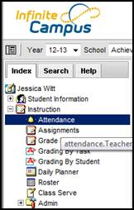
Select the class from the drop down list above.
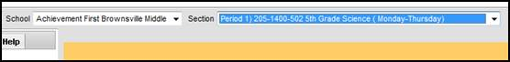
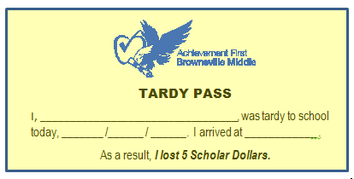
In the scholar list that populates below, mark all scholars not present as ‘Absent’.
All scholars who arrive to the school after 7:30 a.m. enter through the Main Office, sign in, turn in homework, and receive a dated and timed yellow Tardy pass. Scholars that arrive late without such a pass, and/or were not accompanied by another staff member, should be sent to the Main Office immediately to sign in.

Scholars that arrive to homeroom with a Math Pre-teach pass should be marked ‘Present.”

Scholars that arrive to your homeroom with a yellow Tardy pass should be marked ‘Absent’ (if they arrived after attendance is complete at 7:45am) or as ‘Tardy’ (if they arrived by the time attendance is being taken). All tardies will be reconciled with the Main Office Tardy Log.
Attendance is due daily by 7:45 a.m. It is essential to scholar success at our school that attendance is taken daily and in a timely fashion. If scholars are marked ‘Absent’, then they receive phone calls as soon as possible and the task of getting them to school is the Main Office’s primary concern. Without fast and accurate attendance, these calls don’t happen, don’t happen effectively, or in the worst case scenario, alarm the parent (as happens when the student is incorrectly marked ‘Absent’ even though they are actually in class).
If a mistake is made in taking attendance, the teacher is having issues with entering the attendance in IC (it is down, the internet is down, or a computer has frozen), then the correction or the names of all absent scholars should be reported to the Main Office as soon as possible via phone, e-mail, or a handwritten note.
If a teacher takes attendance but is going to be absent during that day or period, it is that teacher’s responsibility to ensure the individual in charge of coverage for the homeroom period is able to take attendance prior to the day or morning of the absence.
Absences
Scholars are allotted up to 15 absences throughout the entire school year. There are no excused absences – all absences are up to the discretion of the parents/guardians, followed up with by the SSM-C and possibly School Counselor or Principal, and recorded in I.C.
Scholars who reach 15 absences, or are on pace to do so, are considered to be Promotion-In-Doubt (PID). Included in this calculation are tardies and early dismissals, which count for 1/5 (0.2) of an absence and are discussed below.
When a scholar is absent, the scholar loses their daily Scholar Dollar deposit of $20. The scholar is also held responsible for self-advocating and collecting missed work/information after returning (which should be placed in his/her mailbox on that day that he/she is absent).
Absences are exempt under rare circumstances, including death of a loved one, hospitalization, and religious observance. In this case, the scholar is not penalized Scholar Dollars, but is held responsible for work missed after returning.
Tardies
The Dean Street entrance through which scholars come in daily is closed promptly at 7:30 a.m. A scholar who arrives after the clock turns 7:30 a.m. is considered tardy and is required to enter through the Bergen Street entrance and go up to the Main Office to sign in, turn in homework, and receive a pass to class.
A scholar who is tardy loses $5 Scholar Dollars and receives 1/5 (0.2) of an absence.
Tardy scholars should not be allowed into class without a yellow tardy pass from the Main Office (see above), and should be marked as ‘Tardy’ in I.C. Please note that the tardy pass includes the scholar’s time of arrival, so judgment should be used to determine whether or not the scholar was proceeding to class in a timely fashion.

Early Dismissals
Scholars who are dismissed early must be signed out by a parent or guardian in the Main Office. In the event that this occurs, the Main Office will retrieve and escort the scholar from class with their belongings.
A scholar who is dismissed early loses $5 Scholar Dollars and receives 1/5 of an absence. He/she is responsible for any work or information missed during the remainder of the day and should seek it out upon return.
Dismissals & Bussing
Dismissal is done in groups of scholars according to where they go after school and how they get home.
The first group dismissed consists of scholars who have earned detention. Scholars with 1 detention (1/2 hour) and those with 2 detentions (1 hour) will proceed to different classrooms. The second group dismissed consists of scholars who ride the school bus. These scholars should be escorted by a homeroom teacher (the teacher designated “Bussers” in the schedule) downstairs in a straight line and dropped off at their respective buses. Buses are designated by color (Blue Bus, Purple Bus, Red Bus etc.), which is communicated through window signage. A list of bus scholars and their buses will be in the door bin of each lower school homeroom. The final group dismissed consists of scholars who are considered “Walkers” – these are scholars who walk, take public busses or the train, or are picked up by their parents/guardians or car services. They are walked down (by the teacher designated “Walkers” on the LS schedule, or by both HR teachers as leader and caboose on the US schedule) and are allowed to leave at once, or when their ride arrives. Homeroom teachers may return upstairs once all of the scholars in their homeroom have gotten on the school bus or left school property.

After-School Attendance
On certain days throughout the year, after-school events may be taking place such as clubs and tutoring.
Scholars in these programs must have signed permission slips turned in prior to staying for any after-school event. These scholars will report to specific areas according to the arrangements of their given after-school program (this will be communicated in advance by the Brownsville After-School Experience (BASE) Coordinator or After-School Tutoring Coordinator).
Attendance must be taken for scholars who are staying after school, and the Main Office should know prior to the program which scholars are intending to stay. After the event has begun, whether it be a daily tutoring session or a special event with a teacher, the Main Office must have access to attendance for which scholars are still at school in the case of an emergency or parent inquiry. This is accomplished by marking attendance on a shared Google spreadsheet. In the event that a staff member is unable to access the Google doc for any reason, a list of scholars should be sent to the Main office via phone, e-mail, or written note.

Interim Assessments

All test dates can be found on the School Calendar. Team Ops will send details in advance of Interim Assessment periods with comprehensive information regarding scheduling and procedures (these will also be available on the shared calendar). Interim Assessments need to be signed out of the Main office each morning of testing by the proctoring staff members. All students who did not take the test on the test day must be noted on the roster in order for make-up testing to be arranged.

Scholar meals/snacks

Breakfast/Lunch
Breakfast is served daily from 7:15am to 7:26am in the school cafeteria. AF Brownsville scholars eat lunch daily in the school cafeteria (Monday-Thursday) or in their classrooms (7th grade on Fridays). All scholars are provided free breakfast and lunch if they desire it.
For accountability purposes, each scholar who receives a school meal (of any size) must be recorded. The primary way of doing this will be through typing meal codes into a meal accountability computer at the entrance to the breakfast and lunch lines in the cafeteria. When the system is down or unable to be accessed, the staff member(s) assigned to meal accountability must record the names of all scholars who received food from the cafeteria. An ATS printout of scholar names for this purpose can be obtained in the Main Office (or any student roster can be used). When this occurs, the meal rosters must be delivered to the Main Office the same day so that accountability can be input.

Snacks
Snack is provided by the school on all school days (with the exception of half days ending at 1:00pm) for every scholar should they elect to receive it. One type of snack items will be supplied in bins for each homeroom at a time. Once the snack bin is low and needs to be refilled, it is the teacher’s responsibility to ensure the homeroom snack bin is placed outside of the homeroom door after dismissal on Fridays to be refilled by Team Ops.
Scholars are welcome to bring snacks from home to eat during PM break, so long as they meet the guidelines outlined in our Family Handbook about healthy foods. Specific procedures regarding snacks brought from home will be communicated in the Common Picture document.

Emergency Procedures

Fire Drills, Evacuations, Lockdowns, and Shelter-Ins
Each Department of Education building has a Building Response Team (BRT) selected by collaboration between campus principals from all schools on campus. In the case of our school building (K055), BRT members are from Achievement First Brownsville Elementary School, Achievement First Brownsville Middle School, and Brooklyn Collegiate Middle and High School staffs. This team is an emergency information and action management team for the building and they are activated to respond to school or student-related emergency incidents before the arrival of first responders. The different roles are outlined in the diagram below. More information about the roles and responsibilities of this team, as well as an introduction to the team members, will be provided at a building-wide meeting in the first few weeks of school.

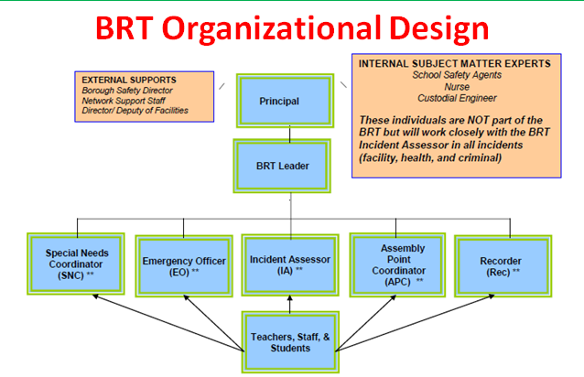

The General Response Protocol (GRP) is a set of procedures that schools throughout the five
boroughs follow in the event of an emergency situation. Depending on the type of emergency (e.g. an intruder, fire, or rabid animal), a different response is required of staff members and scholars. The description of each of the protocols can be found in Appendix VII and will be reviewed in PD during the beginning of the year. Posters with the GRP will also be posted in every classroom and office space in the school for your reference.

Accidents/Injuries & School Nurse

If a student says they need to visit the Nurse:
- The teacher/staff member should evaluate the student and determine whether or not he/she actually needs to leave the classroom. While the health of our scholars is a top priority, we also must remember that middle school scholars will sometimes use a fake illness to get out of class. It is important that we use our teacher senses (much like spidey senses) first.
- If the scholar needs medical attention, please send him/her to the Main Office with a pass indicating he/she may need to see the nurse. If the scholar is too ill to travel alone, please assign another responsible scholar to bring him/her to the Main office.
- If the nurse is needed, the scholars will be escorted by a member of Team Ops to the first floor nurse’s office. Nurse Wynter will evaluate the scholars and contact his/her parents, as needed.
- If the child is able to return to class, he/she will be picked up by a member of Team Ops and sent back to class with a pass. If the nurse indicates that the scholar needs to be picked up, he/she will be escorted to his/her homeroom by a staff member to retrieve his/her belongings and then report to the Main Office to await the parent/guardian.

School Safety
AF Brownsville Middle has invested in some very expensive classroom furniture and technology items. 2021 Bergen is a building that has many people coming and going. Given the security concerns, the following guidelines should be followed:
- Staff members are responsible for locking their classrooms/offices at any time when there is no adult present in the room.
- Staff members must lock their classrooms/offices at the end of each work day.
- Staff members should not leave laptop computers or other valuables unattended. As stated in the AF technology agreement, staff members will be held liable for damaged / lost / stolen laptops.

Since we are in a shared Department of Education building, there are members of the New York City Police Department School Safety division on-site between the hours of 6:30am and 6:30pm daily (and longer on days when extended use permits and placed). Their mission is to provide a safe environment, conducive to learning, where students and faculty can be free from hostility and disruptions which could negatively impact on the educational process. While maintaining classroom order and safety is primarily the role of instructional staff, School Safety officers are available for support as needed. If you need support from School Safety, please let Team Ops or Team Culture know so they can radio a SSA.

APPENDIX I: Tax Exempt Letter
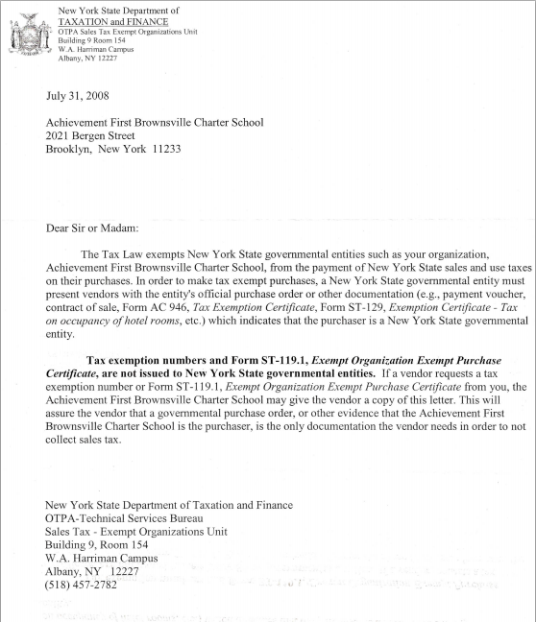

APPENDIX II: Supply Request Form

APPENDIX III: Custodial Repair Request Form
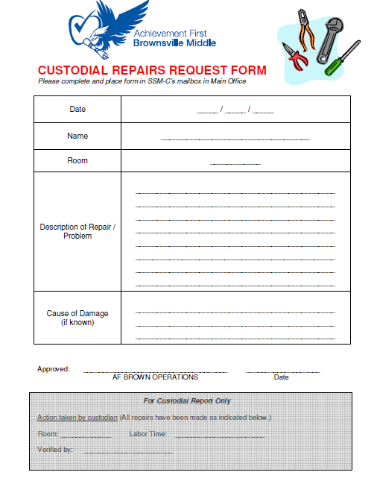

APPENDIX IV: Staff Timesheet (Hourly Work)
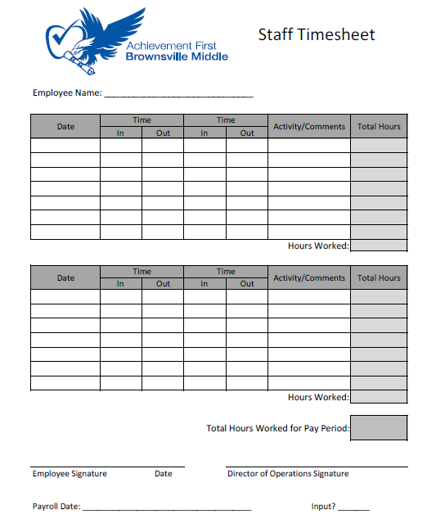

APPENDIX V: General Reponses Protocols
APPENDIX VI: Team Norms

Achievement First Brownsville M.S.
Team Norms (updated August 2014)
TIMELY, PRESENT, AND SOLUTIONS ORIENTED—We respect each other’s time, energy, and ideas. The expectation is that we are on time, fully engaged, and attacking problems with solutions, rather than complaints.
LOOKS LIKE: Planning ahead with productive ideas
DOESN’T LOOK LIKE: Complaining without a solution

BE RATIONALLY OPTIMISTIC—We ground ourselves in the reality of brutal facts, yet we maintain unwavering faith.
LOOKS LIKE: Embracing challenges while staying goal-oriented
DOESN’T LOOK LIKE: Making excuses

DISSENT, DON’T RESENT. COMMIT—We all must be heard, but we need not all be followed. The best idea holds, and once a decision is made, we move together united.
LOOKS LIKE: Sharing all ideas and concerns
DOESN’T LOOK LIKE: Taking disagreement personally

ASSUME THE BEST; EXPECT THE MOST— We always assume colleagues, parents, and scholars are operating with the best intentions. In turn, we hold ourselves to the highest standards.
LOOKS LIKE: Trusting our teammates’ work
DOESN’T LOOK LIKE: Questioning others’ motives

JOY (BE PASSIONATE!)— We do this work because of something inside of us; it brings us joy and incites passion.
LOOKS LIKE: Acting with enthusiasm
DOESN’T LOOK LIKE: Outwardly expressing stress
PERPETUALLY IMPROVE— We will be the iron that sharpens iron, embracing growth opportunities for ourselves and engaging our peers, even when it is difficult.
LOOKS LIKE: Giving feedback when it’s tough
DOESN’T LOOK LIKE: Settling for good enough

