Grade 6 | Unit 1, Lesson 1

Intellectual Preparation Cover Sheet

Directions: Complete the IPP Cover Sheet for every lesson due for submission.
Step | Action:
- Understand the concept and/or big ideas at play in the lesson and be able to articulate them clearly and crisply. | - Read the entire Lesson Plan and identify the key concepts/big ideas students need to understand. Create a lesson summary annotation that describes, in your own words, the purpose of the lesson (why), the key concepts students need to understand (big ideas/what), and how they will come to understand these within the lesson.
- Do the core tasks of the lesson to develop/refine exemplar work and clear CFS for anticipated strategies. | - Print the classwork and complete this step directly in the student packet for the TAI, INM/TTC problem (include exemplar annotations), and all GP/IP problems.
- Anticipate misconceptions and create questions/supports to address these misconceptions. | - For each core task, annotate to describe expected errors on the tasks and back pocket questions to respond to these errors  - Identify the questions in the TAI debrief and INM/TTC that elicit the most important understandings and annotate with the following:  - The exemplar student responses  - 1-2 misconceptions or errors that could surface in response to these questions  - BPQs and/or the instructional strategy to address these misconceptions.
- Optional/As needed: Adjust the plan for any individualized AOTY or intellectual preparation goals. | - As determined with coach, you might:  - Script MVP directions into lesson plans  - Script in additional planned investment moves  - Create rapid & batched feedback forms to capture data  - Determine additional points for differentiation (especially for very high and very low performance during the lesson)  - If you will meet in person to scrimmage this lesson, your coach may also ask you to submit a proposed practice objective and identify the lesson segment to practice.
Submit annotated plans and any additional work as per IPP expectations in soft copy of LPs to your coach weekly (and at least 48 hours in advance of the IPP meeting). Implement any feedback from coach prior to the phase 2 meeting.
- Rehearse and Refine:
  - Meet with coach to further internalize and practice executing the plan.
  - Refine plan as needed based on student data.
  - If possible, prior to teaching the day of, analyze student work from TAI administered at end of CR block; select S work to show call to drive TAI debrief discussion to land Fence Posts and key point.

Aim
- SWBAT apply addition and subtraction of decimal numbers and explain the process in terms of place value.
- SWBAT gauge the reasonableness of the sum or difference using estimation.
Conjecture
- To add or subtract, digits must be in the same place value.
Standard
Compute fluently with multi-digit numbers and find common factors and multiples.
6.NS.3 Fluently add, subtract, multiply, and divide multi-digit decimals using the standard algorithm for each operation.

State Test Alignment
SBAC Sample Item
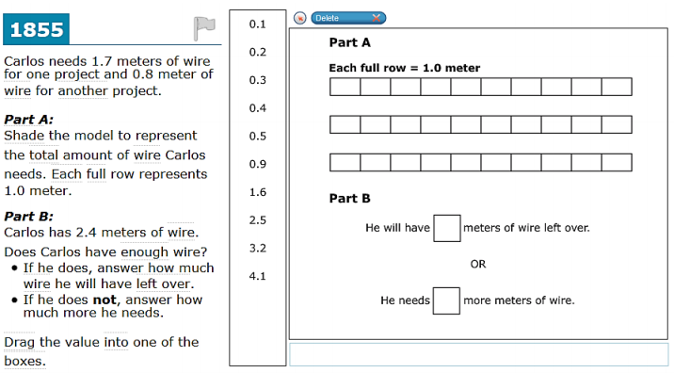

From 2015 NYSE – Secondary Standard
What is the solution of the equation below?
x + 8.63 = 11.001
- x = 19.631
- x = 10.138
- x = 3.471
- x = 2.371

Assessment
Exit Ticket:
- Find the sum of 54.2 and 0.53
- Jeff subtracted 4.3 from 9.85 and got a difference of 9.42. Did he subtract correctly? If yes, how do you know? If no, explain the mistake he made and provide the correct work.
Student Work:
- Addends are lined up by place value written as 54.20 + 0.53. Sum is 54.73
- Jeff subtracted incorrectly. I know this because when you round 4.3 to 4 and 9.85 to 10, 10-4 is 6, and 9.52 is not a reasonable answer given that 6 is the estimate. He made the mistake of not subtracting digits in the same place value. He subtracted 3 tenths from 5 hundredths and 4 wholes from 8 tenths. In the future, he should make sure he subtracts digits with the same place value. (Student provides correct work).

Connection to learning
- How does this lesson connect to previous lessons?
  - This is the first lesson of 6th grade. In 5th grade, students learned to add and subtract decimal fractions using visual models (i.e. 100 grids) and their understanding of place value- for many students, this lesson may come as a refresher/review, and should really aim to deepen the conceptual understanding for the algorithm. Students are building off of what they learned last year to become fluent with adding and subtracting decimals.

- What do we want every student to take away or do as a result of this lesson? How will a teacher know if students have met this goal?
  - Understand: As a result of this lesson, we want every student to understand that you can only add and subtract digits in the same place value, because in the standard algorithm a place value is a unit. Additionally, students understand that one can use estimation in order to determine whether or not a sum or difference is reasonable. This understanding is important because students are able to use estimation to conclude that adding or subtracting digits in different place values yields an incorrect answer.
  - Do: All students can estimate and calculate an exact sum or difference of two decimal fractions.
How
- Key Strategy/ies
  - Line up digits (use zeros as place holders if necessary)
  - Add or subtract
  - Use estimation to check the reasonableness of the answer
- CFS for top quality work
  - Problem is annotated with margin notes to provide additional meaning
  - All calculations are shown
  - Check is performed
  - Work is organized and neat

Anticipated Misconceptions and Errors
- Students may not line up digits by place value, but instead line them up to the left or right.
- Students may flip the order of the minuend and subtrahend because the minuend has fewer digits, thereby making it appear to be the smaller value (instead of using zeros in the place values where there are no digits).

Key Vocabulary
- Place Value – The numerical value of a digit given its position in a number
- Sum – Answer to an addition problem
- Difference – Answer to a subtraction problem

Materials
- Handout
- Place value chart for visual learners

Opening – Prompt for work time, Circulate, Debrief, Synthesis, & Frame – 12-15 min
THINK ABOUT IT!
Analyze the work shown below. Use any strategy to identify and circle the problems that are solved correctly.

42.5 9.8 20.3 29.8
+ 9 + 3.0 - 4.1 - 8
43.4 12.8 16.2 29.0

Which problems were solved correctly? How do you know?
Prompt for Work Time (<30 sec)
      - You will have 5 minutes to work on this Think About It. Please use the entire 5 minutes. Show your work and if you’ve come up with one way to prove which problems are solved correctly and incorrectly, push yourself to come up with another strategy.

Circulate (≤ 5 min)
      - While circulating, collect data on the following:

Scholar thinking (correct and erroneous) | Scholar Initials - Work to show call
S indicated that some or both of the incorrect problems were correct
S ID’d correct and incorrect problems
S used place value reasoning to justify selections
S used estimation reasoning to justify selections

Debrief (≤ 7 min)
      - FENCEPOST #1: Estimation is a strategy to check reasonableness of answers
        - Show call S work that correctly uses estimation to check which answers are correct. Analyze the work. Did this student identify which problems are correct and incorrect? Vote.
        - How did this student figure out which problems were solved correctly and incorrectly? TT. CC. SMS: The scholar estimated for each problem. For example, in the first one, s/he did 43+9 = 52 to show that a sum of 43.4 is not reasonable.
        - How was estimation helpful here? CC.
        - FENCEPOST #1: Estimation is a strategy to check reasonableness of answers.

      - Conjecture: To add or subtract, digits must be in the same place value
        - Let’s look at another student’s explanation. Show call and read S explanation that says we can only add and subtract like units, so we cannot add digits in different place values. This is why problems 1 and 4 are incorrect, and problems 2 and 3 are correct. The digits being added and subtracted are in the same place value.
        - Do you agree or disagree with this students’ explanation? TT. Vote. CC –discussion if needed. SMS: I agree that you can only add and subtract like units- as with whole numbers when we add ones and ones, tens and tens, etc… The same is true when we move to decimal place values. We can tell the first one is not correct because the 9 is put in the tenths place instead of the ones place. [Planner’s note: Students must articulate that digits in the same place value are like units, and only like units can be added or subtracted].

Key Learning Synthesis (≤ 2 min)
      - CONJECTURE: To add or subtract, digits must be in the same place value.
        - Let’s form our conjecture for today. With your partner, come up with a conjecture about addition and subtraction.

Frame (≤ 30 sec)
      - You all just came up with today’s conjecture. To add or subtract, digits must be in the same place value.

Test the Conjecture – 10 min
Post the Conjecture in visible place for student reference: To add or subtract, digits must be in the same place value.

Let’s go ahead and test our conjecture to make sure that it is a true statement all the time!
What will we be able to do if our conjecture is true? TT. CC. When we add or subtract digits in the same place value, we will get the correct sum or difference.

TEST THE CONJECTURE #1
Find the sum of 23.1 and 0.98

        - Take 30 seconds to read and annotate the problem.
        - What is the question asking us to do?
        - How can we apply our conjecture to solve the problem?
        - On your own, apply the conjecture to add the two numbers. (Circulate).
          - Some Ss may line up the digits incorrectly. If this happens, quickly show call and ask students to analyze and fix.
          - Show call exemplar. Vote.
        - How can we prove that our conjecture worked? CC. SMS: We can estimate, or we could use a calculator to make sure we got the exact correct answer.
        - I will use a calculator to be sure. Meanwhile, everyone, mentally estimate the sum. You have 30 seconds. Call it. 24!
        - Is our answer reasonable? How do you know?
        - The calculator provides a sum of 24.08.
        - So far, does our conjecture hold up? How do you know? TT. Vote. CC.

TEST THE CONJECTURE #2
In 2015, Tamya spent 100 hours reading. In 2016, she has only read 9.5 hours. How many more hours does she have to read in order to also read 100 hours in 2016.

      - Take 30 seconds to read and annotate the problem.
      - What is the problem asking us to do? CC.
      - What information are we provided? CC.
      - What equation will represent the number of hours she still has? CC.
      - How can we apply our conjecture to solve the problem? Everybody writes. CC.
      - With your partner, solve the problem to figure out the number of hours she has to read in 2016. TT. CC.
      - Show call correct S work. Did this S solve correctly? How do you know? CC.
      - How can we prove that our conjecture worked?
      - So far, does our conjecture hold up? How do you know? TT. Vote. CC. SMS: The conjecture did hold up because when we subtracted the digits in the same place value, we got a reasonable answer.

Stamp the Learning
      - Point to the written conjecture. So far, does our conjecture hold true? How do you know? TT. CC.
      - STAMP THE CONJECTURE

Frame for PP/IP
      - For the next 5 minutes, you’ll be working with your partner applying the conjecture that we just stamped. While working, make sure that you are meeting our CFS for top quality explanations.
      - CFS for top quality work
  - Problem is annotated with margin notes to provide additional meaning
  - All calculations are shown
  - Check is performed
  - Work is organized and neat

IPP STEP 2: Teacher created exemplars/work for show call.
TAI:
Show call 1:
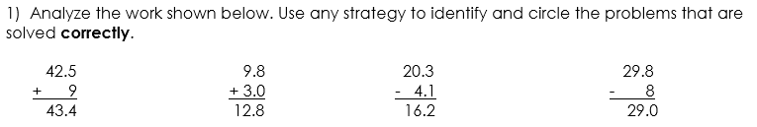
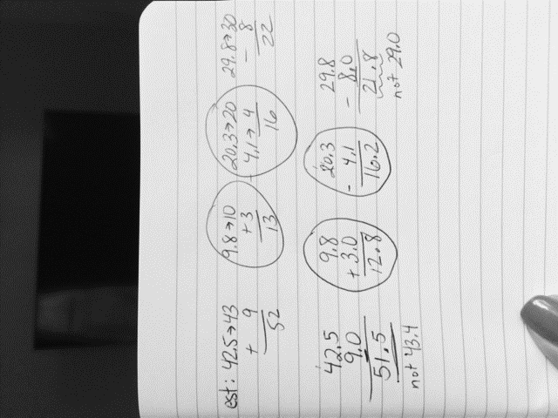
Explanation 1: The second and third problems were done correctly. The sum and difference in these problems is reasonable compared to my estimates. In the first and last problem, the sum and difference is not reasonable.
Show call 2:
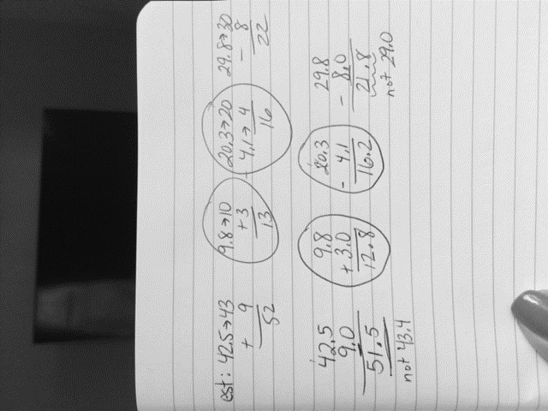
Explanation 2: The second and third problems were done correctly because as I show in my work, the digits are lined up by place value. We can only add and subtract like units. In the first problem, the 9 should be in the ones place under the 2. In the last problem the 8 should be in the ones place under the 9.
TTC1 TTC2
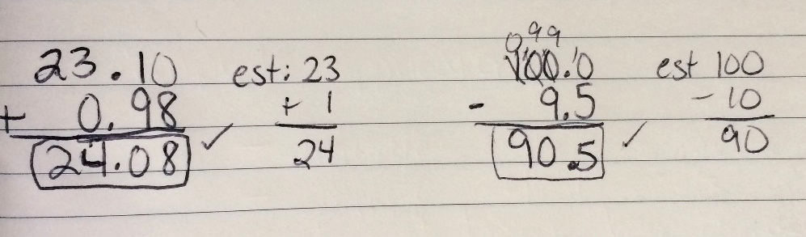

Name: ___________________________ Date: ____________________________
UNIT 1 LESSON 1

AIM: | SWBAT add and subtract decimals.

THINK ABOUT IT!

1) Analyze the work shown below. Use any strategy to identify and circle the problems that are solved correctly.

42.5 9.8 20.3 29.8
+ 9 + 3.0 - 4.1 - 8
43.4 12.8 16.2 29.0

Which problems were solved correctly? How do you know?

_________________________________________________________________________________________________

_________________________________________________________________________________________________

_________________________________________________________________________________________________

_________________________________________________________________________________________________

_________________________________________________________________________________________________

_________________________________________________________________________________________________

_________________________________________________________________________________________________

Test the Conjecture
Test the Conjecture #1)
Find the sum of 23.1 and 0.98

Test the Conjecture #2)
In 2015, Tamya spent 100 hours reading. In 2016, she has only read 9.5 hours. How many more hours does she have to read in order to also read 100 hours in 2016.

Conjecture

PARTNER PRACTICE

Bachelor Level

- What is 5.026 + 3.1? Show your work.

- What is 29.3407 – 14.02? Show your work.

Master Level

- John needs $2.50. He has $0.75. How much more money does he need?

INDEPENDENT PRACTICE

Bachelor Level
- Evaluate each expression

  - 23 – 0.324

  - 9.3 + 19.59

- Isabel answered the problem below incorrectly.

16.007 – 0.55 = 10.507

Describe what she might have done wrong, explain why her answer doesn’t make sense, and then solve the problem correctly.

____________________________________________________________________________________

____________________________________________________________________________________

____________________________________________________________________________________

____________________________________________________________________________________

____________________________________________________________________________________

Master Level
- John walks 1 mile to school and Nina walks 0.351 miles to school. How much farther does John walk than Nina?

- Janelle took two quizzes that were both worth 50 percentage points. On her first quiz she scored 20.49%. On her second quiz (she studied more!), her score was 39.14%. Which of the following statements is true? Circle all that apply.
  - She decreased her score by 18.65%
  - Her second quiz score was 18.65% higher than her first.
  - Her second score was 10.86 percentage points from being a 50%

- Jahkyra added 0.0015 and 0.015 and got 0.030 as her answer. Daniel added the same two numbers and got 0.0030 as his answer. Do you agree with Daniel, Jahkyra, or neither of them? If you agree with one of them, explain who you agree with and why. If you don’t agree with either of them, what do you think is the correct answer and why?

____________________________________________________________________________________

____________________________________________________________________________________

____________________________________________________________________________________

____________________________________________________________________________________

PhD Level

- A swimmer is in a 100-meter race. She swims the first half of the race in 32.34 seconds and the last half of the race in 34.83 seconds.

How long did it take her to swim the whole race?

How much longer did she take the swim the last half of the race?

- Jane buys an apple for $0.75 and an orange for $0.35. She pays with a $5.00 bill. How much change will she get?

- Edwin went to the grocery store and bought several pounds of fruit. The fruit costs $2 per pound. If he bought 2.5 pounds of apples, 1 $\frac{3}{10}$ pounds of bananas, and 0.85 pounds of kiwis, how much did he spend in fruit?

Name: ______________________________ Date: _______________________
EXIT TICKET
Self-assessment | I mastered the learning objective today. | I am almost there. | Need more practice and feedback.
Teacher feedback | You mastered the learning objective today. | You are almost there. | You need more practice and feedback.

- Find the sum of 54.2 and 0.53

- Jeff subtracted 4.3 from 9.85 and got a difference of 9.42. Did he subtract correctly? If yes, how do you know? If no, explain the mistake he made and a strategy for how he should avoid the mistake in the future.

____________________________________________________________________________________

____________________________________________________________________________________

____________________________________________________________________________________

____________________________________________________________________________________

____________________________________________________________________________________

